November 2013
EEevoke: 1. to c--all fortVhV2. to re-cooreate imagincactively
Why Are You Here?
By S. Janet Gildea

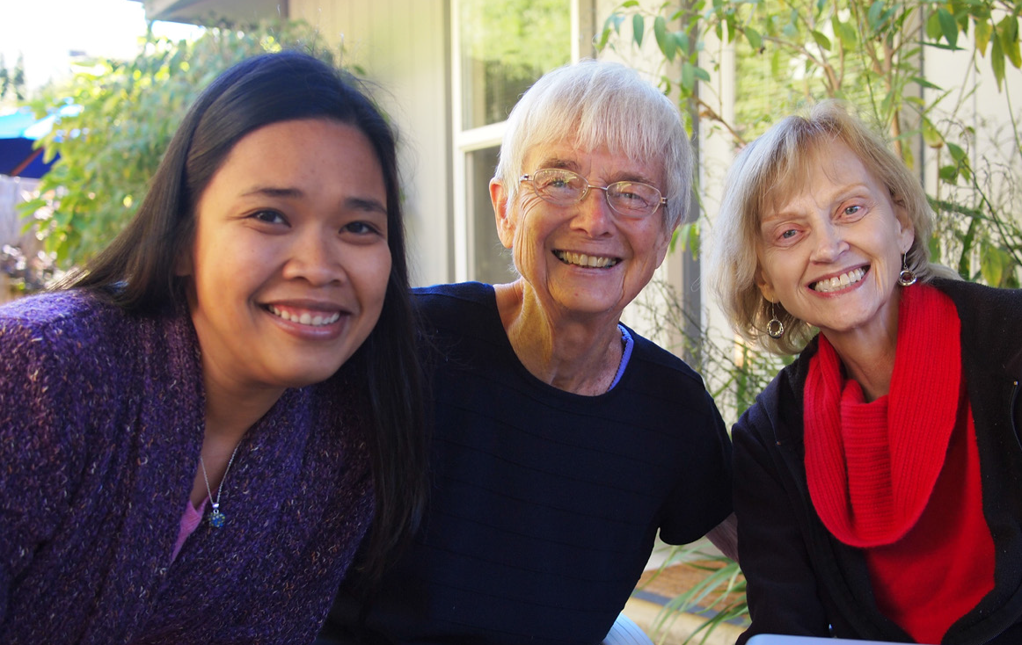

CALENDAR
November 18-22, 2013 November Nuns Build New Orleans, La.

November 24, 2013
Learn, Share and Pray: School of the Americas Vigil
Rose Room, Motherhouse, 10:45 a.m. For more information, click here.

November 28, 2013
Thanksgiving

OPJIC’s Water With Blessings project officially got underway on Wednesday, Oct. 2 with a training of the Water Women in Mexico. The Office of Peace, Justice and Integrity of Creation and SC Family are partnering with mothers,
empowering and equipping them to bring clean water to their families and neighbors.
re you acquainted with the story of the Old Testament prophet Elijah? As with many of the prophets, he was very unpopular with the
powerful folk of his day, especially Queen Jezebel. She wanted to kill him. Eventually Elijah had to flee into the desert where he was ready to give up but the angel of God wouldn’t let him rest. The angel provided food and water so that Elijah could walk on for another 40 days. He arrived at Mount Horeb and holed-up in a cave, safe at last – or so he thought!
A
The voice of God came to Elijah: “Why are you here, Elijah?” Can you imagine Elijah’s reaction to the question? What do you mean, why am I here? You got me into this mess! I could have been killed! (You can read what
he really said in 1Kings 19:10.) While most of us won’t have to flee to a cave
in order to avoid being killed for living our faith, each of us does have to face the ultimate discernment question: Why are you here?
It’s not just the “meaning of life” question but the meaning of my life that needs attention. Elijah’s journey can offer some insights. First, in the daily grind of life it can be difficult to understand what God is asking of us. We can find desert oases at daily Mass, on the commute to work, through various online meditation websites, in a daily exercise routine (not PX90 or Insanity) or in spiritual direction. Those disciplines might buy us time to get to some real sacred space. That’s the second insight from Elijah: at some point you have to ascend the mountain of God and enter the cave for some serious silence if you want to hear God’s voice.
Thirdly, God’s voice might not come the way you expect it. Elijah waited for God at the entrance to the cave. There was a fierce wind ... not God. There was an earthquake ... not God. There was a firestorm ... not God. No great dramatic appearances, no lightning bolts or magic. There was only “a tiny whispering sound”... God! How can you hear or sense that tiny whisper if you’re caught up in the whirlwind of life? For the big questions you must find the time, make the climb, enter the cave and wait. Then, after all the dust of your life settles, you just might hear the whisper of God ... who will ask, “Why are you here?”
The answer to that question might send you right back into life as you know it, just as it did with Elijah. But having had an encounter with the One who is heavily invested in the “why” of your life will clarify your calling and fortify you for the next step on the journey.

Where are the Sisters Today?
S. Mary Gallagher
My Mentor –
S. Barbara Counts
by S. Georgia Kitt
was a newly hired math teacher at
I
Elizabeth Seton High School, South Holland, Ill. I had never met a Sister of Charity before.
The school was new and the staff and students seemed to reflect that new,

youthful energy.
S. Barbara Counts

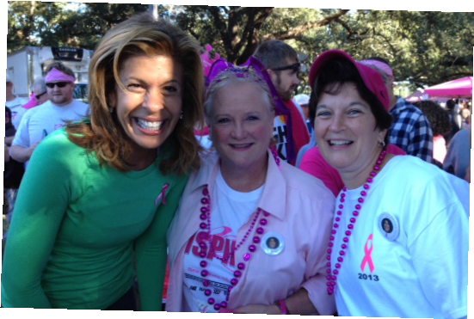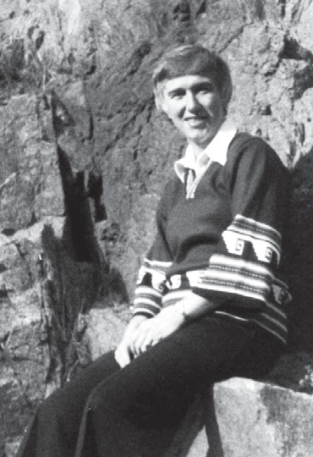

S. Mary Gallagher has ministered in the Commonwealth of Dominica in the West Indies for almost three years, serving the diocese as coordinator of religious education and faith formation for teachers in the Catholic grade and high schools.To read more, click here.

Faith in Film: Sisters
ive young religious from active apostolic congregations are featured

S.
F
in this one-hour documentary that offers real insights about how the call is discerned and lived in the US today. The Sisters themselves tell their stories of faith, ministry, choices and hope for
the future of religious life. These are real Sisters, and our own Vocation Director
S. Monica Gundler is one of them! View it at https://lcwr.org/publications/ sisters-documentary.
The friendliness and hospitality of the SC women, particularly Sisters Magdalen Dolores Harrington and Barbara Counts,
welcomed me into the high school and math department. I felt included and willingly contributed to the school community almost immediately. There was a “we spirit” in the climate they created.
These SC women faculty members were happy and alive; I found myself wanting to be like them. There was something more – an intangible, reflective spirit. As my mentor,
S. Barbara shared her person and her love for the SC Community as I joined them for picnics, drives to Lake Michigan and trips to the airport to meet SCs coming and going, from East to West and back again. In the
classroom S. Barbara met the students at their level and challenged them to reach beyond; in activities the students’ leadership skills were welcomed and their persons respected.
By November we were planning a trip to the Motherhouse in Cincinnati. In December
S. Mary Janet Miller came to interview me and the following August I entered the Sisters of Charity. As they say, the rest is history. Forty- seven years later I continue to find new energy in sharing SC life together as companions who witness to the world, valuing God’s love for each person. Elizabeth continues to plant her mustard seeds – even today.

E-Voc is the electronic newsletter from the Vocations Team of the Sisters of Charity of Cincinnati for single women wondering what new thing God is calling forth in their lives.To unsubscribe, click here.
If you are interested in learning more about life as a Sister of Charity, visit our website at www.srcharitycinti.org or contact S. Monica Gundler at 513-504-5592.
Visit us on Facebook!
www.facebook.com/sistersofcharityofcincinnati

