North of 60 Project
by Peter Ouellette, Western Regional Council
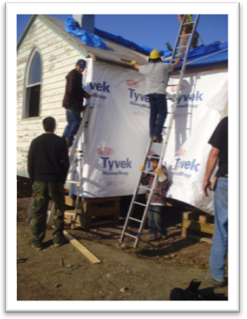
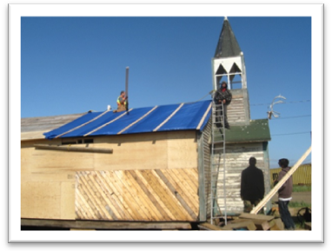
Several years ago our recently departed Vincentian, Eileen Orysiuk started to work with Sister Fay Trombley of Tuktoyaktuk, NWT. Through their efforts, a new SSVP Conference was born. The Tuk Project brought awareness to our Society of the needs of that community. The project team developed food supply programs, church renovation supplies and manpower, driver training programs for the youth and many other initiatives that have led to systemic change in the community of Tuktoyaktuk. There are many more Northern communities in need. The success of the special works of the Tuk Committee led us into thinking about growth. Last year the North of 60 Committee was formed.
Discussions with Fr. Chilaka Magnus of Inuvik, Sister Dorica Server of Wales Cove, and Roger Plouffe of On Eagles Wings (http://www.oneagleswings.org/) all helped to establish the focus of growth in SSVP formation and Northern Community support.
Three communities were identified for 2013:
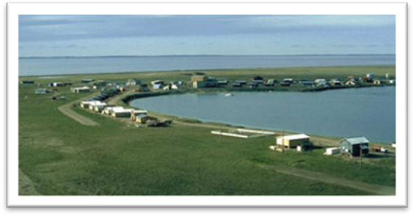
- Paulatuk, where Sister Fay was already working on the formation of a new SSVP Conference,
- Gjoa Haven, where an SSVP Conference already exists however the Conference President Ilulik (Keith) Nimiqtaqtuq was asking for material and spiritual assistance, and
- Inuvik, where Fr. Magnus was asking for financial support to keep their soup kitchen going for another year.
So why is our help needed? As Sister Dorica says health is much more than the absence of disease. A number of factors have an impact on the health of individuals and communities, including income, economic development, housing, environment, food security, education and self-determination.
When food cost and food availability are looked at through a health lens, we see that Inuit families across Canada continue to face challenges in accessing adequate nutritional food.
Some of the causes are low income in Inuit families, changing dietary habits, high cost of food in the North, increasing costs of harvesting and hunting (price of gas for snowmobiles), and lack of awareness of healthy eating habits.
In a 2003 study in Kugaaruk, Nunavut on food security, five out of six Inuit households were classified as “food insecure”. This is an issue that affects many Inuit communities. Over half of the households studied had experienced hunger in the last year.
According to this study, 80 per cent of Inuit women surveyed in earlier Food Mail Program projects (Pond Inlet and Repulse Bay) said they had run out of money to buy food in the previous month. More than 60 per cent of households with children were hungry in the previous 12 months. In Labrador (now Nunatsiavut), 28 per cent of households reported that they on occasion did not have enough to eat with seven per cent stating that they often had insufficient food.
While there is little information on how Inuit families cope internally with food shortages, it is common that in such households, parents (particularly mothers) will forgo meals so their children can eat.
Food costs in the North remain much higher than those in southern Canada. Studies of food costs at grocery stores indicate that northerners pay far more than southerners for the same basket of food. The Northern Food Basket for one week for a family of four, in Kugaaruk costs $327, double that of Edmonton. Three-quarters of the families would have incomes insufficient, or nearly insufficient, to cover the cost of a healthy diet and other necessary family costs.
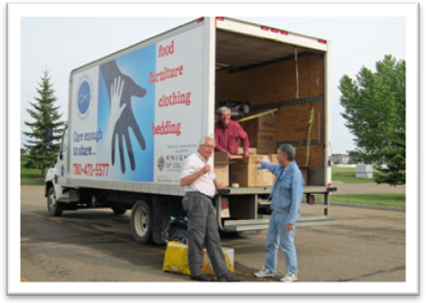
Early this year Ann Marie Hansen, working with CWL at Our Lady of Lourdes Parish in Westbank, B.C. and their new SSVP Conference held discussions with Sr. Fay. They purchased food that was financed by the Western Region’s North of 60 Fund and they organized transport to send food to both Tuktoyaktuk and Paulatuk - by ice roads truck to Tuk and by fly in shipments to Paulatuk. These were needed emergency supplies for spring delivery. It was great to have an SSVP Conference in the BC and Yukon Region helping us with a Western Region Council special project.
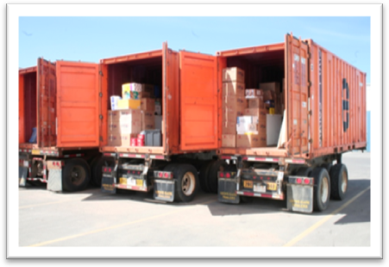
At this same time our North of 60 Committee had negotiated the support of the Northern Transportation Company Limited NTCL (http://www.ntcl.com/) and Landtran Systems (http://www.landtran.com/) for their help to provide us with three sea containers and to ship these containers to our Northern community destinations. This all came together. The cooperation and generosity of these companies has been beyond expectations.
Supplies for these three sea cans were provided by the generous donations of SSVP Conferences in Edmonton. Several thousand pounds of food donated by parishioners, purchased specialty dried meats, vegetables and powdered milk, donated clothing, bedding, freezers, fabric, sewing machines, priests vestments, and many other items filled the containers to the maximum volume. The only problem was that so much came in so fast that we could not keep an inventory list of all the products that were shipped.
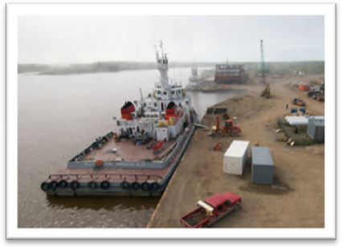
It is mid August at time of reporting this status. The container has arrived at Inuvik and the other two are on the barge in transit.
The team has done a great job of developing the list of Northern community needs and the logistics of transport. Vincentians from Winnipeg, Leduc and Edmonton have been active. The funds have been coming in regularly to support this project but although money is needed it is not the key. SSVP and Vincentians from across Canada are needed. The spirit of Ozanam hearing the cry of the poor has been brought to the table. Yes we need more. We have the need to grow this outreach to more Northern communities. SSVP new Conference formation and material support to Canada’s far North needs to be a priority. Please talk about it in your Conferences. If there is a Vincentian who is interested in taking on the challenge and enjoying the rewards of mentoring one of our many Northern communities in need, then please encourage them to join our North of 60 team with the intent to grow the program in 2014.
God bless and I thank all of you for your support.

