For Vincentians - God has the Answer!
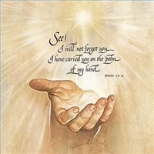
Being a Vincentian is not necessarily easy. It’s not for everyone. It takes a commitment. But it is the same commitment Hannah took when she committed her first son Samuel to the Lord for as long as he would live.
And it is the same commitment to commit our lives to Christ that was made for us as children by our parents when we were baptized. And we confirmed this when we were confirmed and received the gifts of the Holy Spirit. Relying on these gifts will helps us to make the right choices and decisions as we go through life.
Achieving that ultimate profound happiness and peace of heart is the most wonderful gift we can desire and receive. And it is there for us if we accept Jesus as our personal Savior in our life. Also we must accept the calling God has for our life. We are all different and there will be many different callings. Focus on what you feel God wants us to do. Don’t be concerned about what the other person is doing. All tasks are important. There are no “menial” tasks.
Our patron, and the patron of all Charities, Saint Vincent de Paul, had dark spots in his life when he first became a priest. He prayed to the Lord and committed himself to serving the poor if the dark spots would go away. And they did. In today’s terms those dark spots would probably be called depression. As Vincentians, we are privileged to be called to serve our neighbours in need as Saint Vincent and Frederick did so well.
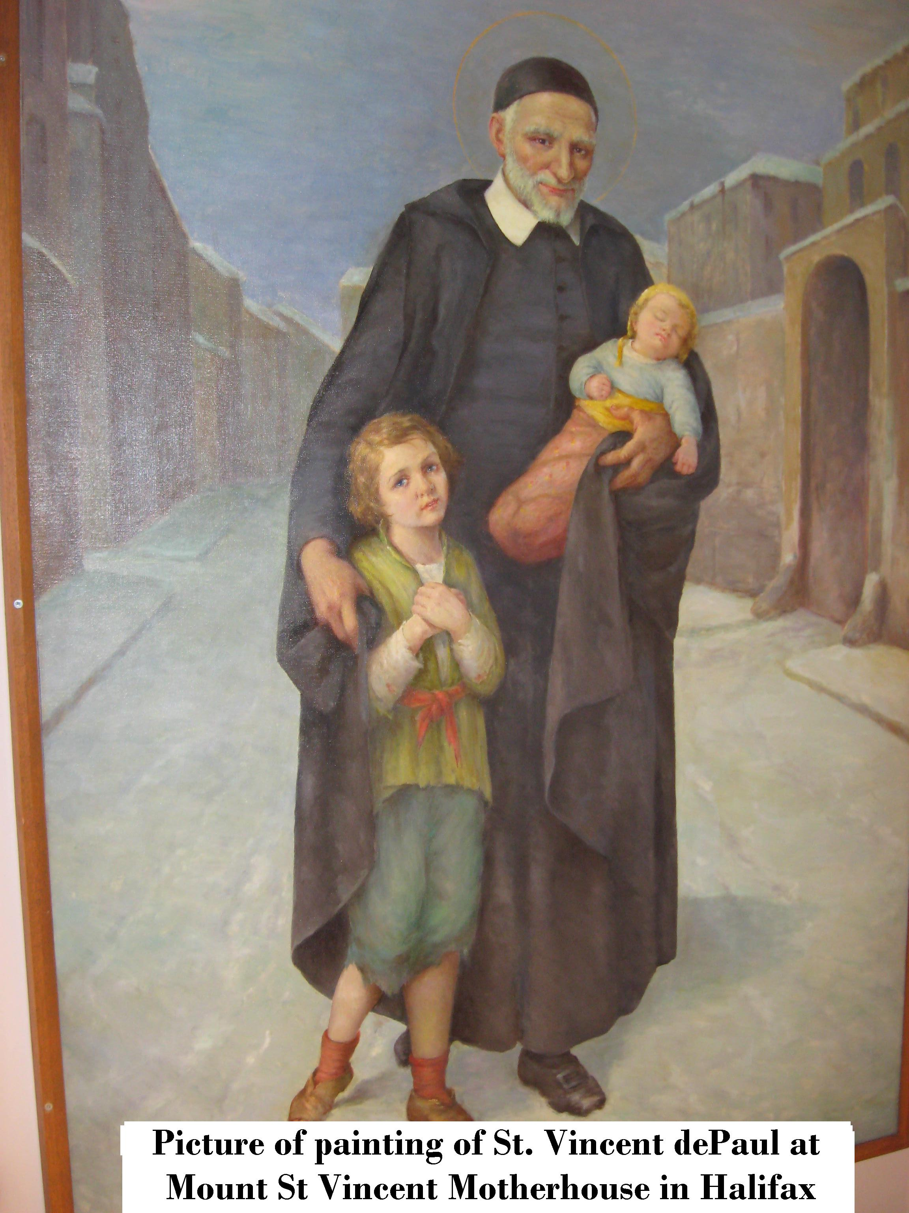
HOW DO WE DO THIS?

Step 1
First, you want to open your heart, mind, and soul to God. Be receptive to the Lord. If you want God to use you for His glory, He will do so. If you continue to search for something, you will eventually find it. – As Matthew 7:7. says .. "Ask, and it will be given to you; seek, and you will find; knock, and it will be opened to you." As Vincentians we experience this so often.

Step 2
Next, ask the Lord to use you for His glory. Let Him know that you want Him to use you. Basically, you are giving your life to God. When you give your life to God, you can be assured that it is in good hands as Hannah did with Samuel. Be an example in your community, at home and at work. Ask yourself what things you could do in your community and home. Be an example to your friends. Set an example for others. Don’t be afraid to do what you know is right.

Step 3
Next, you talk to God and ask Him, "Lord, what is my purpose in life; what is my calling?", “Why am I Here?” “what do You want me to do?” He will give you an answer.
And in the mean time, learn your religion well and develop your relationship with God. Having a good relationship with God simply means communicating to Him about your everyday problems and the things you are thankful for. We can always find things to be thankful for. Talk to the Lord as if He is your best friend because He is your best friend. Ask Him to help you make good decisions and good judgments. Regardless of your age, this is important to you. This will help you to gain more wisdom through His Holy Word and Holy Spirit.

Step 4
Also, take into consideration your hobbies, occupation, and general interests. Whatever they may be, you can use them for God's glory. You can use them to do work for Him. For example, you may have a gift as an artist to paint. You could make paintings that pertain to things that are spiritual, or your paintings could simply have a spiritual meaning or title. You can probably play an instrument. You could attend your church and commit to playing your instrument there. You may have some extra time throughout the week. You could commit some of that extra time to doing community service or volunteer work. Or maybe you are involved in some sport. You could pray before every game that God will guide your every step and movement. If it is His will for you to win the game, simply give God the praise and thanks whether you win or lose. Yes praise God even when you lose. Maybe you could just tell people about Jesus and show His love in your daily work. These are just a few examples of using what God has given you for His glory. Be proud of your faith. Don’t be afraid the bless yourself and say your grace in a restaurant.

Step 5
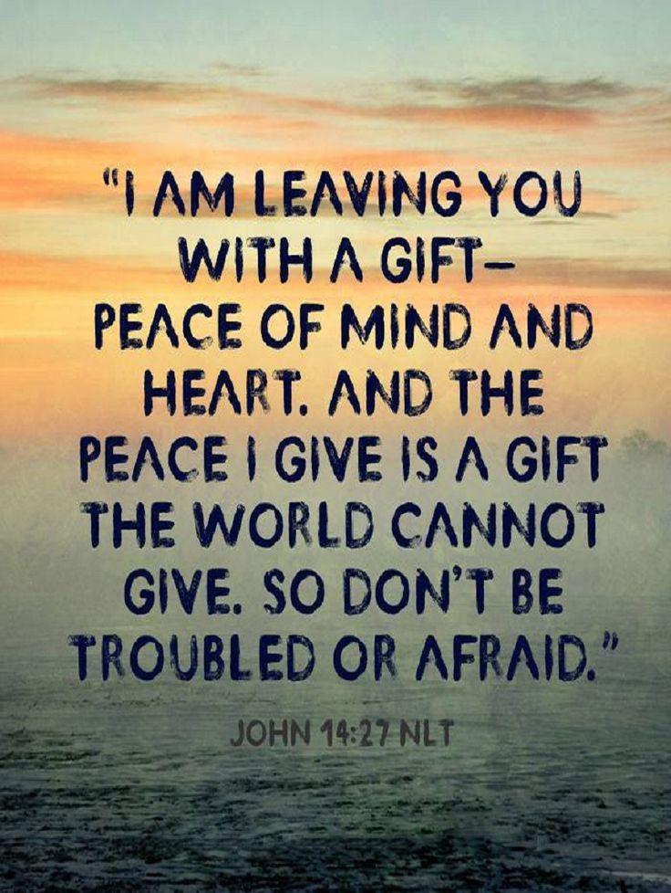
Seek the Lord out by asking for His help and He will help you. You don't have to be perfect to be led by the Lord because he is the only one who is perfect. You just need to have an open mind and be willing to do whatever God has for you to do. And also the faith to believe that if we do our part, He will do His part. We see this so often, especially at Christmas time. As Vincentians we see so many examples of the Lord providing what is needed. I call this “The Miracle of Christmas”. He just expects us to do the work. And he provides so well.

Step 6
As a Vincentian ask the Lord what you can do to help. There are so many ways that you can help. But you must be willing to make this important in your life. It must be high on your list of priorities. Being a Vincentian will mean there will be Spiritual times learning the program and honoring the Lord, Time spent serving those in need in many ways that will often consist of hard work, sorting food, packing food and presents and helping to bring these things to our neighbours in need. We serve the Lord by our actions not just by words and good intentions. Prayer is good and necessary but the actions are the necessary part. There will also be good times meeting fellow Vincentians from all parts of the world.

And in return, we receive “Peace of Heart” the greatest gift the lord can give us. At this point we have learned to trust in the Lord as the day to day happenings no longer worry us because we know everything is in good hands, in the hands of the Lord. We are at peace with ourselves as we realize we can do nothing without the Lord’s help and with His help all things are possible.

