NISISIletters

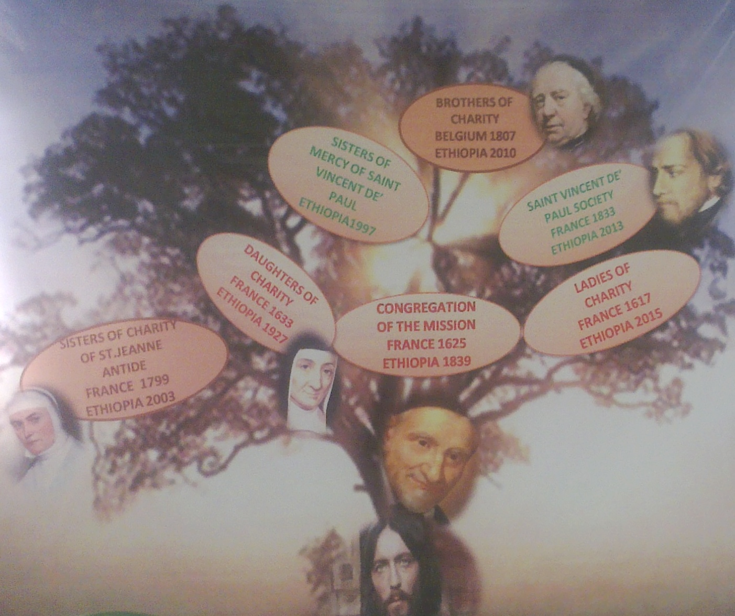 VINCENTIAN FAMILY TREE IN ETHIOPIA
PAGE 1.
VINCENTIAN F.
It’s a calm morning with occasional chilling yet soothing wind: I stare at Gefersa Mental Health Rehabilitation Centre - halfway distracted by the movements of some of our clients. What would Vincent de-Paul do or say? Probably, “My dear, the poor are our Masters and for us to serve them professionally then we should simply ask ourselves what is happening, why is it happening and what is God telling us.”
Tell me why it has to be like this, why should these people struggle with this illness that grabs their dignity and tore away their lives in my very eyes? Why, why...?
Questions like these prompted the Vincentian family to come together to not only serve those in need but more importantly to answer the voice of those who cry out for help, to answer the gentle knock of that who seek assistance and to relieve the load, alleviate the pain and enkindle the dreams that lay silent in those who are abandoned, enlighten the young who will surely carry the mantle that will guide our society tomorrow.
The different founders Louise de Marillac, Jeanne Antide, Rosalie, Frederic, Catherine Laboure, fr. Aladel, Mgr. Leonardus Dobbelaar, fr. Peter J. Triest ...who followed the lead of Vincent de-Paul felt invited in a special way to serve their masters the “poor” with dignity and love while strenuously abandoning themselves to the providence of God and taking great care not to run ahead of it. At the same time great yet simple followers of Vincentian families like Margaret Naseau brought the Vincentian virtues of Simplicity, humility, meekness, mortification and zeal into reality by serving those in need with kindness, teaching them what they themselves have learnt thus uplifting their spirits and rejuvenating their sense of belonging.

NISISIletters

28/03/2015

DID YOU KNOW???
‘There is a subtle difference between collaboration and cooperation?
When you cooperate with someone you work with them, help them, and do what someone has asked or told you to do. And you do it without complaining or arguing.
Collaboration means to work together with 2 or more people to produce a piece of work. It’s a co-production.
Being a cooperative member of a team can mean sharing information, offering help to others, working back to help out. However, you may not be working together with the other staff to produce something together.
To collaborate well I need to be able to:
*Network, *Build alliances and partnerships, *Manage meaning, *Negotiate, *Persist, *Overcome obstacles, *Be flexible

These five Vincentian virtues run way deep into the spiritual and apostolic ways of all the Vincentian family wherever they are. Like a strong wind that splits its way through a forest, swaying the trees to and fro: the virtues trim the lively hood of those it touches with care bringing life, joy, peace and harmoniously fashioning a spirit of collaboration between the various congregations under the Vincentian family, the target group being served, the numerous groups, individuals and governmental institution that give logistical and financial support in order for charity and works of mercy to take its ordained course.
If all this is not being visionary in nature then it is probably walking along the foot prints of their founders re awaking the primitive voice... re telling the stories that defines the Vincentian family way of service and one which re ignites the flame of charity over and over again in this current world that yearns for peace.
Vincentian family are not just about working hard but working smarter. And as one Sr. Eliza of the daughter of charity stated, “It is not about what we do but what change we are impacting on people’s lives.”

PRESENT IN THIS ISSUE:
-VINCENTIAN FAMILY
-READER’S VIEW
BEING A BLISSFUL EXAMPLE
-QUOTES OF LIEFDE
-TRUE STORY SEGMENT
-MIND GRASP
-SHOUT OUTS

NISISIletters

PAGE 2.
motivated to follow in your footsteps hoping to scale to your level or add up further.
Take this living example as a model that will propel you into reflecting in a whole rounded approach.
“As a young girl living along Ethiopia- Eritrean border I was impressed with the pious dedication of some religious sisters working there. Their self giving sacrifice and commitment to their daily service expressed that outmost love which brought hope to many of those who were directly and indirectly involved with them. There positive attitude impressed me so deeply mainly because they were not Ethiopians yet they mingled so nicely in the lives of those they served.
Because of their beautiful example of love and service to those in need I too made up my mind and walked the path of religious life, with one goal in mind to bring joy and hope to those who need it the most.
Now I am overwhelmed with joy when I see young people blossoming like flowers in our Centre and growing up and building their capacity and exploring their talents in a way that they knew not when they joined us.”
.

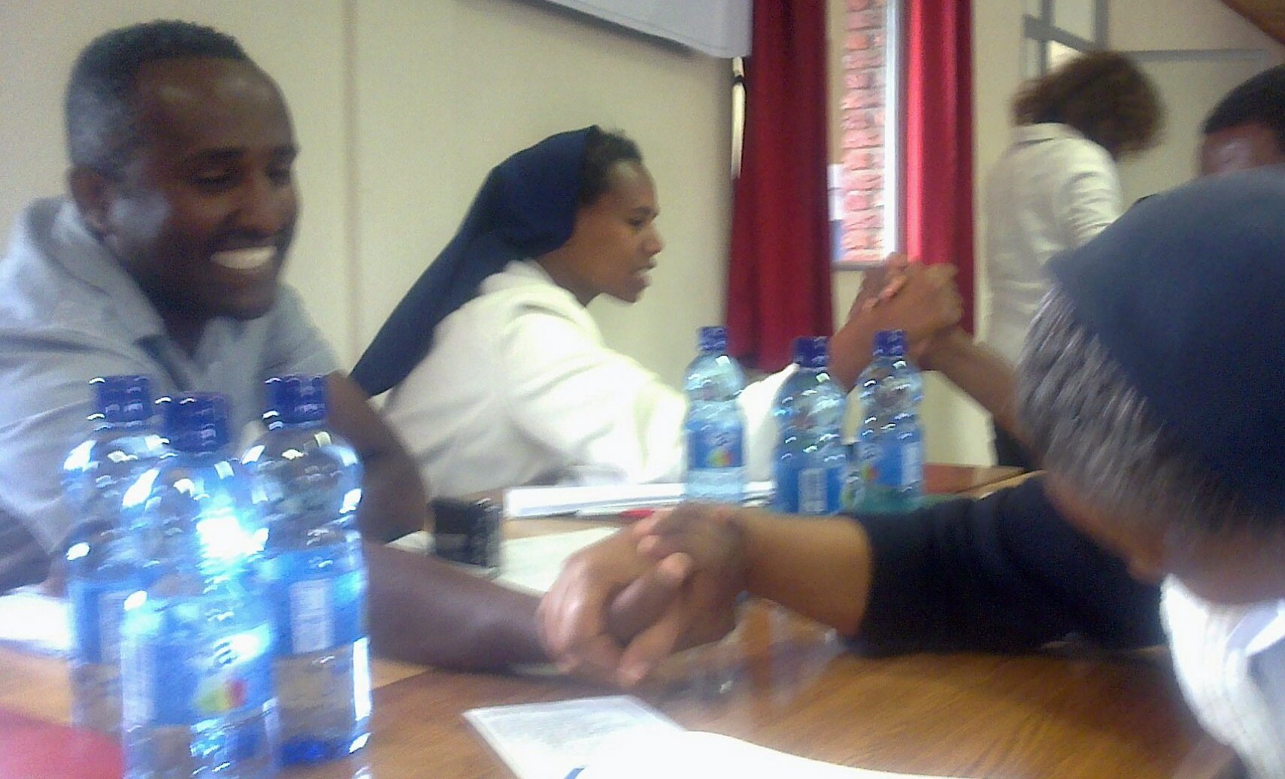

READERS’ VIEW
When asked what she felt about the workshop. Senaite, who was probably the youngest participant in the workshop jovially stated, “WOW!!!!! Words can’t express my feelings.”
An upbeat Mr. Feleke, while sharing about the concluding workshop on collaboration he emphasized that the workshop opened a high way of networking between participants where various experience were shared and learning took place and more over “I am not alone because am rich with collaborators.”
“Without God we are nothing, we are useless, we are incapable of what we do best- serving our masters...allow the flame of love within to burn intently in line with the Vincentian Charism...” -father Joseph

EING A
LISSFUL
EXAMPLE
.

Many are the times we go about our business as though it meant a lot only to us, while forgetting that we ourselves are other people’s business.
Surprised??? You not alone, a huge ratio of the population around view life in the same perspective as you! Am not saying is bad nor is it selfish; am just saying that whatever adventure or business or activity that you are undertaking, remember that there is at least one individual who is watching you, learning from you and probably out of the passion you put in it he or she may be

B

NISISIletters

PAGE 3.

QUOTES OF ‘‘LIEFDE’’ “YE FIQIR MAREJA”

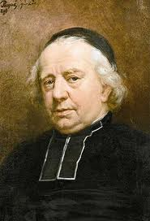
PETER JOSEPH TRIEST once said, “Our lifetime is so short and passes so quickly. It is like a leaf chased by the wind, a fume, smoke that vanishes into thin air. How then do we spend that short period of time that so quickly approaches eternity? Let us make good use of the time that is left to us; let us use it to perform creditable work.”

Let us reflect for a moment on how we have spent the time that has past.
- Have I accomplished anything in life?
- If yes, did my accomplishment bring a positive impact to those around me or were they selfish and self centred?
- If no, what goals (short or long term) have I set to accomplish?
My friends it is not too late to start utilising our time sufficiently!

PRIDE VS. HUMILITY.
In a monastery in Uganda there was a young man seeking God’s call and day in and day out he prayed and worked with the pious monks and in his private time he sat alone searching deep within his heart and mind trying to understand what plans God had laid down for him. For months he searched and searched for answers but it seemed as though no answer came from God, so one night while reflecting about life a fellow aspirant came and joined him there. They sat and enjoyed each other’s company in silence and then without a word they left. A few days later as he sat there the other aspirant joined him and soon it became a kind of routine which attracted two more aspirants. this silent night activity caught the eye of an old monk who has been in the monastery since its foundation. So one day he said to the young man having taken him around the beautiful rose garden within the monastery, “Son, can you see the pride the blossoming rose flowers have?” the young man nodded uncertain of what the monk was aiming at. “they bask in the glory of the time forgetting that in a few days time they will grow big and their little branches will not be able to hold them upward anymore.” At this juncture the young man interrupted the old monk; “what do you mean Abba?” looking directly at the young man’s eyes, the old monk exclaimed, “Son, when you start attracting others towards you don’t allow pride to fill you up to the brim: instead balance your pride with humility so that those around you will feel refreshed by the pious virtue that drips from you.” TRUE STORY!!!

NISISIletters

ACTIVITY CORDINATOR,

Phone: +251-945-240-945
E-mail: socialskills.2004@gmail.com
vekesi01@gmail.com

ARE YOU lugging BEHIND IN YOUR DEALINGS???? WORRY NO MORE; SHE HAS WHAT IT TAKES TO HELP YOU LAUNCH YOUR DEALS!!!
JANNYRANNY

JANE WANJIKU
Contact phone: +254735989793
: +254727022938
Website: http://www.mobiservewebs.com
Email: jannyranny@gmail.com


OUR DREAM IS YOURS.



MIND grasp!!!

“I saw myself in the mirror with a depressed face and I thought I can be like this for the rest of my life or I can rise up from this and make my own life better. And it’s at that moment that I felt a sort of freedom for the first time in my life.” – Zarina Ahmed

SHOUT OUTS/SALAMTA
FINALLY: IF YOU WISH TO USE THIS ONLINE MAGAZINE FOR INFORMATIVE NEWS, SHOUT OUTS, ADVERTISMENT, REAL TIME EXPERIENCE THAT INSPIRE AND EDUCATE …
Or
if you simply have
questions or comments concerning what was posted .
PLEASE!!! Contact us:
socialskills.2004@gmail.com
Or
Vekesi01@gmail.com

WE WISH ALL OUR CHRISTIAN BROTHERS AND SISTERS A PIOUS LENT AND A HAPPY EASTER.
=========
NISISILetters CELEBRATE THE LIVES OF OUR TWO BROTHERS OF CHARITY: KARIUKI, AND CHARLES. MAY THEY REST IN PEACE
=========
MR. NOGUSE ONE OF OUR CLIENTS WHO WAS SUCCESFULLY REHABILITATED AND NOW WORKING IN GEFERSA. SENDS HIS GREETINGS TO BRO. PASCAL CHOLA
=========
WE WISH ALL OUR READERS CELEBRATING THEIR BIRTHDAYS THIS MONTH “HAPPY BIRTHDAY.”
==========
LET’S MAKE 2015 A YEAR OF PEACE.

