
Association of International Charities
AIC UK - Part of the world wide Vincentian Family

ACTING TOGETHER – AGAINST ALL FORMS OF POVERTY

See you at the Autumn Gathering in Mill Hill 12am- 26th October 2013
AIC UK is part of the 200,000 strong International group of, primarily, women whose spirituality is rooted in Vincentian tradition. Begun in 1617 by St Vincent De Paul, the Confraternities of lay volunteers help the disadvantaged in society. Groups became the Ladies of Charity – a name that many countries still use today under the AIC umbrella.
Groups in ABBEY WOOD, BEXLEY, DARLINGTON, GLASGOW AND MILL HILL
Contact Dee Mansi, UK President - deemansi@hotmail.com
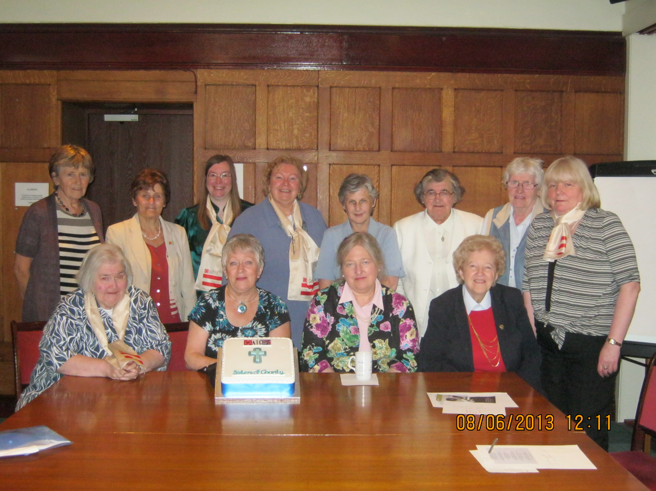
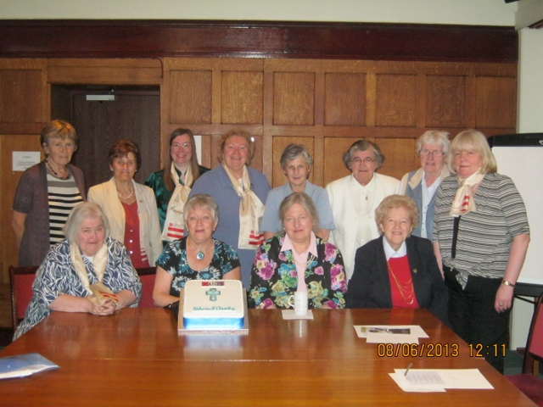
Summer Gathering in Carlisle Place 8th June 2013 – see Marva’s (AIC Abbey Wood) wonderful cake in pride of place. Andrew Hollingsworth, of The Passage took us on an insightful tour of the project, preceded and followed by a thought provoking spiritual input on homelessness from our AIC UK Spiritual Director, Sr Mary Timmons DC. Present also was the former Spiritual Director, Sr Margaret Gilbraith DC, as well as the AIC UK Management Committee who welcomed new members Gabrielle Porte (Abbey Wood), Deirdre Allen (Darlington) and Attracta Connaughton (Mill Hill). Sr Patricia Maxwell DC cared for our every need. It was so welcoming!
19TH OCTOBER 2013. DAY OF REFLECTION LED BY SR BRENDA MATTERSON DC & PAUL SOUTHGATE VIP
VENUE; PROVINCIAL HOUSE, MILL HILL, NW7 1RE. 10AM TO 3.30pm
SOUP & ROLL FOR LUNCH. BRING TOP UP IF NECESSARY. I HIGHLY RECOMMEND BOTH THESE SPEAKERS HAVING ATTENDED PREVIOUS RETREATS & DAYS OF REFLECTION. DONATION WELCOME ON THE DAY!

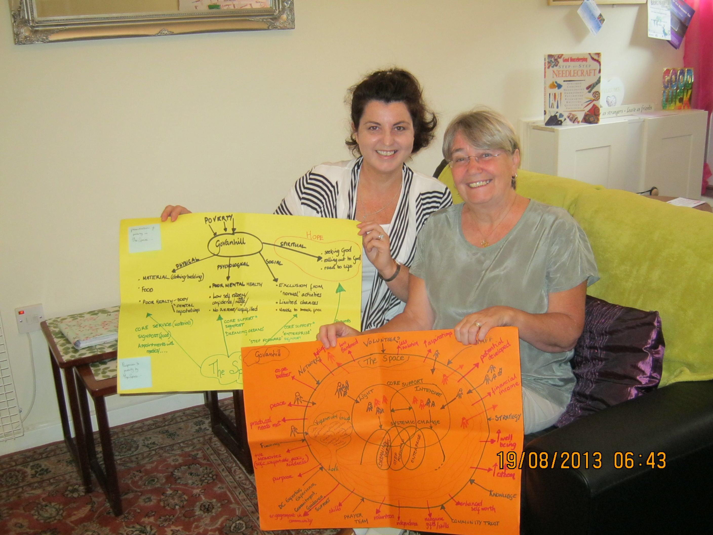
AIC Glasgow’s Liz Anne O’Hare (on right) volunteers in The Space, a drop in centre in Govanhill opened in April, motto; ‘Arrive as strangers, leave as friends’; which is a collaboration between the Daughters of Charity and the St Vincent de Paul Society to support poor people, including the refugees and economic migrants that are newly arrived in the City. During Dee’s visit in August, Manager, Margo Uprichard (on left) explained her philosophy is based on John 10:10, so that the whole person, “regained their dignity in a journey that will take them to fullness in life.” The lovely homely surroundings encourage people to seek support, and the volunteers are on hand to listen and signpost them to outside agencies or help with health or education queries.

AIC Summer Gathering in the North East – Darlington AIC’s, Elspeth Robinson invited several branches of the Vincentian Family to gather in her beautiful home. The past and present Directors of Vincentians in Partnership (Sr Maureen Tinkler DC and Paul Southgate) met with Darlington SVP President John Kilgour, Dee & Gino Mansi and AIC Darlington, Lynne Robinson, Deirdre Allen and Diane Coney.
We all shared news of our own Vincentian Family activities, and there was a discussion between the Darlington SVP and Darlington AIC about collaborating with each other’s involvement in prison work.

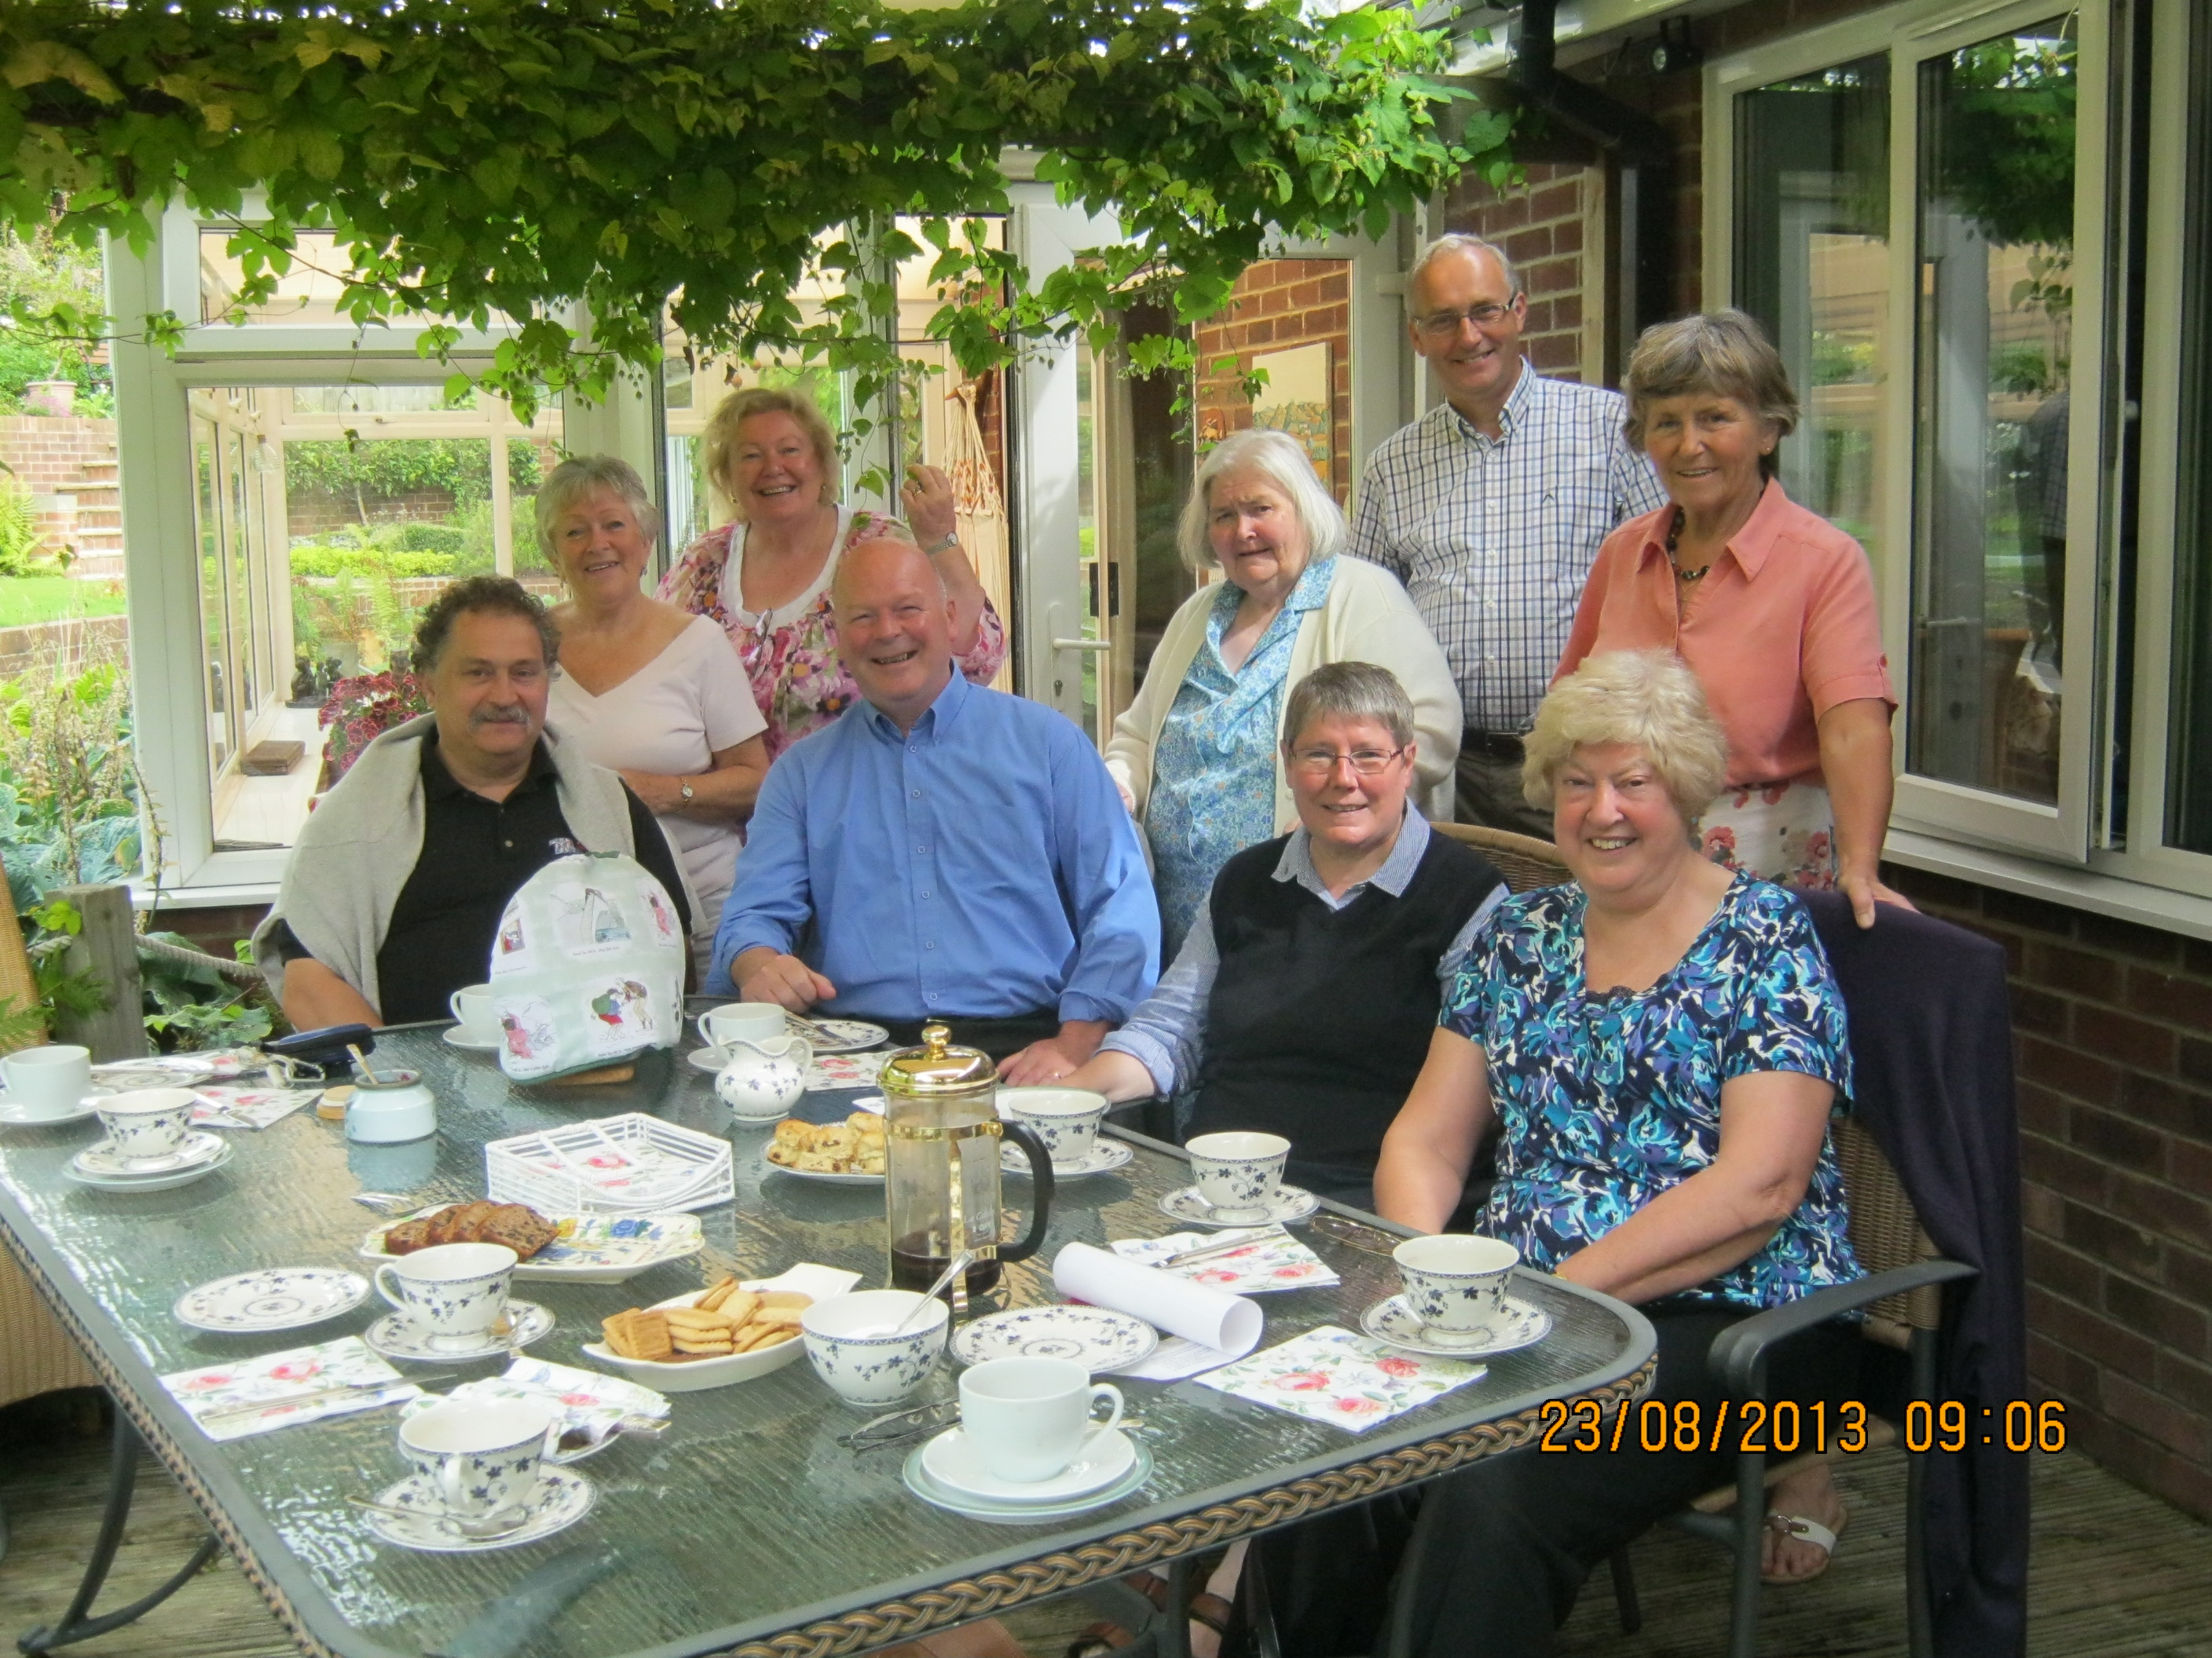

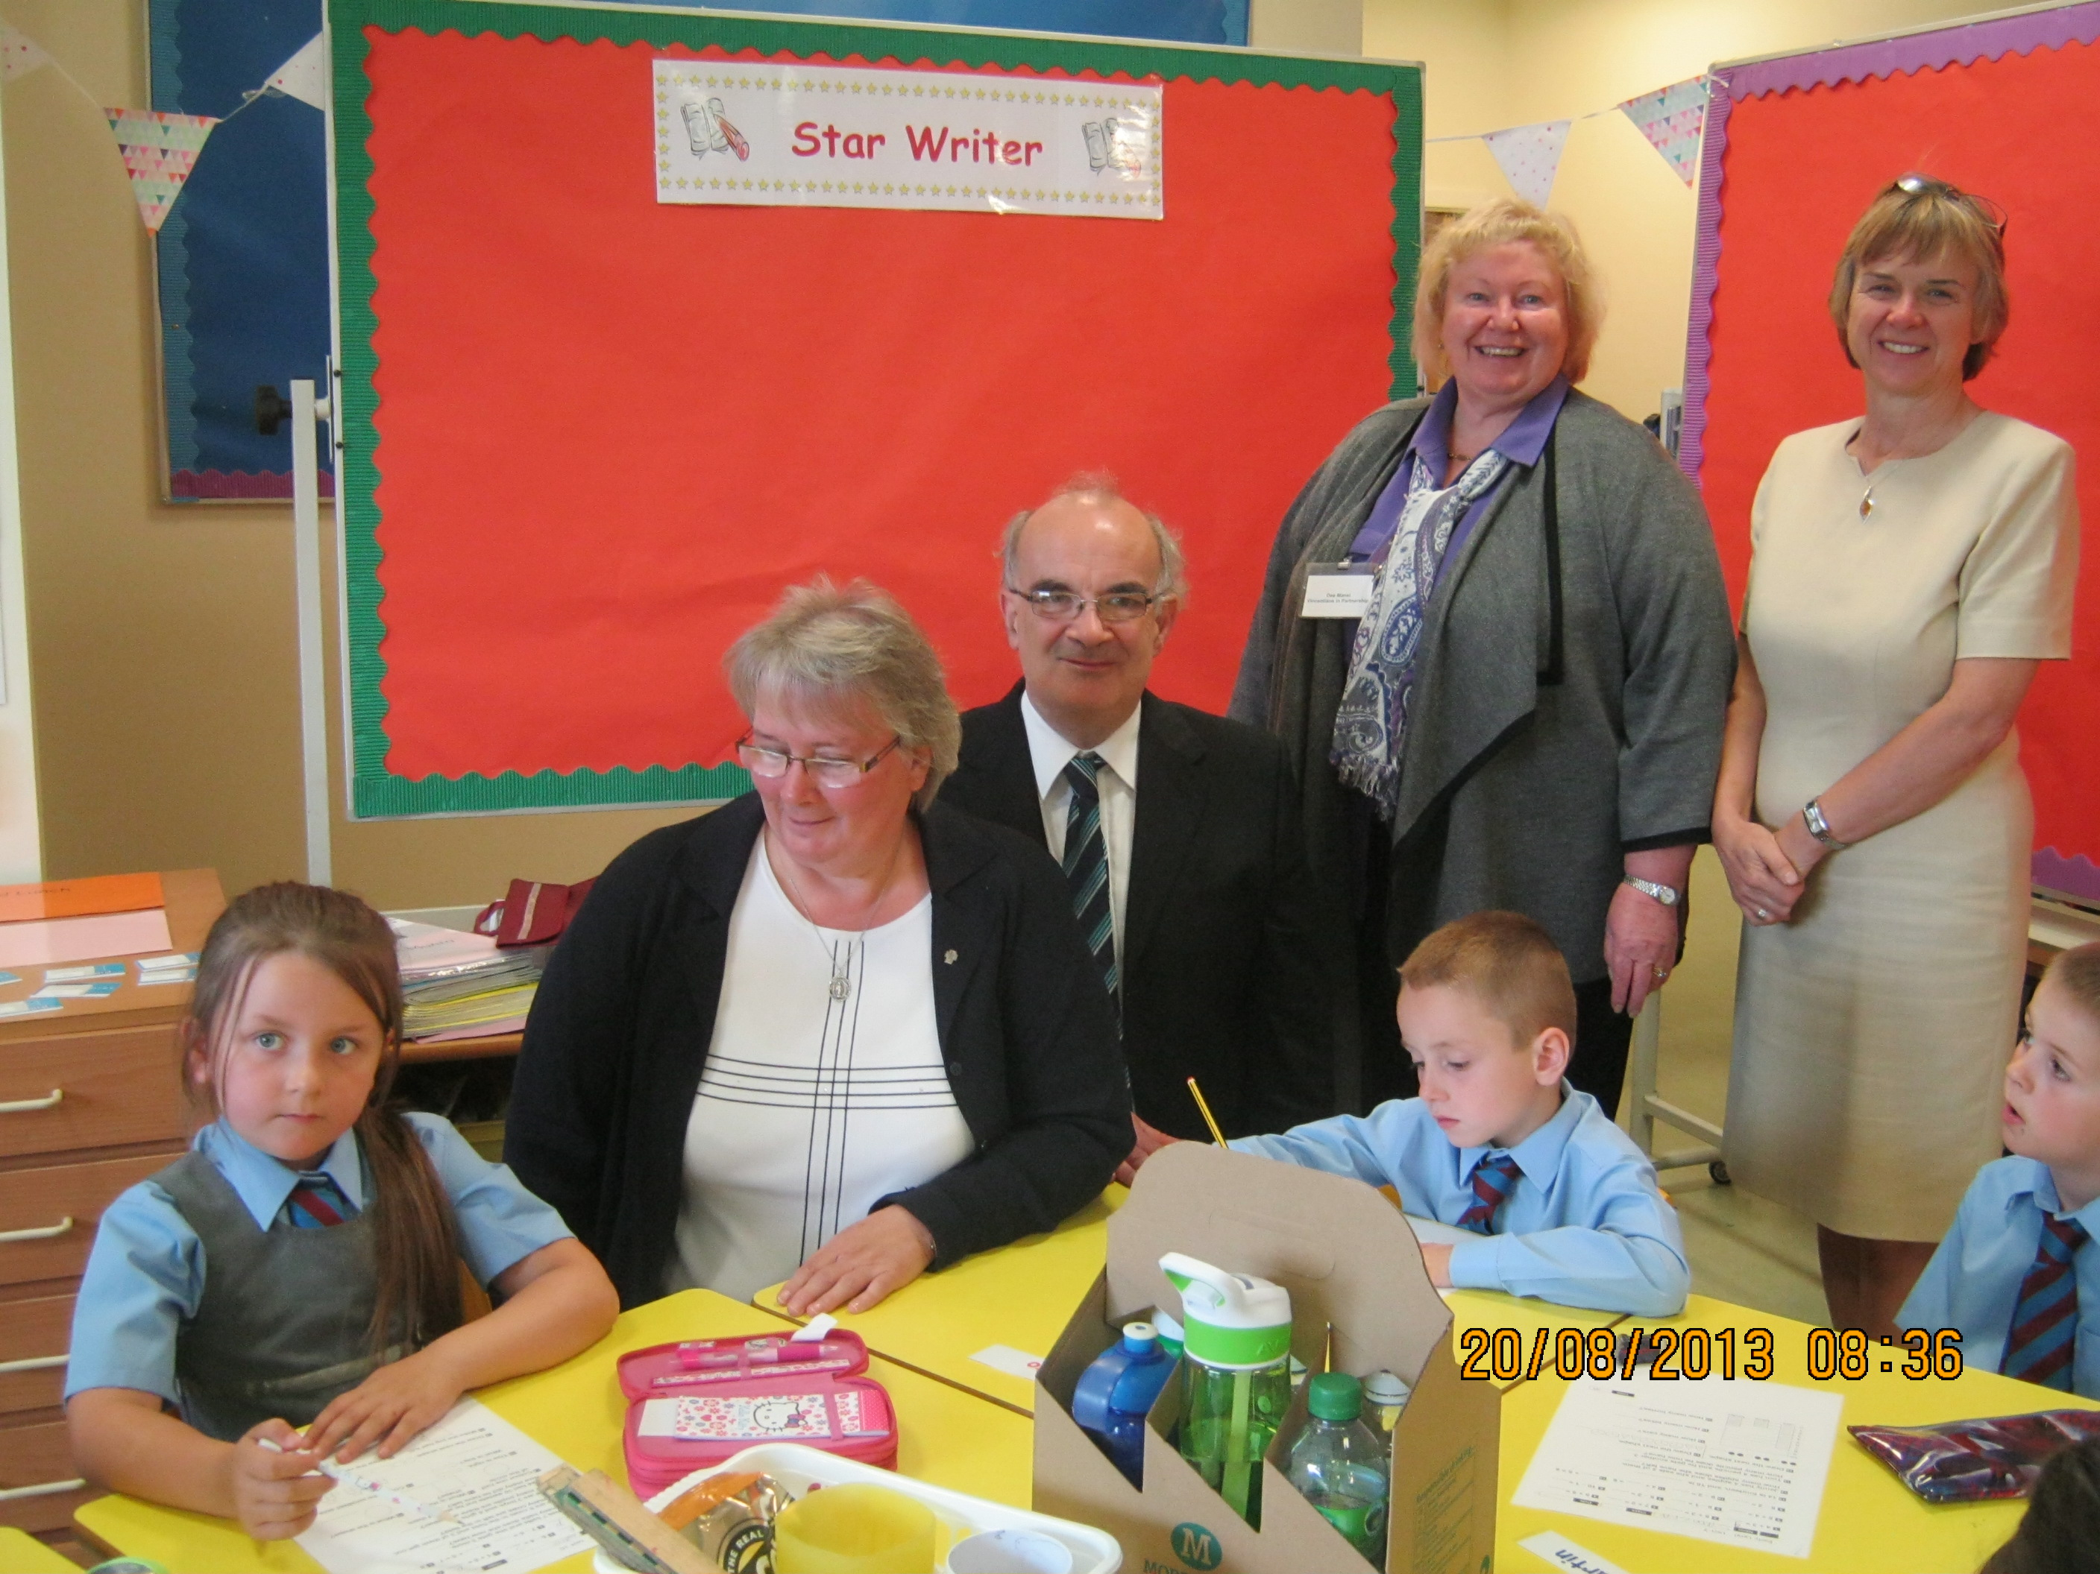
AIC, DC & SVP – a summer of acronyms!
Dee was joined by Sr Theresa Tighe DC, Daughters of Charity Director of Vocations and Joe McEachen, Diocese of Motherwell President of SVP during their joint visits to both St Louise and St Vincent Primary Schools in East Kilbride. The children viewed the recent DVD of St Vincent’s life, acted by children, which gave them the impetus to discuss in class what they could do to carry out today the work that Sts Vincent and Louise started almost 400 years ago. The Headteachers liked the SVP’sMini Vinnies programme Dee demonstrated, and closer collaboration with the local SVP Conference is planned. There is also potential for a future AIC group!

NEUTRALISING KNEE-JERK REACTIONS! Sr Mary Timmons, AIC UK Spiritual Director
The feast of St. Vincent Depaul is on 27th September and all over the world the Vincentian Family will be celebrating his life. I hope you can each find some way of marking the feast day. St. Vincent Depaul was a marvellous man, and we can learn much from his writings and the example of his life. In his life time he inspired people from all walks of life to give themselves to God through acts of kindness, creating a network of charity throughout France and as far away as Scotland, Poland and Madagascar .
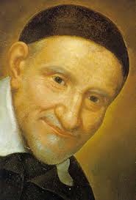
He achieved this through true collaboration with people. He collaborated with St. Louise and the Daughters of Charity, with Monsieur Portail and the Priests of the Mission, with the Confraternities, and the Ladies of Charity. He worked with the Bishops in organising the Tuesday conferences for ordinands and with those in charge of local government, particularly over the plight of the galley slaves. He collaborated with the De Gondi family and with St Jane Chantal and the Visitations sisters. This list is not exhaustive!
Collaboration describes a relationship in which no one is dominant; it is different form partnership, where one person can still have the upper hand, or team work which requires someone to make decisions on behalf of the group. Collaboration is not easy because and it requires a certain maturity.
Because we are human, we all have knee jerk reactions- most of which are negative- to certain situations or provocations. Knee jerk reactions are ‘out of soul’ responses, and although we cannot stop ourselves from having them, we can definitely stop ourselves from expressing them. Vincent understood this very well and constantly cautioned the Vincentian Family to practice humility and gentleness. This is Vincent’s advice:
There are no people more constant and steadfast in doing good than those who are gentle; just as on the contrary, those who allow themselves to give in to anger and the passions of the irascible appetite tend to act on impulse. (Coste vol. 11 p54)
When we feel moved to anger, or any knee jerk emotional response to something, we should stop what we are doing and even what we are saying, and above all, make no decisions until this passion has died down. Above all, it is wise to hold our tongue while our heart is agitated. Sometimes all it takes is a gentle word to convert a hard hearted person; a harsh word on the contrary, is capable of upsetting a soul and causing in it bitterness that could be very harmful to it. (Coste vol. 11 p 55)
These are wise words and a show the depths of Vincent understand of the human heart. Today if something happens to provoke you, pause. Move into your heart, count if it helps, become aware of your breathing ( our breathing is shallow in knee- jerk mode) ask God and Saint Vincent for help and then choose to respond either in a loving way or to keep a noble silence. In this way we can neutralise the knee jerks that can cause so much damage as we strive to work together. It is possible to work together in true collaboration, following the example of our humble, gentle teacher. Sr Mary Timmons DC. AIC UK Spiritual Director
CONGRATULATIONS! Rev. Dr Richard Diala, Spiritual Director of Abbeywood Group, who celebrated the 30th Anniversary of his ordination on 20th July. I was delighted to be present along with members of AIC Abbeywood, his Vincentian confreres, Daughters of Charity and proud parishioners.
AIC INTERNATIONAL NEWS
Headquarters in Brussels, through Secretary Natalie Monteza, relayed from AIC International President, Laurence de la Brosse, are discussing the countdown to 2017 celebrations of the first Vincentian lay involvement inspired by St Vincent. AIC UK will closely follow their plans, so that we can be fully involved, and maximise the opportunity, not only to celebrate, but to harness this event to highlight the strength of AIC and all of the Vincentian Family’s work in the world.
European AIC 2014 in Slovakia, Milagros Galisteo AIC Spain who is the president European Representative on AIC International’s Executive Board has written that in order to support AIC Ukraine, both she and Laurence de la Brosse AIC International President will travel soon to plan the meeting for September 2014. We are privileged that Laurence has been asked to be the keynote speaker at the AGM of Vincentians in Partnership UK in October 2014.
VINCENTIANS IN PARTNERSHIP REPRESENTATION
We have a unique collaboration in the UK, which does not exist elsewhere in the Vincentian world. Vincentians in Partnership was set up in 2000 specifically to increase networking and collaboration between all the members of all the Vincentian Groups. AIC UK is delighted to be elected to Chair this organisation for the next two years. Your AIC UK President Dee Mansi will be busy getting to know the 13 separate Vincentian organisations in order to be of maximum benefit, as Chair, to the Director Paul Southgate and all members of the Vincentian Family.
Marlene Burt, Bexley and AIC representative on the Vincentians in Partnership Justice Group has been on Vincentian Collaboration Week on behalf of AIC UK. Despite not being very well, Marlene has produced the following article on her recent activities. We send her our love for a speedy recovery.
Report for VIP Justice Group Meeting September 11th 2013
Back in May I had the good fortune to attend a Vincentian Family course (representing AIC) in Paris which stressed the importance of the various Vincentian groups (AIC, SVP, Depaul etc) collaborating together to achieve more to help poor people. While I was in Paris I stressed that it is important for the Vincentian Family to also collaborate with other civil society groups , because together you can achieve so much more in large numbers.
For example, the VIP has been very much involved with Citizens UK for some time – especially at the time of the successful ‘End Child Detention campaign’ (from the point of view of immigration purposes) back in 2010 at the time of the last General Election.
I represented the VIP again at a very important meeting on June 19 2013 – the Citizens UK Summit – entitled “Planning Ahead for a Generation”.

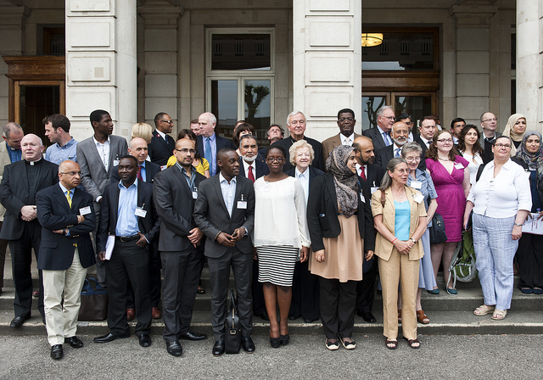
Citizens UK has a membership of over 300 civil society institutions, including schools, churches, synagogues, mosques, diaspora groups, charities and universities, working together for the common good. It is the largest civil society alliance in Europe.
In 2010 Citizens UK, leading up to the General Election, ran a very successful campaign to get rid of Child Detention for immigration purposes, and the VIP was very involved in that campaign. In fact, one of the Citizens UK organizers, George Gabriel, came up to me specially during the recent Summit to say how much Citizens UK valued the participation of the Vincentian Family during that campaign.
On 19th June 2013 Citizens UK hosted a summit of national leaders of Britain’s major faith and educational communities and civil society organisations, including the VIP. I was asked to attend the meeting to represent the Vincentian family.
The summit was held to prepare for the next General Election in 2015. The intention was to look at the challenges that our communities share, and to plan how the various groups and organisations including the VIP can work together to address these key concerns. Citizens UK is planning to build a strong alliance to influence the 2015 General Election. An election is the ideal moment to ask prospective candidates to publicly respond to the main issues and to commit to supporting change to address these issues.
There were several inspiring speakers who addressed the meeting, including the Archbishop of Canterbury and Vincent Nichols, Archbishop of Westminster, the head of the Roman Catholic Church in England and Wales, as well as leaders of the Jewish and Muslim communities.
After the speeches of the invited guests, Neil Jameson, Executive Director of Citizens UK said that the vision is important – but Citizens UK provides the tools. He said that what Citizens UK is about is:
Developing our leadership
Doing the business
Building the power of civil society and recognition
After all the speeches, we had the opportunity in our small groups to discuss the pressures and challenges facing society at this present moment. Then each group shared their ideas with the Assembly. Some of the main issues were: the vulnerability of the elderly, and their care, employment opportunities especially for young people, affordable housing, a living wage, health, the breakdown of community, and the family.
The plan for the coming years leading up to the General Election:
June 2014 There will be the Second Civil Society Summit
September 2014 The manifesto for Civil Society will be ratified and launched
May 2015 (election year) Citizens UK General Election Assembly
At the end of the meeting, we all signed an individual pledge. My personal pledge was:
“To spread the word amongst my organisation, the VIP, and to encourage our members to be involved.”
I will keep you up to date with what is happening.
Having been very much involved in the End Child Detention campaign, I was recently invited by Citizens UK to sit on their Independent Child Detention Monitoring Board (ICDMP), which the Liberal Democrat MP Sarah Teather has agreed to chair - the Independent Child Detention Monitoring Panel has been established by CITIZENS UK to monitor the implementation of the Coalition Government’s commitment to end the detention of children for immigration purposes, as a result of the 2010 campaign, and to provide independent analysis of the government’s compliance with its commitment, and to respond to any issues which arise.
One of the main problems has been the way the Office for National Statistics (ONS) presents the official governments statistics, appearing to show that child detention is continuing, causing confusion and alarm.
I wasn’t able to attend the first meeting of the Monitoring Panel in May because I was attending the Vincentian collaboration course in Paris, but we now have the date for the next meeting which is with the Deputy Prime Minister, Nick Clegg, October 31st.
In the meantime, there has been regular e-mail contact. Recently we were asked for our comments about the current statistics. I gave extensive feedback, and it is good to see that what I said has been taken on board by the ONS, who have now changed the way the monthly statistics are going to be presented as a result. For example they were listing children being held in the detention centre, Tinsley House, without indicating that the children were being held in a special family unit. So the ONS has agreed to adapt the way in which the statistics will be presented. It is good that as a result of the suggestions they have agreed that from August 29 they will make it clear that children held at Cedars and the Tinsley Family House are subject to additional safeguards, protections and limits etc. I’m now looking forward to the meeting with Nick Clegg.
Dee writes; We are rightly proud of Marlene’s work on behalf of AIC UK and Vincentians in Partnership Justice Group because in true Vincentian style she is “prayer in action” speaking out against injustice .

AIC UK AUTUMN NEWSLETTER – SEPTEMBER 2013

