The 400th Anniversary of the Vincentian Charism (1617-2017)

A New Century Dawns:
Hopes for the Vincentian Family
Fr. Robert Maloney, CM

At the beginning of the fifth century of our worldwide Vincentian Family’s history, Fr. Maloney describes a “Dawning of Hope” as the Family's many branches collaborate more closely with each other. After presenting a list of concrete hopes for the future, he reflects on Social Questions, Education and Healthcare, and Fidelity and Freedom in our Mission.

$10.00 each: Catalog #2017

# Copies

You may order On-line at www.svdpusa.org or Email order to: materials@svdpusa.org or by sending in the following order form:

BILL TO:

Name:_________________________________________________

Address:_______________________________________________

City:_________________________ State:______ Zip:_______

SHIP TO: (Complete if different than “Bill to”) Date:__________

Name:________________________________________________

Address:______________________________________________

City:__________________________State:_______Zip:________

Phone:___________________________

SEND ORDER FORM TO: National Council
Society of St. Vincent de Paul
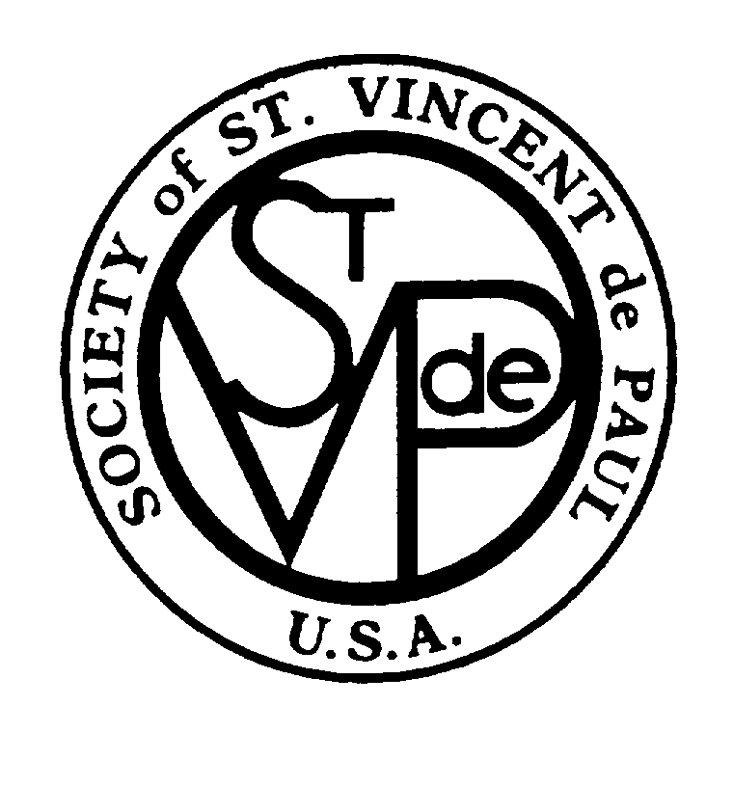
58 Progress Parkway
Maryland Heights, MO 63043
IF ORDER IS SENT TO NATIONAL OFFICE DO NOT SEND PAYMENT
An invoice including shipping charges will accompany your order.

