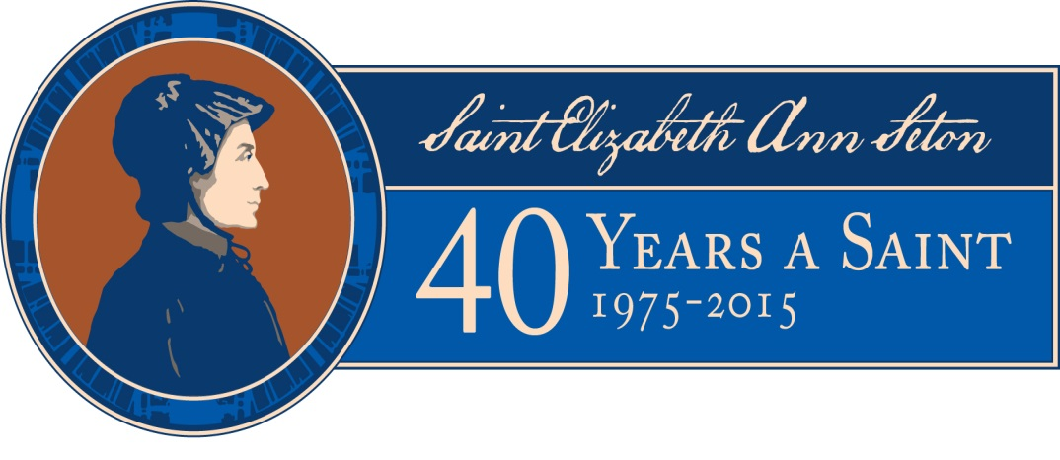

Press Release

Contact:
Scott Dugan
Director of Marketing and Operations
The National Shrine of Saint Elizabeth Ann Seton
339 S. Seton Ave
Emmitsburg, MD 21727
scott.dugan@setonheritage.org
717-599-8328

WEEKEND ANNIVERSARY EVENTS KICK OFF YEAR-LONG CELEBRATION
September 2015 marks 40 years since Saint Elizabeth Ann Seton’s canonization

EMMITSBURG, MD (DATE) – The National Shrine of Saint Elizabeth Ann Seton in Emmitsburg, Maryland, will celebrate the 40th anniversary of the first native-born American saint’s canonization on September 14, 2015.

Free events throughout the weekend of September 12–14 will celebrate the date, 40 years ago on September 14, 1975, when Pope Paul VI proclaimed, “Elizabeth Ann Seton is a saint.”

On Saturday, September 12, members of the 13 Sisters of Charity Federation congregations will join the public for a Commemorative Concert in the Basilica at 7 p.m. Another highlight of the weekend will be a celebration on Sunday, Sept. 13, with live music and refreshments. Archbishop William Lori of the Baltimore Diocese will celebrate Mass at the Basilica on September 13, and Bishop Ronald Gainer of the Harrisburg Diocese will celebrate Mass at the Basilica on Sept. 14.

-more-

Other special offerings throughout the weekend include guided tours, living historians, and the new “40 Years a Saint” exhibit showcasing Elizabeth Ann Seton’s journey to sainthood and highlighting the day she was proclaimed a saint. The centerpiece of the exhibit is the official banner that was hanging in St. Peter’s Square on the day of her canonization. The “40 Years a Saint” exhibit will be open to the
public daily from 10 a.m. to 4:30 p.m. until August 2016. Admission is free.

This weekend kicks off a year-long celebration which will conclude in August 2016.

More than two hundred years ago in Emmitsburg, Maryland, Elizabeth Ann Seton founded the Sisters of Charity of St. Joseph's, the first new community for religious women to be established in the United States. She also began St. Joseph's Academy and Free School, planting the seeds of Catholic education in the U.S. Her legacy now includes religious congregations in the United States and Canada, whose members work on the unmet needs of people living in poverty in North America and beyond. Mother Seton, as she is often called, was canonized on Sunday, September 14, 1975 in St. Peter's Square by Pope Paul VI. She was the first citizen born in the United States to be given the title of “Saint.” Her remains are entombed in Emmitsburg in the Basilica at the National Shrine that bears her name.

###

