**CHRONOLOGICAL HISTORICAL VINCENTIAN DICTIONARY - 1580-1660**

**CHPATER XI**



**INTRODUCTORY NOTES**

**by** *Rafael Villarroya, CM*

*Fr. Mitxel Olabuenaga, CM*

Father Rafael Villarroya (a936-1993) was a member of the Congregation of the Mission and the Visitor of the Province of Zaragoza from 1973-1976. He died without publishing any of his work. Those who knew him also knew that he was dedicated to the research of books, articles, places, photographs … any material related to Vincent de Paul and his various establishments. Father Mixtel put order into much of Father Rafael’s material especially the material that will be found in this Dictionary. The Prologue to this work was written by Father Villarroya and he stated:

*This material can be copied, photocopied, reproduced in its totality or partially without any obligation to cite the author. You can use this material in any way that you desire. The only condition is the following: you may not seek any momentary remuneration from the use of this material unless you poor … this work belongs to those men and women who are poor.*

In the pages that follow you will find the material related to Chapter Thirteen, the final chapter of this work which is entitled *The Final Years: 1658-1660.* The chapter is divided into the following sections:

* 1658: France; 1658: Life of Vincent de Paul; 1658: Letters of Vincent de Paul; 1658: Life of Louise de Marillac; 1658: Letters of Louise de Maillac
* 1659: France; 1659: Life of Vincent de Paul; 1659: Letters of Vincent de Paul; 1659: Life of Louise de Marillac; 1659: Letters of Louise de Maillac
* 1660: France; 1660: Life of Vincent de Paul; 1660: Letters of Vincent de Paul; 1660: Life of Louise de Marillac; 1660: Letters of Louise de Maillac

You will notice that there is a color scheme in this Dictionary: Blue is used when referring to the historical events that occurred in France during the years 1658-1660; Red is used when referring to the events and the writings of Vincent de Paul; Green is used when referring to the events and writings of Louise de Marillac. It is hoped that in the course of time the other twelve chapters will be translated and then published here online.

**CHAPTER XI: VINCENT DE PAUL (1650-1654)**

**1650: FRANCE**

**January 18:**

The Court reached an agreement with Gondi and the “Frondistas” … as a result, the arrest of Condé was ordered. Mazarin convoked a meeting of the Council and when the members arrived the 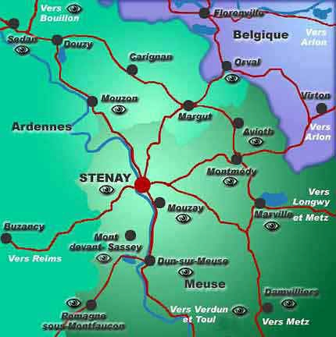Captain of the Guard arrested Condé, his brother (the Prince of Conti) and his brother-in-law (the Duke of Longueville). A carriage entered the meeting place through a secret door and this coach transported the prisoners to Vicennes. Gaston commented: *during the round-up they captured a lion, a monkey and a fox.* The supporters of Condé fled to the Provinces … his mother was exiled in Chantilly, the Duchess of Longueville fled to Normandy … meanwhile the people celebrated the arrest with a display of fireworks in the streets.

**January 26:**

Death of Jean Louis of Erlach, Governor of Briefach.

**February 1:**

The Provinces began to rebel; Normandy was the first and the unrest was led by the Duchess of Longueville. D’Harcourt and Plessis-Belliere put down the rebellion by seizing Dieppe and Pont-de-l’Arche. The Duchess, with great difficult, fled to Stenay and then to Rotterdam. Mazarin, the King and the Queen travelled to Normandy and won the hearts of the people … there they appointed D’Harcourt as governor of Normandy and then returned to Paris on February 21st.

**February 11:**

Death of Descartes in Sweden

**March 2:**

Changes in public administration: Charles l’Aubespine, Marquis de Châteauneuf, became the Keeper of the Seals, Gaston became Lieutenant-General of the Realm, Le Fevre became provost of Mercaderes and a son of Broussel became superintendent at the Bastille. In May, Rene de Longueil, Marquis de Maisons was appointed Superintendent of Finance.

**March 5:**

The royal army, accompanied by the Court, pacified the area of Berry. The Court then travelled to Dijon in an attempt to pacify the area of Burgundy but there was much there, especially in the area of Severe-Bellegarde … there was an attempt to assassinate Mazarin but the presence of the royal Court thwarted that effort. On April 9th Cesar de Vendome who led the royal troops against the rebels in Burgundy, was appointed governor.

**May-June:**

On the northern frontier the Duchess of Longueville, Marshal Turenne and La Moussaye made a pact with the Spanish and mounted an attack on Stenay. The Spanish, led by Archduke Leopold conquered La Chatelet and surrounded Guisa … Mazarin transferred the Court to Compiegne and there encouraged the troops to rise up against the Spanish … Princess Charlotte, the mother of Conde, travelled to Paris and said she thought she would die of embarrassment as she begged the parlement of Paris and Gaston and Beaufort and Cardinal de Retz for the release of her son … during this same period pamphlets were circulated against the policies of Mazarin and these were known as “Mazarinades” .

**May 30, 1650 – April 14, 1651:**

The Assembly of the Clergy opened and measures were taken to protect the Bishops from the arbitrary power of the King … Contí (one of the Princes) was freed … Meeting of the Estates General; on that occasion the Assembly allowed discussion of the five propositions that were put forth by Nicolas Cornet; Isaac Habert, the Bishop of Vabres obtained the signature of more than 85 bishops who supported those propositions. Eleven bishops were opposed: Sens (Gondrin), Agen (Barth-Delbene), Comminges (Choiseul), Valence y Die (LeBeron), Orleáns (Delbene), Saint-Papoul (Bernard), Lescar (J.H. de Salette), Chalons (Félix Vialart), Amiens (F. de Caumartin), Angers (E. Arnauld), Beauvais (N. de Buzenval).

**July 4:**

Various attempts were made to free the Princes who were prisoners in Vicennes; money and 300 hourses were offered as payment for their release … Mazarin decided to transfer those individuals from Vicennes to Marcoussis and on December 1st they were imprisoned at Le Havre.

**December 2:**

The Prelement at Deslande-Payen demanded proof concerning the guilt of the Princes.

**December 15:**

The northern part of France had been pacified. The absence of the King, however, had allowed the Spanish to conquer Rethel. On December 9th the army of Plessis-Praslin marched on that city and the rebellious army of Turenne was defeated on December 15th. There were also armed conflicts in Vervins and Fismes.

**December 29:**

Nicolas Fouquet was appointed Procureur General (he bought that title from B. Meliand).

**December 31:**

Mazarin returned as a conqueror but the problem with the nobles was not resolved. In fact, throughout 1650 as a result of Mazarin’s absence from Court, the nobles had distanced themselves from Mazarin’s policies. Mazarin, with the unconditional assistance of Le Tellier, attempted to obtain the support of Gondi but also attempted to destroy all the hopes of the Coadjutor with regard to obtaining the red hat of the cardinal. Beaufort did not believe in Mazarin’s promises, promises that were offered to Flanders after it had been conquered. At the same time, Anne Gonzaga, the Princess of the Palatinate, attempted to obtain the support of those opposed to the present government … she promised Gondi the red cardinal’s hat that he desired (Anne had the Queen of Poland act as mediator in that matter).

* Pascal developed his principle of the transmission of fluid-pressure.

**1650: VINCENT DE PAUL**

**January 15:**

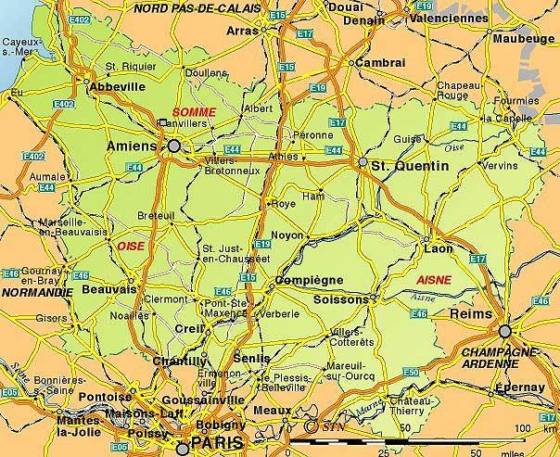Vincent supported the Daughters of the Cross at the time of the death of their Founder, the widow of Claude-Marcel de Villeneuve (CCD:I:130, footnote #4).

**January 18:**

Vincent participated in the marriage of Louise de Marillac’s son, Michel La Gras to Gabrielle Le Clerc. The ceremony took place in the parish church of Saint-Sauveur (CCD:III:537; SWLM:312).

**MAP OF PICARDY**

**May 29:**

Death of M. Charles Nacquart in Madagascar (CCD:IV:444, footnote #1, V:306).

**July 15:**

After Vincent become aware of the situation of the people in Guise, the first shipment of supplies that were intended to assist the people were sent out from Paris. The Ladies of Charity provided this assistance and together with the members of the Confraternity of the Blessed Sacrament assistance was also provided to the people at Port-Royal. This assistance would continue until August of 1652 and would be reinitiated in January 1653 (CCD:XIIIb:427-429).

**August:**

A request was made to provide assistance to the people in Picardy and Champagne (CCD:IV:94, footnote #1). Missionaries were also sent to provide help to these people: M. Berthe was sent to Vermandois, Thierache, Soissons, Remois, Rethel and Laon; later the Daughters of Charity would assist the people in Ham, Laon, Saint-Quentin, Guise, Ribemont, La Fere, Bazoches, Fismes, Mraine, Valle-de-Verde (CCD:IV:150).

**August 26:**

Death of Claude-Marguerite de Gondi, the Marquise de Maignelay who was the sister of Philippe-Emmanuel de Gondi (CCD:II:109).

**September:**

Charles Maignart de Bermieres began the publication of the letters of the Missionaries in an effort to raise funds for the victims of the civil war.

****December:**

A house was established in Périgeux but was closed in April of 1651 (CCD:IV:48, 174, 189-192); Isaac Habert, the Bishop of Vabres, published a letter in which he asked the Holy See to condemn the five propositions of the Jansenists (those proposals were discussed during a meeting of the Estates General) … Habert’s letter was signed by more than 85 bishops (CCD:IV:101-102, 160; in the Spanish Edition to the complete words of Saint Vincent the bishop’s letter is presented in volume X:184-186).

**1650: LETTERS OF VINCENT DE PAUL**

*The grace of vocation depends on prayer, and the grace of prayer depends on rising* (CCD:III:532).

*Exactness to rising has been found so beautiful and beneficial that it has been decided that those who have not been faithful to it should never be given positions of authority in the Company* (CCD:III:536).

With regard to seeking establishments: *if we are good, we will not lack any, and if we are not, we already have too many houses anyway, and can hardly fill the few we have* (CCD:III:538).

*Providence must call us and we must follow it, if we are to go forward confidently* (CCD:III:538).

*Those who have once faltered in their vocation rarely return to the point where they should be* (CCD:III:584)*.*

*It is good for anyone in charge to ask, from time to time, to be relieved, even though the person must remain indifferent* (CCD:III:602).

*You need a little relaxation from your constant work, a little liberty to laugh and talk when the occasion presents itself, if you are not taking an hour or so to recreate together* (CCD:III:604).

*Peace is worth more than all worldly possessions; in addition, God rewards it even in this life. I ask you to work at this and do not even think about giving any revenues* (CCD:III:611-612).

*Peace is worth far more than anything they might take from you* (CCD:III:612-613).

*The works of God are not accomplished when we wish them, but whenever it pleases Him* (CCD:III:613).

*I really think, Monsieur, that a sedentary life is harmful to you. This comes from being hot-blooded and quick-tempered, and these are moderated with age and not by any change of residence. We take our temperament with us wherever we go* (CCD:III:615-616)*.*

*There are some persons who are content with everything and others who are scarcely content with anything* (CCD:III:616).

*It is advisable that the Company not become involved in any way … in making recommendations for or against them … it excites jealousy and aversion in people's minds* (CCD:IV:11).

*As soon as a few temporal possessions were given them, they abandoned God's work* (CCD:IV:14).

*Nature grows weary of austerity. If she is consulted she will say that it is too much* (CCD:IV:21).

*Posts of responsibility are usually an honor to those who occupy them, but I venture to say that you bring honor to yours* (CCD:IV:32).

*We are applying remedies to the sore, using various plasters of gentleness, threats, prayers, and admonitions* (CCD:IV:42).

*Saint Thomas says that, as a matter of fact, spiritual men rise above covetousness and master it to the point of depriving themselves voluntarily of their own satisfactions, but only with difficulty do they succeed in truly loving the hurt that comes to them from others. We are, indeed, more sensitive to pain than to pleasure, to the prick of a rose than to its fragrance* (CCD:IV:55).

*I have never made any distinction between those who have taken vows and those who have not* (CCD:IV:56).

*God be praised, Monsieur, that people say the Company knows the things of God but knows men very little!* (CCD:IV:57).

With regard to the Confraternities composed of men and women: *Men and women working together do not agree on administrative mailers. The men want to assume entire responsibility for them and the women cannot tolerate this* (CCD:IV:76).

*The women ... are so careful and trustworthy* (CCD:IV:76).

*Suspicions are often deceiving* (CCD:IV:85).

*You ask me how you should act with quick-tempered, touchy, critical persons. My reply is that prudence should dictate this. In some cases it is wise to go along with them so as to be all to all, as the Apostle says; I in others, it is good to confront them gently and with moderation; in still others, hold firm against their manner of acting* (CCD:IV:97)*.*

*Live together as having but one heart and one soul so that by this union of spirit you may be a true image of the unity of God* (CCD:IV:96, 238)*.*

*For one man we will lose to maintain good order for the honor of God, His Providence will give us two more* (CCD:IV:103-104).

*Three can do more than ten when Our Lord puts His hand to things, and He always does so when He takes away the means of doing otherwise* (CCD:IV:122).

*We do not go to houses where we have no business, either in town or countryside. We must also refrain from all visits, even though they may be useful in maintaining friendship with certain persons* (CCD:IV:131).

*There is nothing good that does not meet with opposition, and it should not be valued any less because it encounters objections* (CCD:IV:132)*.*

**1650: LOUISE DE MARILLAC**

**January 18:**

Marriage of Louise de Marillac’s son, Michel La Gras to Gabrielle Le Clerc. The ceremony took place in the parish church of Saint-Sauveur (CCD:III:537; SWLM:312).

**April:**

Louise met with the Procurator General, Blas Meliand and requested civil approval for the Company of the Daughters of Charity. The Procurator resigned from his position on December 29th and his secretary died and as a result the papers granting civil approval were lost (SWLM:318 {L.283]).

**MONTMIRAIL**

**June 13:**

Monsieur de la Rochemaillet, uncle of Michel Le Gras’ wife, left to Michel the office of deputy in the currency court. The act was signed on June 13, 1650 (SWLM:316 [L.279, footnote #3]).

**October:**

Establishment of the Daughters of Charity in Montmirail (SWLM:312; CCD:IV:512, footnote #1).

**October 22:**

Establishment of the Daughters of Charity in Hennebont (the Diocese of Vannes (SWLM:312; CCD:IV:115-116, footnote #1; IX:430-433; XIIIb:309).

**1650: LETTERS OF LOUISE DE MARILLAC**

*Renew yourselves in the spirit of unity and cordiality that the Daughters of Charity must possess through the practice of this same charity which is accompanied by all the Christian virtues, particularly mutual support which is our dearest virtue* (SWLM:313 [L.275]).

*I also believe that you are as exact as possible in the observance of your little Rules without detriment to the poor since their service must always come first. However, it must be carried out properly and not according to your own will* (SWLM:314 [L.276]).

Louise visited the Procurator General: Blas Meliand - *He asked me if we considered ourselves regular or secular. I told him that we aspired only to the latter* (SWLM:318 [L.283]).

*Be very gentle and courteous toward your poor. You know that they are our masters and that we must love them tenderly and respect them deeply. It is not enough for these maxims to be in our minds; we must bear witness to· them by our gentle and charitable care* (SWLM:320-321 [L.284b]).

*We must also be on our guard against two extremes: one is affectation in speaking with outsiders; … the second is that the idea we may have of not seeking to please anyone may lead us to make no effort to be pleasant with outsiders* (SWLM:321 [L.284b]).

*Lead her* (Sister Perrette) *to understand that bodily ailments are advantageous for us when we bear them for the love of God and try to love His most holy will. If we act in this way, then the noblest part of our being, our soul, is perfectly healthy* (SWLM:326 [L.287]).

**MONTMIRAIL**

*Remember the interior trials you endured … when you lived in places where you had little work. … We must be very humble and mistrust ourselves because we have no greater enemy than self-love* (SWLM:329 [L.130c]).

*You must realize that authority is not to be wielded absolutely but charitably and that we are Sister Servants which means that we must bear the greatest burdens of body and mind. In so far as we are able, we must console our dear sisters who will always have sufficient difficulty in putting up with us* (SWLM:330 [L.290b]).

*Our Lord will suffice for you* (Sister Mathurine) *because, although you do not know how to add or subtract, no harm will be caused by that, and you will soon learn* (SWLM:331 [L.130b]).

*I make many mistakes because of my excessive haste without speaking of those committed through ill-will* (SWLM:337 [L.42]).

*I do not know whether or not it is my pride which causes me to suffer because of the trials with which I burden others* (SWLM:339 [L.90]).

*I beg you very humbly, Monsieur, not to let the delicate sensibilities which I have revealed to you lead your Charity, in a spirit of condescension, to think that I want you to defer to my Ideas. That is very far from my desire. I am never happier than when I am reasonably contradicted. God almost always gives me the grace to acknowledge and appreciate the opinions of others even when they are completely contrary to my own. This applies particularly to the advice of your Charity* (SWLM:340 [L.118b])

*My heart is still overflowing with joy on account of the understanding which, I believe, our good God has given me of the words, "God is my God"* (SWLM:341 [L.369]).

**1651: FRANCE**

**January 31:**

Gaston, Gondi, Beaufort and Montmorency reached an agreement with regard to freeing the Princes and exiling Mazarin. Parlement affirmed that agreement and were joined by the nobles and the people. Several women played an important role in this matter: Anna de Gonzaga, Madame la Chevreuse, Madame la Montbazon and Anne Marie Louise d’Orleans.

**February 4:**

Parlement voted 140 in favor to 40 opposed in the matter of releasing the Princes from prison; at the same time they voted in favor of exiling Mazarin.

**February 6-7:**

Mazarin had to abandon the royal palace and the court. On February 10th Mazarin was in Pont d’Arc and on February 13th he was in Lillebonne. The people took measures to insure that the royal court could not flee.

**February 10:**

****The King and Queen, who were living as virtual prisoners in the palace, signed an order for the release of the Princes. Parlement had designated la Vrilliere and Comminges to go to Le Havre and free them but Mazarin, who had been informed about the order of release by the Queen, traveled to Le Havre and personally communicated to the Princes their release from prison. He had hoped to obtain the favor of the Princes but Conde rejected any form of agreement with Mazarin. As a result the cardinal had to continue his flight from France (La Fere, Rethel, Bar-le-Duc, Clermont-en-Argonne, Sedan, Bouillon).

**NOTRE-DAME - PARIS**

**February 16:**

As soon as the Princes were freed they entered triumphantly into Paris. In the beginning there was a common bloc opposed to Mazarin and the Queen … marriages were being planned in order to unite the primary noble families. There was an attempt to remove the Regency from Anne and to replace her with a Regency Council that would be appointed by the three estates. But very quickly there was division and intrigue that was stirred up and enflamed by Mazarin who was in Germany. Mazarin has promised the cardinal’s hat and was secretly planning marriages for various members of the royal court. By spring there was an open conflict between Gaston and Gondi with the families of Conde, Chatillon, Nemours and Rochefoucauld.

**February 20:**

Parlement ordered the seizure of all of Mazarin’s possessions.

**March 11:**

Scarron wrote *La Mazarinade*. Throughout the year pamphlets and poems were circulated throughout Paris, mocking and criticizing Mazarin, for example, Bussy wrote *The Law of Mazarin.*

**April 1:**

The Queen refused to remain a prisoner in the palace and traveled to Notre Dame. Nobody dared to prevent her from traveling and as a result she began to act … but did so in accord with the dictates of Mazarin.

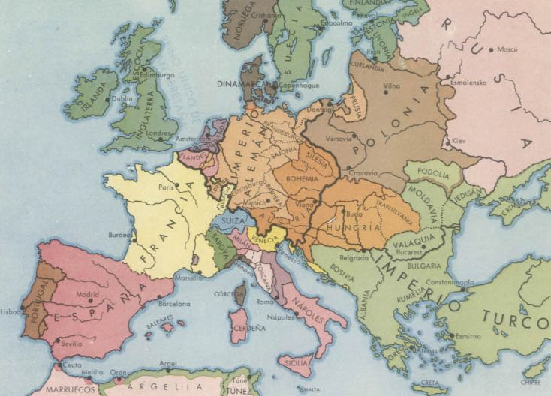

**EUROPE IN THE MIDDLE OF THE 17TH CENTURY**

**April 3:**

The Royal Court was reorganized: Chateauneuf and Viole were removed and Mole and Chavigny became members of the Court.

**April 11:**

Mazarin had fled to the northern part of France but he was now forced to go to Germany. He went to Bruhl, near Cologne and was protected by Maximillian. He remained there until the end of October but he was always in communication with the Queen and, in reality, directed the affairs of government (with the help of Jean-Baptiste Colbert).

**April 14:**

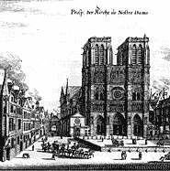The Assembly of the Clergy, which began in May 1650, was concluded. The eleven bishops with Jansenist tendencies wrote the Pope in order to counteract the letter that was written by the other bishops. On April 12 the Pope created a commission to study this issue.

**June – July**

Louis de Bourbon-Vendome married Larua Manzini in Bruhl (Cologne). D’Elbeuf was appointed Viceroy of Cataluña. He was a substitute for Mercoeur but later that year La Mothe would take the place of D’Elbeuf. With the appointed of Mothe the siege of Barcelona began (July 1651) … the siege ended with a Spanish victory in 1652.

**July 5-6:**

Conde fled to Saint-Maur-des-Fesses. In light of the imminent danger of civil war the Queen entered into negotiations with Mazarin. Conde demanded that Le Tellier, Servien and Lionne (ministers who supported Marazin) be removed from office. François de Chavigny also had to leave his position in the government. As a result of the arrogance and the activity of Conde the Queen became more and more inclined toward the position of Gondi.

**NOTRE-DAME, PARIS**

**July 21:**

Conde returned to Paris but did not go to the Palace. On July 31st Conde crossed paths with the carriage of the King but he did not pause to greet the King.

**August 21:**

A tense session of Parliament because the supporters of Gondi demanded an explanation as well as the punishment of Conde (this was demanded because of Conde’s refusal to meet with or to greet the King). Gondi was almost killed during a confrontation with Conde but it would be Conde who later would have to kneel before Gondi as he carried the Blessed Sacrament in procession.

**September 6:**

Conde, on the eve of the proclamation that enabled the king to take possession of the throne, fled to Chantilly and then to Normandy … on September 22nd he was in Bordeaux and preparations were being made for civil war.

**September 7:**

In the Royal Palace, in Parliament and in ecclesiastical circles Louis XIV was recognized as being of age to rule the country. On the following day the Queen went to Notre-Dame to celebrate that event. The first actions of the King resulted in a decree being issued against blasphemy, against duels and the proclamation of the innocence of the Conde.

**September 8:**

The rebellion of Conde and the ascent of Louis XIV to the throne resulted in changes in the government: Chateauneuf and Mole returned to the Court as Keepers of the Seal, La Vieuville became head of finances; Chavigny and Seguier were removed from their positions.

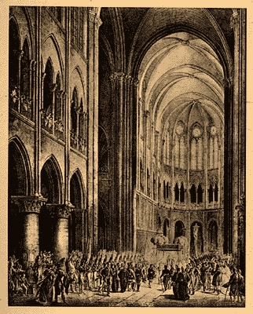

**September 21:**

The Queen supported Gondi and requested that he be made a cardinal. The following day that request was sent to Rome in an urgent message. In Paris pamphlets were distributed that criticized Conde who was in the process of gathering together an army to march toward Paris. At the same time Tavannes maintained his position in Northern France and was waiting to join up with the forces of Turena and Bouillon.

**NOTRE-DAME, PARIS**

**October 7:**

The Court traveled to the South and entered Bourges in a triumphant manner. They continued their journey to Poitiers. The army conquered La Rochelle and as a result of the efforts of Estissac and D’Harcourt Cognac was conquered. Conde was defeasted at Saintonge and Borbonese and was forced to retreat.

**October 8:**

Conde, Conti, Nemours, La Rochefoucold and La Longueville were declared traitors. Louise XIV placed his army under the command of Henri de Lorraine, Comte d’Harcourt. The King placed his army under the command of Marshal Aumont and obliged Tavannes to seek refuge in the Low Countries. The situation was calmed in the North and so the King and Queen,with the army under the command of D’Harcourt moved to the south in order to confront the rebellious forces of Conde and thus avoid an insurrection in Normandy (the support of the English, and the Spanish and support from Lorraine were being sought by Conde).

**November 6:**

Mazarin in Germany was putting together an army … he contacted Fabert in Sedan and Hocquincourt and then on November 6th Mazarin received a secret message from the Queen and the King to return to France as soon as possible.

**December 5:**

After various failed attempts, the Jansenists sent a delegation to Rome to defend their position before the Pope. The group was composed of Brouse, Lalane and Angra.

**December 13:**

The King, after gathering together his misters and the Royal Council, requested, in an official manner, the return of Mazarin.

**December 24:**

Mazarin, having recruited an army in Germany, returned to France through Sedan. He pacified the area of Champagne and the commanders of the army, Hocquincourt, Novalles and De Brogli adorned him with a green rosette.

**December 29:**

Parlement placed a price on the head of Mazarin, sold his library and sent a negotiating team to Potiers where the Royal Court was gathered.

* Corneille wrote *Nicodeme* in which the people recognized Conde. As a result of that publication Corneille lost his position and Mazarin would never forgive him. He would spend the rest of his life writing religious poetry and translating the *Imitation of Christ* into verse. That work was dedicated to Pope Alexander VII and completed in 1656 (books one and two of the *Imitation* were translated in 1653,book three in 1654 and in 1656 a beautiful edition was published.
* This year would be remembers by the people as a year of flooding.

**1651: VINCENT DE PAUL**

**January:**

Throughout the year assistance was sent to the war-torn provinces of Picardy, Champagne … (CCD:188-189, 201-202).

**January – February:**

The bishops published a letter supporting those opposed to the doctrine of the Jansenists (CCD:IV:156, 159-161, 178-79, 182-187, 209-213).

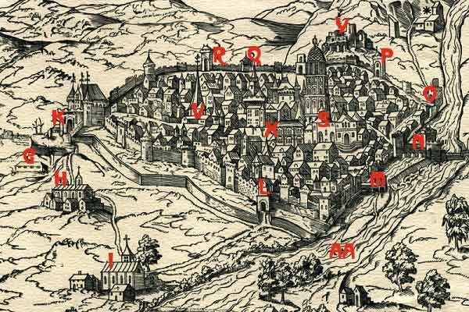

**Perigueux at the middle of the 16th Century**

**February 14:**

Vincent obtained safe-conduct for the Missionaries serving in those areas afflicted by the war (CCD:XIIIa:367-368).

**March:**

Vincent was hurt in a fall (CCD:IV:170; SWLM:347 [L.301]).

**April:**

The house that was established in Perigueux in 1650 was closed (CCD:IV:191)

**April 9:**

Death of Adrien Lebon, the former prior of Saint-Lazare.

**April 12:**

In Rome Innocent X created a commission to study the Jansenist doctrine … the commission was composed of the Roman cardinals Spada, Guetti, Cecchini, Chigi, Camilo and Albizzi (secretary of the commission). The first nine sessions were intended to be informational ... the opening of the tenth session marked the beginning of an intense study of the five propositions, a period of consultation and then the matter was laid to rest on September 24, 1652. During those first nine sessions the French representatives from both sides of the controversy were heard as well as thirteen consulters from various Congregations. On January 2, 1653 the thirty-ninth session of this commission was held and once again the five propositions were examined and it was decided that they should be studied in accord with the meaning that had been given to them by the Jansenists. During the forty-first session it was decided that the consulters should prepare for the sessions during which the Pope would be present. In fact the Pope was present for ten sessions that took place between March 10th and April 7th and during which the various representatives of both sides of the dispute were heard. Then on May 31st 1653 the Pope signed the Bull in which the five propositions were condemned … the Bull was published on June 9th, 1653.



**PERIGUEUX**

**May 28:**

In the parish Church of Saint-Sulpice various nobles made a commitment not to engage in a duel (the Marechal de Babert, Antoine de Salignac [Marquis de la Mothe-Fenelon, uncle of the Archbishop of Cambral]) … that document was accepted by Parlement and sealed in the presence of the King on September 7th … Rome was requested to affirm that document by the publication of a Brief (CCD:V:616-618).

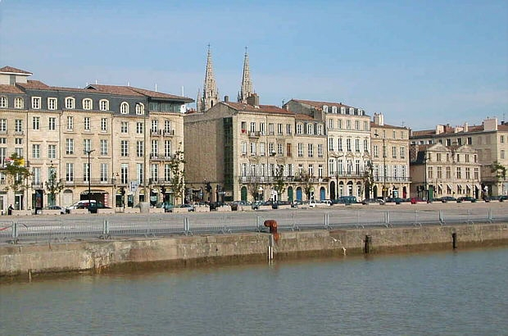

**BORDEAUX**

**June 28:**

Establishment of the third Visitation Monastery in Chaillot … Vincent would minister to the Sisters who resided there.

**July**

Brother Barreau is freed in Algiers (CCD:IV:86, 597).

**July 1 – August 11:**

The Second General Assembly of the Congregation of the Mission … themes: the Rules and the Vows … the Assembly concluded on August 11th. The Minutes of the assembly can be found in CCD:XIIIa:368-373; an account of the Assembly can be found in CCD:XIIIa374-395; the document confirming the approval of the Rules by the General Assembly can be found in CCD:XIIIa:395-397.

**July 29:**

Henri de Béthune, the Bishop of Bordeaux, entrusted the Congregation with the Shrine of Notre-Dame in Montuzet (was this offer accepted?) (CCD:IV:249).

**August:**

There was an epidemic in Paris and Vincent became seriously ill (CCD:IV:250, 267-268).

**November 2:**

M. Lambert aux Couteaux and Guillaume Desdames (priests), Nicolas Guillot (subdeacon), Kazimierz Stanislaw Zelazewski (seminarian) and Jacques Posny (coadjutor Brother) arrived in Poland to begin their ministry there … they had left Paris in September with their authorization to minister (CCD:XIIIa:398-399; IV:251-253, 273-274).

**December 17:**

Decree of the Propagation of faith made at the behest of Achille Le Vazeux (at the request of Vincent) which prevented Henri de Levis de Ventadour (a Canon of Paris) from creating a Congregation similar to that of the Congregation of the Mission (CCD:IV:610-611).

**1651: LETTERS OF VINCENT DE PAUL**

*Our Lord sanctifies souls by crosses, just as He has redeemed them by His own Cross* (CCD:IV:180).

To a superior: *there are superiors who want everything to go their way and people to obey them without comment or delay … and there are others who consider themselves the servants of others* (CCD:IV:181).

*The alms are not for those able to work on the fortifications or to do something else, but for seriously ill sick persons, orphans, or the elderly* (CCD:IV:188)*.*

*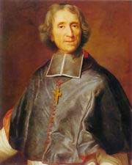Laws must never be made compatible with crimes, no more than lying should be in harmony with the truth* (CCD:IV:210).

*People**are made in such a way that even the holiest ones are liable to offend one another* (CCD:IV:232-233).

*Better for him to have unburdened his heart to you as to his good friend than if he had kept this resentment inside him* (CCD:IV:233).

*People think that doctors kill more patients than they cure, since God wants to be acknowledged as the sovereign physician of our souls and bodies, especially with regard to persons who do not use any remedies. Nevertheless, when one is ill, one should be submissive to the doctor and obey him* (CCD:IV:259).

**FENELON**

*We should help and support one another and strive for peace and union among ourselves. This is the wine that cheers and strengthens travelers along this narrow path of Jesus Christ* (CCD:IV:265).

*Remember, Monsieur, and firmly believe that, regardless of what may happen to you, you will never be tempted beyond your strength. God Himself will be your support and your courage* (CCD:IV283).

*Our perfect happiness consists in doing His Will in the true wisdom of desiring nothing other than that. God often wants to build lasting benefits on the patience of those who undertake them; that is why He tries them in many ways* (CCD:IV:290)*.*

**1651: LOUISE DE MARILLAC**

**January:**

The Daughters continued to help the people in the Provinces that had been devastated by the war … this included providing medical services to the wounded soldiers and caring for the people in Saint-Étienne and Saint-Souplet (SWLM:354-355 [L.347; CCD:IV:168-169).

**May:**

Louise made her retreat during the days between the feast of the Ascension and Pentecost (SWLM:352 [L.305]).

**June:**

Both Louise and Vincent were inclined toward the Daughters taking annual vows, that is, they would take the vows for one year and those vows could then be renewed each year (SWLM358 [L.307]).

**July:**

M. Lambert visited the houses: from Richelieu he visited the Sisters in Angers and Nantes … in Angers there was a new bishop, Henri Arnauld, a friend of the poor and of the hospital (SWLM:348 [L.521], 361-362 [L.313], 372-373 [L.285]).

**July 5:**

Louise began to reflect on the future of the Company, the Rules were to be written down, the Company was to be legally established under the authority of the Superior General of the Congregation of the Mission (SWLM:363-364 [L.315]). Louise’s son, Michel was gravely ill and was cared for by Vincent and by the doctor at Saint-Lazare; Louise was also ill … there was an epidemic (SWLM:373 [L.329]; CCD:IV:256-258).

**CATHEDRAL IN NANTES**

**November:**

Louise made preparations to close the house in Nantes and explained her reasoning to Vincent (SWLM:380 [L.494], 381-382 [L.333]; CCD:IV:276-277).

**December 31:**

Death of Madame de Lamoignon (SWLM:386 [L.337]); death of Blas Meliand and soon thereafter Blas’ secretary died and the papers with regard to episcopal approval also disappeared … neither Nicolas Fouquet (the new Procurator General) nor Brother Djcournau were able to find those documents (CCD:IV:277).

**1651: LETTERS OF LOUISE DE MARILLAC**

*The easiest thing to do would be to have the horses seized on their way to the drinking-trough* (SWLM:344 [L.298]).

*We must be submissive to the guidance of our Superiors who, for very important reasons, have determined that it is sufficient to make this offering for one year and to renew it annually. Do you not think, my dear Sisters, that this will be very pleasing to Our Lord since, having your freedom again at the end of the year, you can sacrifice it to Him anew?* (SWLM:346 [L.300]).

*He* [the pastor] *is a bit brusque. The only way to deal with him is by gentleness, by not arguing and by doing what he asks when you can. When you cannot carry out his request, you must explain your reasons to him gently and humbly* (SWLM:349 [l.302]).

*I continue to do everything so badly that I have come to the conclusion that I do not take sufficient time to seek from you the advice which we so greatly need* (SWLM:350 [L.303]).

*The Blessed Trinity is a model of unity, acceptance and diversity in the community* (SWLM:353 [L.429]).

*I would like to receive news of you more often, my dear Sister, but since it is the service of God which prevents us from being in touch more frequently, blessed be His holy name! We must try to meet often in the presence of Our Lord, contemplating His practice of charity toward the neighbor* (SWLM:355 [L.347])*.*

*Continue to be faithful to God, my dear Sisters, and consider yourselves blessed to be far away from your birthplace. God wants you where you now are, my dear Sisters, so that you may work more generously to acquire the holiness He expects of you* (SWLM:357 [L.306b]).

*It is true that the duty God, in His goodness, has entrusted to you is extremely trying and apparently devoid of consolation. Therefore, you must find comfort in the certainty that you are fulfilling the most holy will of God, and you will always do so as long as you remain in a spirit of submission* (SWLM:359 [L.309]).

Letter of Louise: written rules, strengthening the establishment of the Company (SWLM:363-364 [L. 315]).

*Let us try to bear the contradictions and repugnances that we meet in carrying out our duty because this will make our actions more pleasing to God* (SWLM:365 [L.317]).

*Please remember, my dear Sister, that the more we are deprived of human assistance and consolation, the more our souls are filled with divine consolation if we trust in God and abandon ourselves to Him* (SWLM:371 [L.327]).

*It is only reasonable that those whom God has called to follow His Son should strive to become holy as He is holy and to make their lives a continuation of His* (SWLM:372 [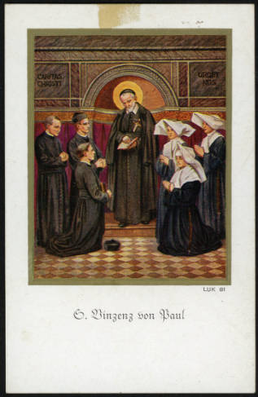L.328]).

*it seems to me, Monsieur, that to leave her as Sister Servant in her present dispositions, in which she is unable either to overcome herself or to obey, would be a bad way to begin the direction of the house, and this would cause me to worry about the outcome* (SWLM:372 [L.285]).

*I am sure, my very dear Sister, that you agree with me when I say how blessed you are to have only to obey* (SWLM:374 [L.334]).

*It is so easy to raise oneself above one's rightful place without even noticing it, that I consider it a great charity to point this out to her* (SWLM:377 [L.330]).

*The goodness of your heart is too great for its effects to be bad* (SWLM:377 [L.331]).

*I urge you to think often of eternity so that the thought of the roses to come may console them amidst the thorns* (SWLM:379 [L.405]).

*We must strive to acquire spiritual balance and inner peace in all the circumstances that may arise … to develop the habit of accepting all our little contradictions as coming from the hand of God, who is our Father … to reflect on the fact that the sadness we are experiencing will not last forever … to recall that God knows our present state* (SWLM:379 [L.405]).

Louise’s letter in which she expressed her fears with regard to the survival of the Company (SWLM:381-382 [L.333]).

*I beg Our Lord to be your strength and consolation and to be good to you at the Crib* (SWLM:385 [L.336]).

*Sister Servants must die to themselves, if they are to fulfill their duties well …* *you must not conclude, my dear Sister, that, because you have repeated something a dozen times, it is enough* (SWLM:385 [L.337]).

*Tell us to do what you believe God is asking of us. Please add the maxims and instructions which will encourage us and keep us faithful and exact in the observance of all the points of our Rule because, it seems to me, that, as we are, we do not pay sufficient attention to our obligations because we do not look upon them as such* (SWLM:388 [L.357]).

**1652: FRANCE**

**January:**

When Parlement became aware of Mazarin’s return they issued an order opposed to the return and placed a price of 50,000 escudos on his head. A commission, led by de Bellievre went to Poitiers where the Royal Court was staying. Nothing was obtained as a result of those negotiations and Parlement decided to sell Mazarin’s library. This sale was organized by Gabriel Naude and involved the sale of more than 40,000 volumes.

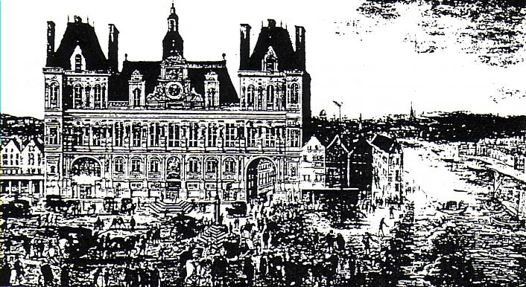

**CITY HALL OF PARIS**

**January 29:**

Mazarin entered France on January 2 by way of Epernay. On January 9th he was in Montereau, on January 16 in Loire, and on the 29th he joined the royal court at Poitiers. His army of seven thousand men (commanded by Hocquincourt) was of much assistance to the royal army. Gaston openly supported Conde but Turena and Bouillon sided with the King and Mazarin. Parlament maintained their independence.

**February 2:**

Bouillon and Turena met up with the Royal Court and the following week Chateauneuf was dismissed.

**February 19:**

Gondi was named cardinal … that news was communicated to Paris on March 1st by the Duke of Tuscany, Ferdinand II. The King congratulated him on March 11 and council did the same on March 19th; he would receive the red hat in Compiegne on September 11th.

**February 28:**

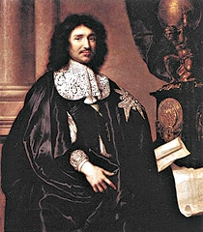Hocquincourt’s army captured Angers and then together with the King and Mazarin they traveled to Tours where the people almost immediately submitted themselves to the King. They then went to Amboise and Blois and the people there responded in the same manner.

**March 24:**

Conde left Agen and traveled toward Paris; before arriving in the city he would engage in the battle of Bleneau.

**March 27:**

The insurgents, Nemours and Beaufort, together with the daughter of Gaston (and aided by the troops that they had recruited) seized Orleans.

**April 7:**

Conde surprised Hocquincourt but Turena saved the situation in Bleneau. Conde then moved toward Paris where Gaston could do very little since de Retz and La Chevreuse now supported the King.

**COLBERT**

**April 11:**

Despite the opposition of Parlement and the bourgeoisie, Conde arrived in Paris … Conti, Longueville and Marsin, who had abandoned the government in Catalonia, remained in Guyenne

**April 28:**

The arrival of Conde in Paris made the Court travel to Saint-Germain-les-Corbeil. Turena’s army established itself in Palaiseau and was able to control Conde’s troops which were at Etampes.

**May 4:**

Anne Marie Louise d’Orleans traveled from Orleans to Paris and reviewed Conde’s troops at Etampes. Turena observed her review the troops and once she had finished he immediately set his troops against Conde’s army … 1,200 soldiers died.

**May 18:**

The Spanish, who had entered into an agreement with Conde, seized Gravelinas and offered Conde the troops of Charles of Lorraine.

**June 6:**

Conde’s army, encamped at Etamples waited for assistance from Charles of Lorraine but Charles had already made an agreement with Mazarin and prepared to engage in battle on Mazarin’s side. Turena retreated near Etampes in order to allow Conde the opportunity to escape (which he did but only after destroying the city). A few day later Charles traveled to Flanders. Turena then pursued the royal army through Suresnes, Meudon and Saint-Cloud and finally established himself on the other side of the Seine.

**June 11:**

Mass and procession in the evening with the relics of Saint Genevieve … prayers for peace.

**June 25:**

The supporters of Conde organized protests in Paris (April 3 and the 30, June 21 and 25) in an attempt to persuade parlement to support the Princes … parlement only wanted to see the departure of Mazarin … the price of bread rose to a level beyond the reach of most people and hunger became a constant companion of the citizens of France.

**June 28:**

The Court established itself at Saint-Denis. Le Ferte’s reinforcements arrived from Lorraine and this facilitated an attack on the bridge of Saint Cloud. The Court would remain in Saint-Denis until July 17 when it traveled to Pontoise.

**CHURCH OF SAINT GERMAIN**

**July 1:**

Conde fled to Charenton-le-Pont by way of Tours-la-Reine, Saint-Honore and Saint-Antoine; Turena continued the pursuit and attacked the rear guard near Saint-Denis and Saint Martin; at the same time La Ferte crossed the bridge at Saint-Cloud and joined forces with Turena. The King traveled to Charonne where he was able to view the battle. Conde’s troops placed themselves in front of the doors of Saint-Antoine and took advantage of the trenches that had been dug there when the troops of Charles of Lorraine threatened Etampes. The battle was very difficult and soldiers and nobles died (on July 18th the nephew of Mazarin died as a result of injuries suffered during the battle and La Rochefoucold was gravely wounded). When La Ferte’s troops arrived the struggle turned and the doors of the city were opened and the canons of the Bastille open fire upon the royal troops. This allowed Conde to take refuge in the city there.

**July 4:**

The supporters of Conde met together and there was a celebration that lasted almost the entire day. At about six in the evening Conde arrived and was received courteously but coldly by the governor. When the governor left, Conde announced that the town was filled with supporters of Mazarin. The people however began to stone the supporters of Conde who had gathered there and threatened to burn the place down. Those who had gathered there for the celebration became fearful and sought for a way out. A battle ensued and Conde fled to Luxemburg. The disturbances continued until the following day.

**PARIS – XV CENTURY**

**July 6:**

Conde attempted to create an Assembly that would recognize Gaston as the lieutenant-general of the realm, Beaufort as governor and Broussel as provost. He also proposed the creation of Council composed of Gaston, Conde, Seguier and the other princes, dukes, officials and two presidents of the tribunal … but those efforts failed. Nemours and Beaufort, brothers-in-law, engaged in duel and Nemours was killed. The streets were filled with mercenaries, houses were sacked, and crimes of every kind were committed.

**July 31:**

Parlement was ordered to move to Pontoise and there, on August 9th, Bouillon died.

**PARIS – XVI CENTURY**

**August 18:**

The political differences of the leaders in Paris were exploited by Mazarin and the King. Although they had no legal authority, the government in Paris gave in to the desires of Mazarin.

**September 7:**

Conde attempted to seek support from outside the country. The Spaniards responded and with the help of the English were able to seize Dunkirk. The Duke of Lorraine, with his army, moved toward Paris but was stopped in Laon by the royal army of Turena. The people, parlement and the bourgeoisie found it more difficult to support the Princes and the authorities in Paris because of the threat of a new civil war, the movement of people from the rural areas into the cities, the scarcity of food and a general environment of misery. Gondi placed himself on the side of the people.

**September 9 – 14:**

Gondi joined the royal court in Compiegne where they had been staying since August 20th; on September 11th he received the cardinal’s hat and during his address spoke about the misery in which the people were living and asked for peace. His aggressive tone did not convince the King but rather angered him. Gondi departed on the 14th and was unable to obtain any type of agreement.

**September 18:**

The Spanish, under archduke Leopold, seized Dunkirk.

**September 24:**

Four thousand people from the upper class gathered in front of the Royal Palace and requested the return of the King. Broussel was removed as provost … little effort was made to defend the princes despite the encouragement of Ane Marie Louise d’Orleans to do so.

**CONDÉ**

**October 11:**

Death of Chavigny and Beaufort renounces his government position. After a fifteen month siege Barcelona was reconquered by the troops of John Joseph of Austria … that marked the end of the Catalonian rebellion even though the war would continue in the north under the direction of Mothe and Magarit..

**October 14:**

Conde marched toward Paris. Despite the efforts of Mazarin the Duke of Lorraine was able to travel to Juvisy but Turena held him at bay for over a month. Nevertheless he was unable to prevent his army from creating havoc in the areas surrounding Paris. All of these events led Parlement (October 12th) to demand the withdrawal of the troops … in this way Gaston obtained the withdrawal of Conde as well as the Duke of Lorraine, the both of whom traveled to Flanders. Very soon the Duke of Lorraine was labeled suspicious and was arrested in 1654 and brought to Toledo where he would remained until the signing of the Peace of the Princes.

**TURENA**

**October 21:**

At night, while Gaston was leaving Paris, Louis XIV entered the city surrounded by a great multitude of people who were carrying torches. Gaston went to Limours and his daughter went to her estate at Saint-Farceau. The Marquis of Caracena, the governor of Milan, seized Casal and gave it to the Duke of Mantua.

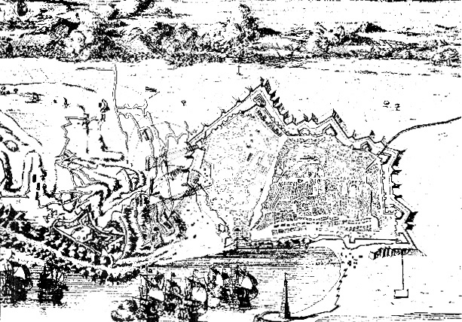

**BARCELONA – XV CENTURY**

**October 22:**

A solemn session of parlement was held in the Louvre … a general amnesty was granted to everyone except Beaufort, la Rochefoucold (wounded and almost blind as a result of the injuries he suffered during the battle that took place on July 2nd), Rohan, Broussel and Madame de Chatillon. Parlement, however, was forbidden to address the issue of the Princes and the nobles, could not discuss the issue of housing and their functions became merely juridical.

**October 23:**

Conde, allied with the Spanish, seized Saint-Menehould.

**October 26:**

Louis XIV attempted to have Mazarin return but encountered resistance. Meanwhile Chateauneuf was removed from office and exiled to Montrouge where he died in 1653 … Gondi also had to be dealt with.

**November 7:**

Death of Mademoiselle de Chevreuse (known as Charlotte Marie of Lorraine, the daughter of Marie Rohan and Claude de Lorrained).

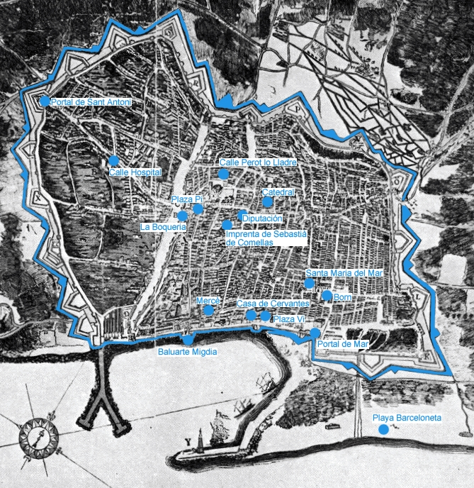

**BARCELONA – XVI CENTURY**

**December 19:**

Cardinal de Retz imprisoned … his requests for peace (as a Roman ambassador) had failed and Mazarin insisted on eliminating him and so as a result of the King’s order he was led to prison. On October 21st Cardinal de Retz had traveled to the Louvre in order to welcome the King in the name of the Church. After that visit he did not leave Paris because of the rumored intentions of Mazarin with regard to his situation. On December 19th Louis XIV (to the surprise of the Queen) had Cardinal de Retz arrested and imprisoned at Vincennes.

**December 30:**

When Parlement attempted to discuss the edict on finances the King intervened and disbanded the session; Philip IV recognized the historical rights of the people of Catalonia; Barcelona surrendered to John-Joseph of Austria.

**1652: VINCENT DE PAUL**

**January:**

Throughout the year assistance was sent to the war-torn provinces of Picardy and Champagne (CCD:IV:375, XIIIb:449-450).

**January 15:**

The Propaganda Fide granted permission to the Congregation to begin a mission in Salé (in the Kingdom of Morocco in Africa) … this mission was in reality begun by the Capuchins (CCD:III:6, 32-33, 40; IV:301-302)

**February:**

Vincent provided assistance to the people of Gennecilliers (today known as Port Sena in Paris.

**February 19:**

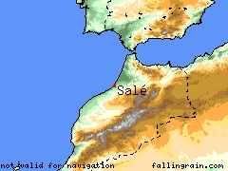Jean-François-Paul de Gondi obtained the cardinal’s hat and became known as Cardinal de Retz (CCD:II:442)

**March:**

The persecution in Ireland was intensified … death of Brother Thady Lee (Thaddée Lye), the first martyr of the Congregation of the Mission (CCD:IV:339-342, 344); M. Thomas Lumsden (evangelizer of the Orkney Islands) met up with those ecclesiastics who fled to Scotland (CCD:IV:373, 495-4970); *Relations* described the misery in Paris (CCD:IV:371, footnote #1).

**SALE**

**Lent:**

Bossuet made his ordination retreat at Saint-Lazare … he would preach retreats to the ordinands in 1659, 1660, 1663 and 1666.

**March 28:**

Vincent presided at the Holy Week Services in Saint-Lazare (CCD:XIIIa:173)

**April 26:**

Death of Jean-Pierre Camus, the Bishop of Belley.

**April – May:**

A house was established in Notre-Dame de Lorm (CCD:IV:383)

**May 13:**

During the Civil War (the Fronde) there was a disturbance near Saint-Lazare … the Sisters and the wet-nurses fled from the area carrying with them infants who were breast-feeding (CCD:IV:377-378).

**May 24:**

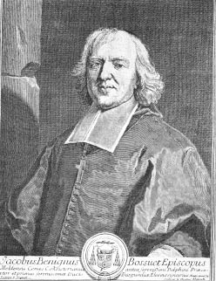Vincent supported the commission composed of three learned doctors (François Hallier, François Joysel and Jerome Legault) who travelled to Rome hoping that the five Jansenist propositions that were being studied there would be condemned (CCD:IV:394, 413)

**June:**

A mission was given in Niolo on the island of Corsica and later in Corte and Cotone (CCD:IV:404-408).

**June 4:**

The Congregation of the Daughters of Providence (founded by Marie de Loumague Pollalion, a Lady of Charity) took possession of the former hospital in Santé and there was a formal ceremony on June 11th. These Sisters had ministered in Pitié, Fontenay-aus Roses and Charonne. Two other Congregations would arise from the Congregation of the Daughters of Providence, namely, the Christian Union and the New Catholics.

**BOSSUET**

**June 5:**

Vincent obtained safe conduct for the Missionaries traveling to Palaiseau … every day a wagon filled with various provisions left from the house of Saint-Lazare (CCD:XIIIa:400)



**June 11:**

Procession from the parish Church of Saint-Genevieve to Notre-Dame … fasting and prayer for peace (CCD:IV:395, X:200; SWLM:397 [L.353]).

**July:**

The Civil War (the Fronde) forced the members living at Saint-Lazare, in the various parishes and hospitals in Paris and the surrounding areas (especially in the area of Etampes) to take measures as they confronted extraordinary situations (CCD:391-393, 399-400, 423-426).

**MAZARIN**

**July 1-2:**

Saint-charles Seminary, situated at the far end of the Saint-Lazare enclosure was directly in the path of the royal army and the rebel army as they engaged in battle (CCD:IV:409)

**July 4:**

City Hall in Paris was attacked and M. Gros was caught up in the confrontation; at that time the Congregation lost the income from its coaches and from its harvest of wheat … Vincent would state that the poor *are my worry and my concern* (Abelly III:117)

**July 5 – 17:**

Vincent met with the Queen and Mazarin and asked for peace (CCD:IV:414, 421-422).

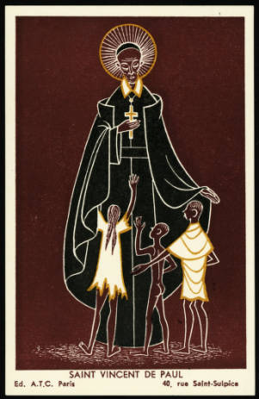

**August 16:**

Vincent wrote to Innocent X and requested peace (CCD:IV:445-447).

**September 11:**

Vincent wrote to Mazarin requesting the return of the King to Paris (even if this means that Mazarin would have to wait before returning himself). For all practical purposes Vincent could now consider himself removed from the Council of Conscience … two Jesuits became the confessors of the King (CCD:459-464).

**October 17:**

The members of the Congregation of the Daughters of Providence (founded by Marie de Loumague Pollalion, a Lady of Charity) consecrated themselves in the presence of Vincent.

**October 25:**

Vincent submitted his report to Rome concerning his visitation with the Franciscan Abbess of Longchamp Monastery in the Diocese of Paris, a mission that had been entrusted to him by the Holy See on March 1 … this report was sent to Cardinal Antonio Barberini (CCD:IV:483-487).

**October:**

Hippolyte Feret, pastor of Saint-Nicolas-de-Chardonnet and Vicar-General of the Archdiocese of Paris, organized the assistance that was given to France. In addition to Etampes and Palaiseau the Missionaries also provided help to the area of Savigny-su-Orge and Juvisy-sur-Orge (some 20 towns and villages) … in November the Missionaries provided assistance to the area of Lagny (CCD:IV:510-511, 472-475).

**November:**

Vincent, with the advice of his doctor, traveled to Orsigny (CCD:IV:510-511); as a result of the Fronde Vincent’s family suffered economic losses and Charles du Fresne gave money to Vincent for his family (CCD:IV:515-516).

**December 19:**

Cardinal de Retz was imprisoned in Vincennes (CCD:II:442-443).

**1652: LETTERS OF VINCENT DE PAUL**

*You tell me that the rumor about the arrival of some regiments' is forcing everyone around Le Mans to hide whatever they have in the town and that you, trusting in God, are moving nothing, or very little. I am glad, Monsieur, that you have such trust, but neither should one tempt God* (CCD:IV:324).

*It should be remembered that we enter [the Congregation] to do whatever obedience ordains and not to live in it according to our own will* (CCD:IV:326)*.*

*Where human means fail, divine operation begins* (CCD:IV:329)*.*

**

*If we divested ourselves, once and for all, of all self-will, we would then be in a position of being sure of doing the Will of God* (CCD:IV:339).

*His good humor has left me quite delighted because it is accompanied by piety and the fear of God* (CCD:IV:340-341).

*This gives you some idea of where his mind is leading him, and where it might go if we let it* [nullity of vows and even sinfulness](CCD:IV:345)*.*

*Foresight is good when it is subject to the latter* [divine Providence]*, but it becomes excessive when we are in a hurry to avoid something we fear* (CCD:IV:346).

*It would be better to have a hundred ventures under the name Missions," even were they prejudicial to our Institute, than for us to have thwarted one good one, such as his, under pretext of maintaining ourselves … let us have greater confidence in Him than we do; let us allow Him to steer our little bark; if it is useful and pleasing to Him, He will save it from shipwreck … it will sail along with greater assurance in the midst of all those fine ships* (CCD:IV:347).

*You know that the grace of our Redemption must be attributed to the merits of His Passion and that the more God's affairs are thwarted, the better they will succeed, provided that our submissiveness and trust do not falter. Rarely is any good done without difficulty* (CCD:IV:361).

*Let us establish ourselves in total dependence on God* (CCD:IV:387).

*You should lake as a maxim always to consider that Superiors do the best they can* (CCD:IV:390).

*Our Lord did not always treat His disciples gently. He said some very hard words to them, even to calling Saint Peter "Satan”* (CCD:IV:391).

Regarding missions in the city: *we should take our good wherever we find it* (CCD:IV:390).

*The coming of the Son of God was the downfall and the redemption of man … this war will be the cause of the damnation of many persons, but that God will also make use of it for the grace, the justification, and the .glory of many persons* (CCD:IV:415)*.*

*Remember that the greatest pleasure you can give me is to see that your patients are well taken care of* (CCD:IV:424)*.*

*I am sure you are deeply grieved at this* [the death of M. David]*, since your nature is so good, and grace does not destroy our natural feelings* (CCD:IV:431)*.*

**

*Thank you for sending me a report of the present state of your house. I see some straw in it and some good grain. We must not hope for anything else from the condition of mortal men; we have to wait until we are in heaven to find pure wheat* (CCD:IV:439).

*Let us humble ourselves and, while working to support others, let us strive to make ourselves pleasing to God and to those with whom we live* (CCD:IV:439).

*With the shepherd absent, it has been easy for the wolf to disturb the fold, but now that the Superior has returned, it is at peace* (CCD:IV:442).

*The Lord of us all has so strongly inculcated reciprocal love in us, knowing how difficult it is for those who do not have it to live happily together … practice humility and patience* (CCD:IV:442-443).

*No type of life in this world is without its crosses. Nevertheless, people have a natural desire to avoid them and everyone imagines that by changing his situation he will be happier* (CCD:IV:443)*.*

*Make no pretense, Monsieur, but tell them clearly that we take simple vows, so that If they do not want to take them, they should not expect to join us* CCD:IV:465-466)*.*

*We must pay no attention to the complaints people make of us when it is a question of some good custom in the Company, such as not going to eat in the homes of persons outside the Company* (CCD:IV:470)*.*

*Duplicity is displeasing to God and that, to be truly simple, we must have only Him in view. You also mention* (CCD:IV:471).

**1652: LOUISE DE MARILLAC**

**January 2:**

Burial of Madame de Lamoignon in Saint-Leu (SWLM:390 [L.339]).

**February – March**

Louise was gravely ill (SWLM:390 [L.340]).



**March – April:**

As a result of the great misery in Paris the Daughters participated in various activities in order to provide assistance to the poor (SWLM:399-400 [L.408], 400-401 [L.135]; CCD:IV:370-374, 377-378).

**June 13:**

Assembly of the Ladies of Charity presided by Henri de Savoie, the Archbishop-elect of Reims. He was never ordained and he resigned his bishopric in order to marry Marie d’Orléans de Longueville on May 22, 1657. Marie was a Lady of Charity and became a widow on January 14, 1659 when Henri died (CCD:IV:201, 391-392).

**July:**

Some of the Daughters died as they participated in relief efforts that were necessitated as a result of the Fronde. A center of relief was established in Etampes (this center was focused on providing assistance to the orphans). Other centers were established in Etrechy, Villeconim, Saint-Arnould and Guillerval (CCD:IV:379-380, 423-426, 472-475). Establishment of a house in Brienne-Le-Chateau (CCD:V:61-62; SWLM:388); establishment of a house in Varize (SWLM:388).

**September 7:**

Establishment of a house in Poland (Sister Marguerite Moreau and two others); Another group was sent but because of the war they returned … they would, however, arrive in Poland in December (SWLM:388; CCD:IV:472, 493, 575-576).

**October:**

Louise rejoiced knowing that the Rule for the Daughters had been completed … through his conferences Vincent would communicate the more important aspects of that Rule … for the Daughters in Richelieu obedience is their cloister (SWLM:407 [L.377]).

**1652: LETTERS OF LOUISE DE MARILLAC**

*Be very careful not to profit from anything belonging to the poor* (SWLM:389 [L.339])*.*

*Do not be impatient with your trials, and at seeing yourselves as receiving no other consolation but God's* (SWLM:396 [L.353]).

*Who are we to think that we should be exempt from public evils?* (SWLM:396 [L.353])

*I beg God, in His goodness, to continue to bestow His holy graces upon you, especially love for your vocation, which you will know that you possess if you are faithful to the observance of your Rules, insofar as the service of the poor permits* (SWLM:406 [L.377]).

*Our Most Honored Father recommended this* [visits from men] *to us in recent conferences. He went so far as to say that we should not receive even him in any of the parishes or at this House where he comes only in case of illness, for serious matters, or to give a conference. I beg you to consider what must be done in other cases* (SWLM:406 [L.377]).

*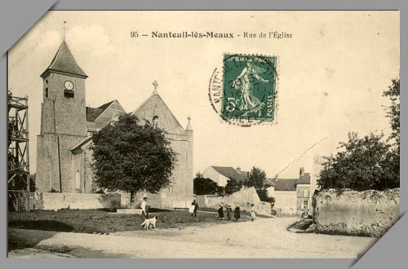Gentleness, cordiality and forbearance must be the practices of the Daughters of Charity just as humility, simplicity and the love of the holy humanity of Jesus Christ, who is perfect charity, is their spirit* (SWLM:406 [L.377])*.*

**1653: FRANCE**

**January:**

Cardinal Mazarin’s troops conquered areas that had been occupied by Conde.

**NANTEUIL**

**February 2:**

As Mazarin journeyed toward Paris he spent a night in Nanteuil … royal officials went out to await him in Dammartin.

**February 3:**

At two in the afternoon Mazarin entered Paris riding in the king’s carriage. The king had intended to meet him in Mesneil-Rance but was prevented from doing so because of the mud and the torrential rains. Louis XIV offered a banquet in honor of Mazarin at the Louvre and the municipality gave another banquet on March 29th.

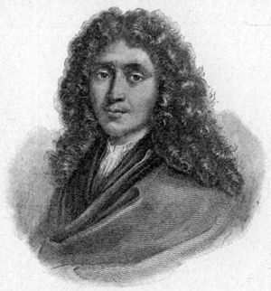

**February:**

Mazarin took his place in the government … his governing team was composed of Servien de Montigny, Nicolas Fouquet (administrator of finances), Harwarth and Jean-Baptiste Colbert. Mazarin then felt that it was necessary to educate the King with regard to political absolutism and at the same time exerted every effort to put an end to the Civil War in the Provinces (his troops seized Provence and Borgona.

**March:**

Mathieu Mole was replaced by Pompone de Bellievre as First President of Parlement.

**MOLIERE**

**March:**

 Moliere presented his work,[*L'Étourdi, ou le Contretemps*](http://en.wikipedia.org/w/index.php?title=L%27%C3%89tourdi&action=edit&redlink=1) (The Bungler), in Lyon; in September he was summoned to the residence of Conti (Grange-des-Pres) and then travelled throughout the lands that were governed by Conti … he ceased those travels in 1657 when Conti converted and became one of Moliere’s enemies.

**March:**

D’Harcourt left the army that was in Guyenne and sought refuge in Alsace … he was replaced by the Duke of Epernon.

**May 31:**

With the publication of the Bull, *Cum Ocasiones,* Innocent X condemned the five Jansenist propositions. On June 4, a royal edict led to the publication of the Bull in France and thus, fulfilled the pontifical decision. On July 8th, the Papal Nuncio gave copies of the Bull to each one of the bishops.

**D’HARCOURT**

**June 22:**

Mazarin met with six Archbishops and twenty-six Bishops in the Louvre … they all manifested their acceptance of the Bull, *Cum Ocasione* and at the same time expressed their gratitude to the Pope for said decision. At that same gathering it was decided that Pierre de Marca, Archbishop of Toulouse, would write to the Pope and Antoine Godeau, Bishop of Grasse, would write a circular letter to the Bishops.

**July 16:**

Mazarin met with various prelates to examine the letters of de Marca and Antoine Godeau which were corrected and refined. The letter of Godeau, less decisive and somewhat ambiguous, exhorted the bishops to comply with the pontifical decree … that letter, however, was not well received by the Holy See. The letter of de Marca, translated into French, was accepted and confirmed by more than sixty-five bishops.

**July 18:**

During the whole year the Pope and other ecclesiastical elements exerted pressure on the government for the release of Cardinal de Retz … the King ignored all such requests. Then on July 18th the King stated that the Cardinal would be released if he renounced his position as Archbishop of Paris. The Cardinal, on the advice of his friends, refused to renounce his position and that decision was supported by the Jansenists. Therefore, as a reprisal, Mazarin openly approved the Bull which condemned Jansenism.



**THE SEAT OF JUSTICE**

**July 19:**

Louis XIV accompanied the army of Turena in his campaign in the North against the troops of Conde and the Spanish forces. After ten days the King returned to the Court.

**August 3:**

Mazarin, known for his political intrigue, began to put some distance between himself and his enemies by winning the support of the nobles and the people as well we the support of parlement … tt Bordeaux the rebel troops surrendered to Mazarin and on August 13th the last hold outs would surrender at Villeneuve-sur-Lot.

**August 28:**

The Canon of Notre-Dame, who had been imprisoned with Cardinal de Retz in Vincennes, committed suicide.

**September:**

The King once again attempted to raise the spirits of the army and traveled to the northern part of the country … there were armed conflicts in Mouzon, Rocroy and Rethel.

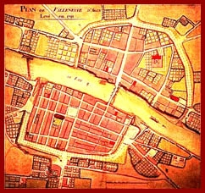**October 17:**

There were notable responses to the Papal Bull that condemned Jansenism and to the letters that Bishop de Marca and Godeau wrote … among those who responded we note here: the Bishop of Angers, Henri Arnauld; the Bishop of Comminges, Gilbert de Choiseul; the Bishop of Orleans who was ill; the Bishop of Beauvais, Choart Buzenval … of special note is the Archbishop of Sens, Louis Henri de Pardaillan de Gondrin, who wrote a letter against the papal decision on October 17 … some of those bishops wrote to Rome.

**VILLENEUVE-SUR-LOT**

**November 16:**

During the month of October the royal army laid siege to the city of Saint-Menehould and conquered it on November 26th.

**December 19:**

The Bishop of Lodeve, François Bosquet, was sent to Rome to replace Henri Estampes. Bosquet would remain there until November 1654 and his objective was to obtain the Pope’s support in removing Cardinal de Retz from his position in Paris … Hugues de Lionne was sent to Rome on an extraordinary mission but when he arrive Pope Innocent had died.

* Amand Jean de Plessis (1631-1715), Duke of Richelieu, was appointed General of the Galleys, a position that he would retain until 1661.

**1653: VINCENT DE PAUL**

**January:**

The Missionaries who had returned in August left once again for the war-torn provinces of Picardy and Champagne as well as the areas of Etampes, Lagny and Palaiseau (CCD:IV:423-426; V:99, 147-148); Warehouses were set up to store the clothing and food and farming tools that were collected (CCD:IV:519, footnote #80). One of these warehouses was established at the house of Bretonvilliers and the other at the house of Mendosse … they had begun to function the previous year as a result of the initiative of Christophe du Plessis, Baron de Montbard (CCD:IV:596).

**January 6:**

****The persecutions in Ireland become more intense; first there was the “Act of Colonization” and then the seizure of land which was followed by the expulsion of all Catholic priests (they were viewed as traitors) … a reward was offered for the capture of any priest.

**January 31:**

Death of Monsieur Lambert aux Couteaux in Poland (CCD:IV:538; SWLM:415 [L.516]);

**March:**

Establishment of the Hospice du Nom-du-Jésu which was formally erected on March 15, 1654 (CCD:IV:530; IX:521ff; SWLM:730-732 [A.77], 794 [A.99]).

**March 6:**

Death of Jean Guerin in Annecy.

**VINCENNES**

**April:**

Lack of meat in Paris … butcher’s strike … there was fear that the Procurator General of the State would use Saint-Lazare as a place to feed the sheep and cattle that were being brought to Paris from Poissy (CCD:IV:548).

**May:**

Vincent preached a mission in Sevran despite the protest of the Duchess d’Aiguillon who was concerned about Vincent’s health (CCD:IV:561, footnote #1)

**May 31:**

With the Bull, *Cum Ocasione,* Innocent X condemned Jansenism; the Bull was published on June 19th and arrived in Paris on June 29th … Vincent went to the Oratory and Port-Royal to hear the Bull accepted … a polemic between Arnauld and Fr. Annat (CCD:IV:580-582, 592-594; XI:149-150).

**July 10:**

Martin Husson left for Tunis as Consul (CCD:IV:549, 560-561, 596-596; VI:643-644); rule of life for Jean Le Vacher and Martin Husson (CCD:XIIIa:401-402).

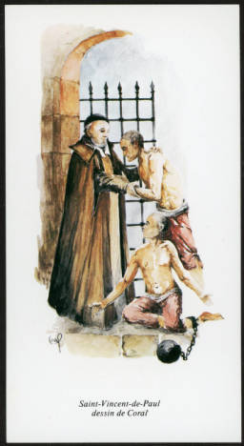**July:**

Vincent wrote to the Pope, Innocent X, with regard to establishing the Church in Tonkin and Cochin-China (CCD:IV: 595-596; V:15-17).

**August 9:**

Fr. Ozenne and the Visitation Sisters left Paris for Poland and had to confront many difficulties in order to arrive at their destination (CCD:V:27, 37-39, 47-49, 52).

**August:**

The Abbe de Tournus and the Prior of Saint-Pourcin, Louise Chandenier, went to Saint-Suplice seeking greater poverty and requested permission to reside at Saint-Lazare.

**August 23:**

The Archbishop of Paris endorsed the Constitutions, the Rule and the Vows (approved during the 1651 General Assembly of the Congregation of the Mission) and steps were taken to obtain the approval of Rome through the mediation of the Missionaries, Berthe, Blatiron and Joly (CCD:V:317.

**1653: LETTERS OF VINCENT DE PAUL**

*Missionaries, who must always tend to their perfection, must always also have no other possession than God* (CCD:IV:546-547).

*How true it is that, by nature, we are very unstable when we have no bond to retain us* (CCD:IV:556).

*If you do not practice continence in the Mission, you will not do so anywhere in the world; of that I can assure you* (CCD:IV:566)*.*

*It is important to form them* [the seminarians] *in solid piety and devotion* (CCD:IV:570).

*Trying to act as masters with those under our care, or to neglect or disedify them, would be a great hindrance* [to their formation] (CCD:IV:570).

*We must be firm but not rough … and avoid an insipid kind of meekness, which is ineffective* (CCD:IV:571).

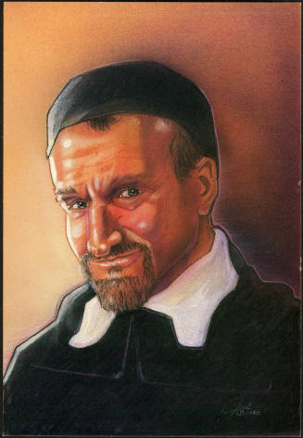*These are ill-disposed persons who usually oppose good and, since they do little good themselves, think it is an exaggeration to say that others do a great deal* (CCD:IV:587).

*Parishes are not our business* (CCD:IV:589).

*Our Lord is always present in replies that are made in accordance with things as they are, and blesses them....* (CCD:IV:605).

*You should draw profit from the departure of your Sister and be more closely united than ever* (CCD:V:5).

*When you are left in peace by those outside, you wage war against one another within the Community. Oh! what a shame!* (CCD:V:9).

*Let us allow God to act; He brings things to completion when we least expect it* (CCD:V:27)*.*

*The vine-stock bears fruit as long as it is attached to its stem; apart from that, no* (CCD:V:45)*.*

*I am sure you are well aware how important it is for those in authority to do nothing of consequence without consulting others* (CCD:V:59)*.*

*There are good, God-fearing persons who still fall into certain faults, and it is better to bear with them than to be hard on them* CCD:V:63).

**1653: LOUISE DE MARILLAC**

**January:** Louise requested Monsieur Berthe to obtain an Apostolic Blessing from the Holy Father. Innocent X granted that blessing in 1655.

**January 31:** Louise exhorted the Daughters of Charity at Chars to accustom themselves to travel on horseback or donkey *because it is impossible to undertake a long trip on foot* (SWLM:411 [L.359]).

**February:** Monsieur de Chesne visited the Daughters at Angers (SWLM:418 [L.365b]). Vincent gave three conferences to the Daughters on the spirit of the Company (February 2, 9, 24, 1653; cf. CCD:IX:456-478).

**March 1:** Louise organized a new work at the Hospice of the Saint-nom-de-Jésus (SWLM:400, 417 [L.364]).

**September:** Monsieur Almeras visited the Daughters in Angers and Nantes (SWLM:408, 424 [L.372], 426 {L.373]).

**October:** Some Daughters from Brienne were sent to Châlons-sur-Marne and Sainte-****Menehould in order to care for the wounded soldiers (CCD:V:174; IX:135; SWLM:432 [L.400], 435 [L.383], 436-437 [L.385]).

**December 28:** Louise added a new codicil in her will dated 1645 … that codicil was motivated by the marriage of her son (cf. Betty Ann McNeil, DC, “Last Will and Testament of Saint Louise de Marillac in *Vincentian Heritage,* Volume 15, #2, 1994, p. 109-110).

**1653: LETTERS OF LOUISE DE MARILLAC**

*Oh, how dangerous it is, my dear Sisters, to desire something before God wills it!* (SWLM:412 [L.360b]).

*For love of God, give nature what it needs for its relief, and what you need for your health* (SWLM:414 [L.516]).

*I believe you have remembered to pray for the preservation of our Most Honored Father … his fine example is a living Rule in the House. You know that we are obliged to pray for the perfection of the Company in general and for that of each member, especially for all those whom we know to be involved in difficult and dangerous work* (SWLM:419 [L. 365b]).

*Oh, how good it is, my dear Sisters, to suffer for the sake of justice! However, let us be very careful not willingly to be the cause of any accusations against us* (SWLM:420 [L.310]).

*Please continue to serve our dear masters with great gentleness, respect and cordiality, always seeing God in them* (SWLM:421 [L.361]).

*I am sure that you know from experience, my dear Sister, that when human beings fail us, God reveals Himself more abundantly to us. This is for our greater good, if we offer to Him all the satisfaction we would have received had we revealed our tiniest thoughts* (SWLM:427 [L.370]).

*I hope, Sister, that you are very careful not to show more affection for some than for others. If some are more faithful to you than others, do not give them any reason to believe that you want them to report the faults of their sisters to you* (SWLM:427 [L.370]).

*Oh, what consolation I experienced in the desolation expressed in your letter! Oh, how true it is that souls who seek God will find Him everywhere but especially in the poor!* (SWLM:431 [L.292])*.*

*I wish Sister' would let me know if she is truly practicing the humble submission, forbearance and reserve that a Sister Servant relieved of her duties should demonstrate, because it is a maxim that those who no longer have authority over others should be the most humble and obedient in the house* (SWLM:432-433 [L.400]).

*****In the name of God, my dear Sister, reflect often that it is not enough to have good intentions or for our wills to be inclined to do good solely for the love of God because, when we received the commandment to love God with all our heart, we also received a second commandment which is to love our neighbor. In order to do this we must give good example* (SWLM:434-435 [L.383]).

*[The Bishop of Châlons’] directions concerning the administrators are for cases of necessity and when they are able to hear your confessions. Ordinarily in hospitals or in parishes, the priests there are not the confessors for our sisters. On the contrary it is not allowed* (SWLM:438 [L.375]).

**BATTLE OF ARRAS**

*As for those two good girls, test them well considering both their physical and their mental attitudes because you know that a girl who shows delicacy in one or the other is not suitable for us* (SWLM:438 [L.375]).

**1654: FRANCE**

**February 24:**

Conti, destined as a second son to an ecclesiastical life and yet despite the promise of a cardinal’s hat, he renounced any intention to become an ecclesiastic and married the niece of Mazarin, Anna Marie Martinozzi.

**March 21:**

Death of the Archbishop of Paris, Cardinal Jean-François de Gondi … the friends of the cardinal had camouflaged Pierre Labeur so that he could be given the powers of succession. At five in the morning, when the Council had been notified about the death of the Cardinal, they proclaimed Jean-François Paul his successor. When the Court became aware of the death of the Cardinal they sent Le Tellier to declare the see of Paris vacant … but he arrived late … The Archbishop was buried on April 2nd in the chapel of the de Gondi’s.

**August 4:**

Rome received news of the flight of Jean-François Paul. Despite the efforts of Cardinal d’Este who was responsible for matters that involved France, Pope Innocent X would not accept the renunciation of the Cardinal … instead the Pope congratulated him and offered him protection.

**August 8:**

The cardinal was able to avoid the vigilance of La Meilleraye in Nantes … the soldiers were drunk and at five in the afternoon the cardinal climbed over the wall. He fell and broke his back but he continued to flee on horseback with those who were waiting for him. He crossed the river and arrived in Beaupreau where he received the assistance of the duchess of Retz. He was brought to Belle-Isle, the patrimony of the Retz family. Mazarin surrounded the Isle but the cardinal, with the help of some fishermen was able to escape and he arrived in Saint-Sebastian on September 12th. On September 9th the cardinals renunciation was annulled (a renunciation which had been forced upon him in Vincennes (August 9th).

**October 1:**

The Cardinal left Saint-Sebastian and travelled to Pamplona, Tudela and Zaragoza (there he visited Aljaferia and Our Lady of Pilar (a miracle occurred there involved a crippled individual from Calanda). He continued he triumphal journey to Vinaroz where on October 14th he embarked for Rome.

**October 6:**

The Duke of Guise prepared a new attack against Naples and received the French support. The Cardinal almost met up with these forces near Sardinia but he was able to avoid any contact with that ship because storms were battering the ships of Guise.

**November 3:**

After various difficulties the Cardinal disembarked in Piombino and on the 28th he arrived in Rome.

**November 23:**

As a result of an accident and “the night of fire” Pascal experienced a second conversion. He ask that he would be able to make good use of his illness. From October 1st he lived at the present rue Monsieur-le-Prince, #54.

**December 4:**

Innocent X granted the Cardinal a four hour audience … the Pope affirmed his dignity and gave him the house of the missionaries as his residence. Since the relations between the Vatican and France had deteriorated as a result of the departure of the French ambassador, Hugo de Lionne was ****sent to substitute for provisional ambassador, Nicolas Bosquet.

**December:**

Death of Mazarin’s father; Fermat and Pascal developed the theory of probability; Anat and Arnaul wrote several pamphlets defending their position; Louis Le Vau designed several wings and the colonnade for the Louvre and construction continued there until 1660; Michel le Tellier, the Marquis de Louvois became Secretary of State for War (a position that had been held by his father since 1643).

**BEAPREU**

**1654: VINCENT DE PAUL**

**January:**

Help was provided to the people living in those provinces that had been devastated by the war: Picary, Champagne … Brother Jean Parre (CCD:III:429; V:59-60) provided hands on supervision with regard to the distribution of this assistance that was coordinated by Moniseur Almeras (CCD:V:79, footnote #2, 123, 204ff, 206ff.).

**February:**

A group of people from Ireland (more than a hundred girls and many children) sought refuge in the house in Troyes and Monsieur John McEnery became their pastor … he instructed them and provided them with clothing and other forms of assistance (CCD:V:82)

**MACHECOUL**

**February 25:**

Vincent requested from the Ambassador, Monsieur de la Haye-Vantelay, a copy of the documents that would provide financial guarantees to the Consuls of Tunis and Algiers … that document was never given to Vincent (CCD:V:88-92).

**March:**

Establishment of a house in Agde; Bossuet participated in the Tuesday Conferences (CCD:V:101, 136),

**March 8:**

A second group of Missionaries was sent to Madagascar. On March 8th Toussaint Bourdaise, Jean-François Mousnier and Brother Forest departed from Nantes … they would arrive in Madagascar on August 16th (CCD:V:71)

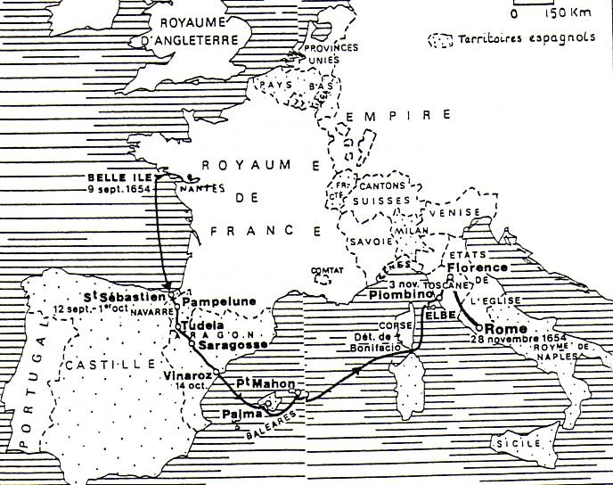

**JOURNEY OF CARDINAL DE RETZ**

**March 16:**

The Missionaries had been ministering in Treguier at the request of the bishop, Grangier de Liverdi and would later establish a house there (CCD:III:447).

**March 20:**

An eclipse of the sun occurred in Poland (CCD:V:168, 182). Monsieur Nicolas Guillot wanted to return to France and Monsieur Zelazewski desired to leave the Congregation (CCD:V: 110ff., 114, 312-313).

**March 21:**

Death of Jean-François de Gondi, Archbishop of Paris … he was buried in one of the chapels at Notre-Dame. He was succeeded by his nephew, Jean-François Paul (the second Cardinal de Retz) who was imprisoned at Vincennes (CCD:V:115).

**May:**

A brother of Brother Jean Barreau, who was procurator, had a nervous breakdown and was brought to Saint Lazare (CCD:V:149-150).

**May 26:**

The Missionaries gave a mission in Charenton and they wanted the Bishop to go there to administer the sacrament of Confirmation (the bishop had neither crozier nor miter and Vincent asked François Boulart to help in that matter (CCD:V:144)

**July:**

Brother Durant, who would be ordained a priest in September, went to Poland to minister there with two other Missionaries … Monsieur Guillot wanted to return to Paris (CCD:161, 164; XI:310-316).

**August 8:**

Cardinal de Retz escaped from the prison in Nantes and after many difficulties arrived in Rome (CCD:V:115, 117-118; VIII:160, footnote #2).

**August 22:**

Mazarin sent De Gondi into exile at Clermont and even though later he would be permitted to return to Paris he remained in Joigny until his death (June 29, 16620). His remains were brought to Paris and he was buried at the seminary of the Oratorians. **CATHEDRAL AT TROYES**

**September:**

Vincent consulted Canon Pierre Gassendi in the matter of the expected eclipse of the sun that was expected to occur on August 12th between nine and ten in the morning (CCD:V:168, 182).

**September 27:**

Innocent X affirmed the statement of thirty-eight French bishops (June 24th) opposing Jansenism (CCD:VI:101) … that statement was made after a report from the bishops from Toulouse and Embrum. The bishops from Sens, Comminges, Beauvais and Valence had also responded to that same report.

**November 23:**

Second conversion of Pascal – Night of Fire.

**December:**

By order of the Pope, Monsieur Berthe offered hospitality to Cardinal de Retz who had arrived there in November … after spending seven or eight days there he transferred (with great pomp) to the palace of Our Lady of Loretto … as a result of providing hospitality Monsieur Berthe was forced to leave Rome (CCD:V:334, 359; vi:12ff.).

**1654: LETTERS OF VINCENT DE PAUL**

*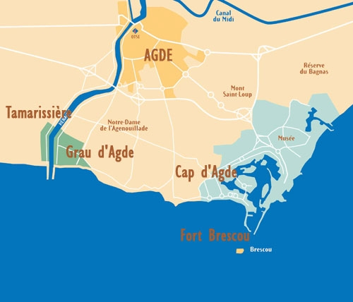God ordinarily allows good plans to encounter setbacks so that, when they succeed, people may know that it was He who brought this about* (CCD:V:84)*.*

*As for your question about how a person observes the fourth vow… my answer is that, first of all, it is by being prepared in spirit, ready to go to preach missions at the slightest sign indicated to us, and secondly, because forming good Pastors and diocesan priests who will subsequently go to instruct the poor people in rural areas and exhort them to lead good lives* (CCD:V:87-88).

**AGDE**

*One good soldier is worth ten, and God will certainly bless your little flock even if the loss you fear* [the departure of M. Guillot and M. Zelazewski] *should occur* (CCD:V:114).

*A man who behaves poorly in a Community will not do well in a parish* (CCD:V:120).

*God has permitted that, in the early stages of every Community, several persons leave, some even in the midst of scandal. He has His own reasons for this; it is for us to be prepared for it and to adore His ways* (CCD:V:141)*.*

*We should hope that God will be more honored by our submission to His Providence in awaiting His orders than if we ventured to anticipate them* (CCD:V:165)*.*

*Please make your prayer on this and, during the day, raise your heart to God from time to time to ask Him for the grace of grounding yourself firmly on this principle namely, that after considering your own miseries, you will always direct them to His mercies* (CCD:V:166).

*I have heard that the Polish people are more easily won over by this cordial, charitable method than by harshness. Naturally, everyone is disheartened by sharp reprimands, and by the most amiable corrections as well, if they are frequent, immoderate, or given inappropriately* (CCD:V:167).

*You are Daughters of Charity, but you would no longer be so if you lived amid misunderstanding, aversion, or mistrust of one another. God grant that this may not be the case among you!* (CCD:V:169).

**SEDAN**



*I am sure your building is costing more than was thought; that is usually the case* (CCD:V:170).

*What a happiness to become impoverished in order to oblige someone who has been our benefactor!* (CCD:V:181).

*Just as you, in your humility, persevere in asking to be relieved of the direction of the Marseilles house, I continue to ask you to do the contrary, that is, to carry out its responsibilities, in conformity with what I have written you* (CCD:V:199).

*If you were a Gascon or a Norman, I would not find it strange. To think, however, that a straightforward man from Picardy, whom I consider one of the most sincere men in the Company, would have hidden that from me* (hid the fact of incurring a debt) (CCD:V:199-200).

**SEDAN**

*I cannot restrain myself and must tell you quite simply that this gives me renewed, greater desires to be able, in the midst of my petty infirmities, to go and finish my life near a bush, working in some village* (CCD:V:204).

*Nature makes trees put down deep roots before having them bear fmit, and even this is done gradually* (CCD:V:219)*.*

*You must conquer evil with good* (CCD:V:235).

*It is a custom of that Company to change the Sisters frequently* (CCD:V:246).

*God has been pleased to compose this Little Company of persons of lowly condition and average intelligence. By his mercy, however, they have good will, which, by His grace, is increasing in them daily* (CCD:V:267).

*The custom of taking these simple vows has existed in the Company for about thirteen years now,' it seems unlikely that it will be changed simply because of the thinking of one or two members of the Company* (CCD:V:318)*.*

*We must suffer in silence, however, because it is the Master who has acted, and we must love the paternal hand that strikes us, as adorable in the punishments it metes out as in the favors it distributes* (CCD:V:329).

*How I wish that members of the Mission who are together would do everything in conjunction with one another! That is how friends act, and how much more so should two brothers who live together* (CCD:V:333).

Vincent viewed his carriage as *his ignominy* (CCD:V:344).

**PARIS**

With regard to banquets: *never go to them under any pretext whatsoever* (CCD:V:346).

**1654: LOUISE DE MARILLAC**

**January:**

the war-torn Provinces continued to receive assistance; the Sisters engaged in a very important ministry in Sedan where they served the wounded soldiers.

**May 11:**

Vincent requested that one hundred thirty loads of firewood that was brought from Compiegne for the house of the Daughters be exempt from the new tax (CCD:V:139).

**June 31:**

The Queen of Poland requested the presence of more Daughters of Charity … but there arose a discussion: who would be the superior: a Daughter, one of the Ladies of Charity, 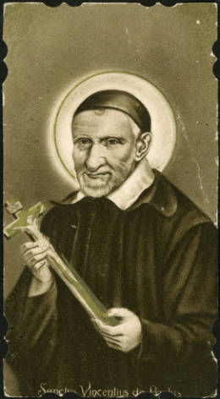Mademoiselle de Villers? (CCD:V:164-165, 169, 228-230, 479)

**November:**

MarieJoly ministered in Sedan during thirteen years and was summoned back to Paris. The Ladies of Charity and Sister Marie resisted said request but then one afternoon she left the house without saying a word to anyone …the following day, however, she returned to the house (CCD:V:207-208, 225, 260-261; SWLM:451 [L.451], 452 [L.93], 455 [L.294]). Establishment of a house at Bernay and at La Roche-Guyon (SWLM:439); the thirteen houses on the Champ-Saint-Laurent near Saint-Lazare receive the infants from the women who gave birth at the Hotel Dieu, children whose mother died in childbirth or who were abandoned by their mother.

**1654: LETTERS OF LOUISE DE MARILLAC**

*I beg Our Lord that you all may be as his heart wills you to be and that today you have entered into the death of the Blessed Virgin by the voluntary sacrifice you make to him of dying to yourselves so that you may live in God* (SWLM:447 [L.412]).

*Permit me to tell you, my dear Sister, that if great care is not taken when one is first placed in a position of authority and if one is not filled with a great desire for solid virtue, then one finds oneself in peril* (SWLM:449 [L.415]).

*Encourage one another, and may your mutual good example speak louder than any words could* SWLM:402 [L.402]).

*Believe me, my dear Sister, when I see splendidly appointed houses where everything goes beautifully at the beginning, I always fear for the future* (SWLM:456 [L.419]).

All references to the writings of Vincent de Paul are taken from:

VINCENT DE PAUL, *Correspondence, Conferences, Documents,* translators: Helen Marie Law, DC (Vol. 1), Marie Poole, DC (Vol. 1-14), James King, CM (Vol. 1-2), Francis Germovnik, CM (Vol. 1-8, 13a-13b [Latin]), Esther Cavanagh, DC (Vol. 2), Ann Mary Dougherty, DC (Vol. 12); Evelyne Franc, DC (Vol. 13a-13b), Thomas Davitt, CM (Vol. 13a-13b [Latin]), Glennon E. Figge, CM (Vol. 13a-13b [Latin]), John G. Nugent, CM (Vol. 13a-13b [Latin]), Andrew Spellman, CM (Vol. 13a-13b [Latin]); edited: Jacqueline Kilar, DC (Vol. 1-2), Marie Poole, DC (Vol. 2-14), Julia Denton, DC [editor-in-chief] (Vol. 3-10, 13a-13b), Paule Freeburg, DC (Vol. 3), Mirian Hamway, DC (Vol. 3), Elinor Hartman, DC (Vol. 4-10, 13a-13b), Ellen Van Zandt, DC (Vol. 9-13b), Ann Mary Dougherty (Vol. 11, 12 and 14); annotated: John W. Carven, CM (Vol. 1-14); New City Press, Brooklyn and Hyde Park, 1985-2014.

All reference to the writings of Louise de Marillac are taken from:

LOUISE DE MARILLAC, *Spiritual Writings of Louise de Marillac,* Edited and Translated from the French by Sister Louise Sullivan, DC, New City Press, Brooklyn, New York, 1991.

The reference to Abelly is taken from:

L. ABELLY, *The Life of the Venerable Servant of God Vincent de Paul: Founder and First Superior General of the Congregation of the Mission,* 3 vol., edited by John E. Rybolt, CM, translated by William Quinn, FSC, notes by Edward R. Udovic, CM and John E. Rybolt, CM, introduction by Stafford Poole, CM, New City Press, New Rochelle, New York, 1993.

Translated by: Charles T. Plock