WHAT LIFE IS LIKE IN THE MURDER CAPITAL OF THE WORLD
On a Saturday morning in late August 2013, 10-year-old Daniel Chacon awoke early. It was hot, as mornings often are in Bordos de Agua Azul, his neighbourhood in San Pedro Sula, Honduras. His family was poor, barely scraping together a living by selling pickled vegetables on the roadside.
Daniel and his 14-year-old brother insisted on contributing as best they could. They’d managed to talk their parents into renting a horse and buggy, which they used to collect discarded boxes, selling the cardboard to recycling collectors for pennies a pound.
It may have seemed like a tedious job, but there was an element of risk to the task because of an unfortunate characteristic of the area: Since 2011, San Pedro Sula has been the world’s most murderous city. (Tegucigalpa, the capital of Honduras, holds the No. 4 spot.) Children fleeing these horrors have recently become a political issue in the US, where they are increasingly turning up in search of asylum and safety. But Daniel and his brother are among those who stayed.
Occasionally during their rounds, they’d split up to cover more ground, taking turns leaving the cart to scout for boxes on foot. At 2 p.m., Daniel’s brother was making his way back to the cart through the crowded streets of the Medina neighbourhood when shots rang out. Police sped by on motorcycles.
By the time he arrived, Daniel was dead.
“He got shot,” a bystander told him. “They took him to the hospital.”
Sadly, the slaying of a child for no discernible reason is hardly a noteworthy event in Honduras, where there are on average some 19 homicides reported every day. In San Pedro Sula, residents are murdered at the annual rate of 169 per 100,000 residents, a staggering figure that dwarfs the US leader, Flint, Michigan, where the murder rate is 62 for every 100,000.
While the Obama administration struggles to get a handle on the problem — having recently instituted a “get tough” detention policy designed to slow the influx of families seeking asylum — children like Daniel Chacon are caught in the crossfire every day.
In an effort to understand what life is like in the world’s murder capital, we spent 2 weeks in San Pedro Sula. We found a city in crisis, but also a place steeped in hope, where the circus still comes to town, the local crime reporter struggles with an overwhelming task, and life goes on — until it doesn’t.

Bearing Witness
It’s mid-afternoon when Paulo Cerrato, a 30-year-old reporter on the crime beat at La Prensa, a local newspaper, steps from the paper’s imposing, largely windowless building on Third Street — the most notable feature is a 16-foot guard tower — and slides his solid frame into the back seat of the cab of one of the office’s white pickups. One of two dailies in San Pedro Sula, La Prensa claims the highest circulation in the country.
It’s an average day, with 9 murders reported so far, when Business Insider joins Cerrato on a trip to the police station. A boxer, Cerrato is 5-foot-8, with muscular shoulders. He wears khakis and a striped collared shirt, unbuttoned halfway down his chest. His dark hair, thick with unruly curls, is pushed back on his head.
Accompanied, as he usually is, by a photographer and a driver, Cerrato sits in the back seat of the pickup’s cab as we thread our way through San Pedro’s downtown, passing parkettes, independent hotels, and street markets. There are numerous funeral homes. Warehouses are surrounded by high walls topped with barbed wire. Guards armed with shotguns ride in the back of a Coke delivery truck. And everywhere, it seems, there are murals and billboards proclaiming the loving nature of Jesus. Honduras is a country soaked in God, more so now, perhaps, than ever before.
We wait in front of the police station while Cerrato talks to some officers. Several cops roll up on Suzuki DR-Z dirt bikes. Their helmets, Cerrato explains later, were donated by a local businessman. “I wanted to be reporting on tourism and beautiful flowers,” Cerrato says. “There are lots of areas you can work on in journalism and you don’t imagine you’ll be getting your master’s degree in violence.”
Cerrato has been covering the crime beat for three years, and he’s well sourced. Reports come in day and night, texts and calls from police, the public prosecutor, people who know him.
Sadly, he is rarely at a loss for material.

Staggering Numbers
Cerrato’s days are spent driving from murder scenes to morgues to police stations to the homes of the grieving and back to the office, where he files as many as seven stories in a day.
The killings run the gamut. Some involve land disputes; many are related to the drug trade or the flourishing extortion business. Some spring from battles over gang turf, and others occur at the hands of police, whether as a means of stifling political dissent or because of widespread corruption. The result has been a vicious circle, a general sense of lawlessness and chaos that keeps the citizenry cowering in fear and allows criminal syndicates and other entities to maintain power, resulting in still more death.
The police are overwhelmed. They’re also corrupt and poorly trained. The vast majority of murders — more than 97% — go unsolved.
San Pedro Sula’s horrors are hardly new. Many trace the origins of the city’s crime wave to 2009′s military coup, which saw President Manuel Zelaya Rosales, a leftist, hustled onto a plane in his pajamas and ushered out of the country following a constitutional dispute. The following election was won by Porfirio Lobo Sosa of the right wing National Party, which has ruled the country since.
While most countries strenuously protested the coup, the response of the US, which has longstanding ties to the Honduran military, was seen as notably ambivalent. “One of the only governments to support it was the United States,” says Larry Birns, director of the Washington, D.C.-based Council on Hemispheric Affairs. The US continued its financial support of the Honduran security apparatus, and worked behind the scenes, as Hilary Clinton recounted in her memoir, “Hard Choices,” to thwart Zelaya’s possible return to power. Today he serves in the Honduran parliament.
Under the National Party, the rule of law declined and political repression became endemic. Extrajudicial killings by the police are not uncommon. In many neighborhoods, police and military patrols, however corrupt, are all that exists of the state. The real power lies with the forces of disorder, petty criminals and gangs like Mara Salvatrucha (MS-13) and Barrio 18. The gangs were given a jump-start in the ’90s, when the US began deporting Honduran members of violent Los Angeles street gangs. Barrio 18 is named for 18th Street, its birthplace in the Ramparts section of L.A.
Sandwiched between Guatemala and Nicaragua with coasts on the Pacific Ocean and the Caribbean Sea, Honduras is a convenient transit point for drugs making their way north to the US. As interdiction efforts in Mexico have become more effective, traffickers have increasingly relied on Honduras. By some estimates, nearly 90% of all US-bound cocaine passes through the beleaguered country. Much of Honduras is undeveloped and difficult to police. The US has responded by placing four forward operating bases in rural and coastal areas. Signs greeting incoming US troops have been erected at the country’s airports.
“What little aid Honduras receives from the US is mostly military aid, some of it distributed as assistance in anti-drug-trafficking activity,” Birns says. The US spent $US75 million on drug-interdiction efforts in Honduras in 2012, while funding for democracy, human rights, and governance was $US7 million. One result of this imbalance is that the conditions that make drug money attractive remain: 64.5% of the population lives in abject poverty.

We No Longer Have A State’
We arrive at the Mario Catarino Rivas Hospital’s morgue, a regular stop on Cerrato’s tour. The parking lot is nearly full. It’s the rainy season, and a humid breeze caresses the trees surrounding the parking lot. Cerrato is looking for grieving family members. The hospital treats the sick as well, but most of the 50 or so people in the lot are here to visit the morgue, and the silence is palpable. Cerrato wades into the crowd clutching a notebook. His tone is soft. He is direct and patient, balancing his need for facts with a gentle respect for the grieving.
They want their stories told. “The state is broken down,” the father of a murdered teenager, Dr. Juan Jose Dubon Murcia, says. His son, Lenín Bladimir Dubón Monge, a 19-year-old systems-engineering student, was gunned down while he waited for a bus. “We no longer have a state.”
Cerrato scrolls through his tablet as we ride to the newspaper in the back of the pickup. It’s a showcase of horrors. The images help place him at the scene when he writes; he keeps them in case he wants to follow up. A headless torso, arms beneath intestines, gathered where trash and detritus have caught in a creek, a pale man hanging from a noose in a dark room.
We pass a group of joggers, breathing heavily in the late evening, running through pools of light.
After returning to the office to write up his stories, Cerrato will catch a ride home by 11 p.m. and attempt not to wake his 4-year-old daughter as he crawls into bed with his wife, trying to put the day’s scenes out of his mind.
“Gunmen Impose Another Day of Terror in San Pedro” reads a below-the-fold headline on the front of the next morning’s paper.
Cerrato’s stories are mostly short items. Some run fewer than 200 words. They’re in the back of the paper, sandwiched between classifieds and the entertainment section. “Engineering Student Shot Dead by Two Assailants” reads a typical headline. Cerrato’s writing is direct: Lenín Bladimir Dubón Monge, he writes, “was expecting the Route 7 bus to go to university classes when he was wounded by the assailants, according to what eyewitnesses told the police.” Monge’s murder was one of 10 reported in San Pedro Sula that day. A few merit a lengthy treatment of a few hundred words.
There was the car dealership owner, Manuel de Jesus Castro Romero, and his wife, Nidya Sujey Orellana Cerrato, daughter of the National Party candidate for mayor of Villanueva — both gunned down as they rode in a pickup some 500 meters from a police station.
There was the lawyer, Jose Angel Perez Aguilar, who’d been prosecuting a gang member. Aguilar had been warned that he was a target and had left the country not long before. He might have escaped his assassin had he not returned to the city from Guatemala; he was killed on his way to pick up his wife.
Three other murders receive a blurb each: a dead woman found in a blue blouse and black bra, curled up in the fetal position with machete wounds to her head and left hand; a man tied up in a green garbage bag with orange string; an older man found in a banana plantation with gunshot wounds.
One story that did not make the edition was the killing of a peasant farmer, Darwin Franco, gunned down amid a politically charged land dispute in the mountains two
hours outside of San Pedro Sula. There’s only so much space.
Picture below: Lizeth Cerros mourns her murdered husband, Darwin Franco, with her children. Later she would receive another death threat. Franco was a community organiser. 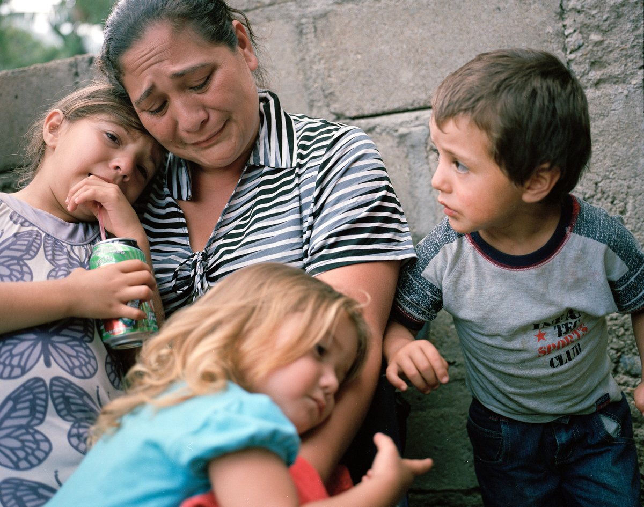

A Visit To The Morgue
We’re driving around lost in La Sabana, a neighbourhood on the outskirts of San Pedro Sula, when Cerrato receives a report of a triple murder. The information is sparse, as usual. Something about the owner of a secondhand-clothing store being shot by an assailant in plain view of onlookers, who turned on the killer and chased him, shooting wildly, killing a young boy before catching the original assailant and gunning him down in front of a shop.
It wouldn’t be the first time the city’s residents meted out justice — given the state’s impotence, many seek retribution themselves. Then again, for a homicide department consisting of just 23 officers, the death of the main perpetrator is also a convenient development.
We arrive at the first body — a man in teal and pink Nikes is sprawled in front of a store. A trail of blood runs from his head down the sidewalk and off the curb, where it has begun to pool. As Cerrato speaks to the police, it’s clear everyone knows one another; every murder scene seems to double as a reunion for cops and journalists.
Later at the Mario Catarino Rivas Hospital’s morgue, Cerrato spots his target instantly. She is the woman standing, alone, in the darkened hallway, her chest heaving and her eyes empty. A police officer leads Angelica Ortiz back to the parking lot, to daylight, outside the single glass door to the morgue. Through the glass, one can glimpse a figure lying under a sheet on a steel bed in the morgue’s hallway, one arm pointing toward the floor. This is Daniel, her son. Angelica sits on the sidewalk and speaks with Cerrato.
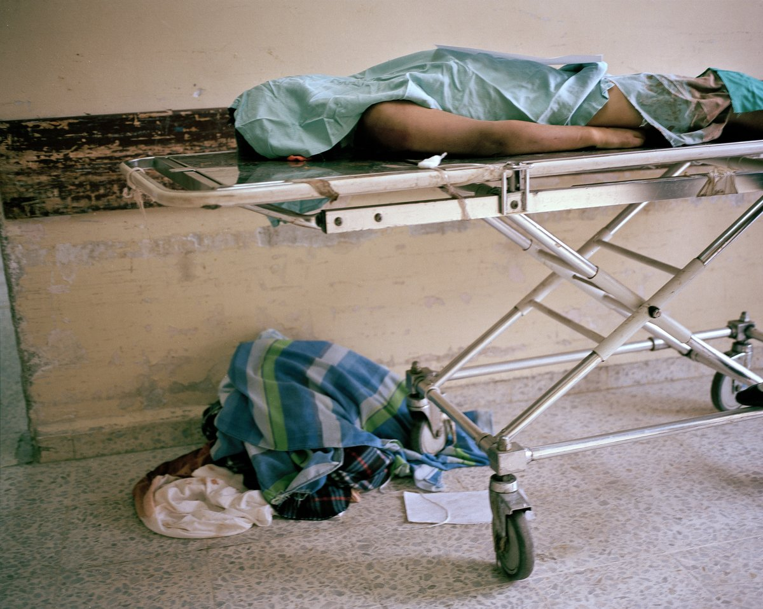
Three days earlier, she tells him, Daniel asked her what heaven was like. The day he was killed he’d given her a ring and earrings to wear to church. “He was saying goodbye,” she says. Cerrato finds a chair for her, then retreats across the parking lot, giving her space.
They will wait for hours — Ortiz for family members to bring her son’s ID, so the body won’t be lost in bureaucratic limbo, and Cerrato for an interview with Daniel’s brother, and for photos of his ID.
“You get used to it,” he tells me. “You make yourself stronger, try not to involve your feelings, because it will drive you crazy.”
Cerrato’s boxing hobby isn’t just about keeping in shape. It helps him clear his mind. There is no time to think of the dead when you can scarcely catch your breath, when your muscles are screaming.
There are times, however, when a story penetrates Cerrato’s emotional defenses. It’s always harder when a young person is the victim. A few months earlier, he says, a stepfather beat up a 3-year-old in front of the girl’s mother. Cerrato heard the story directly from the perpetrator, who thought the reporter was a cop and volunteered a chillingly offhanded account of the crime, before asking Cerrato to loosen his handcuffs. “That case really got to me,” he says. “I wanted to get myself into trouble. I was thinking about beating him up.” The murder of Daniel Ortiz is shaping up to be another troubling case.
Across the parking lot, Ortiz moans. It is the sort of sound an animal might make, stuck in a trap, waiting to die.

‘Tell Me Who To Kill’
Late one afternoon, on our third day in San Pedro Sula, we drive to the Colonia El Estadio neighbourhood. The sun is delivering that magical light, its most brilliant, before it dies for the day. There are reports of a body out in a field. Cerrato talks as we drive, telling stories of abandoned homes, of teachers afraid of students, of narcos with private zoos. En route we pass a water park named Wonderland! Despite the heat there are just four cars in the parking lot. It’s hard to imagine any locals might afford it. And certainly there are no tourists.
When we arrive at the crime scene, a policeman at the edge of the field tells us we should wear masks to protect ourselves from the smell of decomposition. Having none, we figure our shirts will work if necessary and set off into the field, young corn brushing our legs. It’s 5 p.m. and the sun peeks through the clouds. A man and a woman stand some 100 yards back, intently watching the police work. The woman tells us her nephew, a 14-year-old, has been missing for several days.
Three kids sit silently on a nearby berm as police and technicians tug at a yellow bag that seems to be stuck in ground. It doesn’t come. They hack around it with machetes. A police officer steps away, walking past us back to the street, looking green. Sound carries over the field, birds, children playing. Wind plays over the tops of corn plants. The smell is of things burning, a nearby trash fire.
The man watching patiently, a neighbour, is called over to help carry the bag containing the body. He takes the legs while the forensic guys hold the other side, which contains the head and torso, wrapped in newspaper and wire.
The investigation appears far from thorough. The police will not look too hard, Cerrato says. They will be especially careful not to dig around the body, for fear they might find others. This would only make their terrible stats worse and complicate an already impossible workload. They learned this lesson with the Anibal Barrow case. Barrow, the host of a morning show on Globo TV, “Aníbal and Nothing More,” disappeared on June 24, 2013. An unusually diligent police search turned up his body — and some 30 others. “Other people don’t get the same effort,” Cerrato notes. “In this country, if you have the bad luck of being poor, your mother could be killed and nothing would be done.”
When Barrow was found, an acquaintance of Cerrato’s, an assassin, offered his condolences. “It’s not right,” he told Cerrato. “Tell me who to kill and I’ll do it for free.”

Among The Papa Limas
Over time, the murder scenes begin blend together. Bodies hacked like meat, or left on the road, burning in garbage bags, rotting in fields, unfound. Journalists, police officers, anyone working these scenes find ways to accept reality. They use nicknames to distance themselves from the horror. The corpses are “papa limas” (potato limes), local police code for dead bodies. At one murder scene a female police officer admits she places the dead in categories, the ones who are culpable in some way, part of the crime world, and the bystanders. “The weight you carry for someone who did something is different.” Different from when it’s “someone who’s innocent.”
Cerrato says the most murders he has covered in a day is 22, but then he reconsiders. “The day they killed 17 in a shoe store there was probably more,” he says. “There was no space left in the paper.” On days like that, Cerrato would focus on the bodies that have been identified, or those killed in a well-trafficked place, or the cases in which witnesses could at least describe the events that surrounded the murder. Unidentified bodies would be left till the following day, or slower days, when there would be time to run down interviews, find people who knew the victims. “But we knew we would have other news to report,” Cerrato says. “So we had to move fast.”
In San Pedro Sula, sometimes it seems like the gap between the living and the dead has been made almost nonexistent. For Cerrato, simply naming them, devoting even a few lines to telling their stories in newsprint, is a kind of sacred responsibility, a daily act of bearing witness. It’s a small thing, given the nature of the crisis, but its importance is magnified by the failure of the state, and of law enforcement.
Most of Cerrato’s stories are straightforward and factual. A few details about the case and the victim, maybe a quote or two from the relatives, then on to the next. But once in a while he manages to dig up a fact or a piece of evidence the authorities missed, or one they intentionally ignored.
As he begins looking into the killing of Daniel Chacon, for instance, Cerrato finds a witness whose story differed from the official narrative the police put forth. According to the witness, there was no crowd of vigilantes chasing down the gunmen, firing wildly into the busy afternoon market. The witness says the only people they saw firing guns that afternoon were police on motorcycles. One eyewitness report isn’t proof of anything, but Cerrato thinks it has merit and sounds at least as plausible as the official narrative, maybe more so. He includes it in his story, an alternate theory floated in a short paragraph toward the end of the report.
A few days later, he visits Angelica Ortiz. After a brief interview in the family home, he and his photographer and driver step out into the sun to find a group of armed men standing across the street, staring them down. They waste little time heading back to the office.
A few months later, he decides to return. The drive takes us through MS 13 territory, and the family’s home is in the 18th Street territory. Cerrato suggests a police escort for our visit, prompting a debate. While the murder rate has recently dropped in the community, it’s still a dangerous place. And yet, a police escort could frighten Ortiz. Finally, it’s decided a visit cannot safely occur without an escort, so we go looking for police who might be willing to accompany us. The first police station defers, so we head to a second police station in Colonia Lomas del Carmen.
We wait while Cerrato speaks with the officers. Two young Mormons on their mission pass by in their signature short-sleeved dress shirts. Walking with faith, stripped of possessions, seems to make one less of a target. National police and heavily armed soldiers lounge in the shade outside yellow and blue cinder-block building. A soldier sips a bottle of Coke.
There have been no murders today and it’s close to noon. “There are low seasons,” Cerrato says. A set of bullet dents in the driver’s side of a police pickup serves as a reminder of other seasons. In the end, several additional officers decide to accompany us, perhaps out of boredom.
As we approach the Ortiz home, men standing the single-lane dirt road disappear. Maria Ortiz and her husband, Manuel Chacon Lopez, invite us in.
“We’re still bearing the pain,” Ortiz says. She means emotionally, of course, but the financial burden is also significant. The family’s meager finances have been wiped out by the funeral, which cost 5,000 lempiras, close to $US240. They make up to 900 lempiras a month. “I have beautiful dreams with my son, that he is in heaven,” she says.
Chickens run through the room. Onions and carrots are spread about the dirt floor on a mat. Photos of Daniel, now frozen in time, abound. Our joint escort remains outside.
“We go to church, and God provides us with strength,” she says. “We understand that God took him. These are things that happen here.”
In San Pedro Sula, the illusion of forward movement, of working one’s way into a better life, has long since shattered. The reality is that things happen and they aren’t good things. As we talk, a neighbour enters the home. He doesn’t acknowledge the family, and they don’t acknowledge him. He asks if the car outside is ours, as though perhaps the lone car in the neighbourhood, the one accompanied by a security detail, might be someone else’s. When we leave, the interloper suggests we help out the neighbourhood. It’s not an entirely friendly suggestion. Declining to take the hint, we leave with our entourage of heavily armed police and soldiers.

Dread And Distraction
Even amid all the killing, life in San Pedro Sula goes on. It has to. One beloved distraction is the circus. We head there one day — hearing the announcements and reggaeton blasting from speakers well before we spot the convoy of trucks, trailers, and jury-rigged campers arranged in a protective circle around the Circo America’s big top. Lions and jaguars sit in tight cages on the perimeter. Inside the tent, we’re transported to another world. There is popcorn, candy apples, and the panicked music of the circus. Circo America, which has been around for six decades, is based in Honduras but performs throughout Central America. Its small size, appreciative fan base and perhaps the performers’ vulnerability seems to grant the circus a measure of safety. The performers (who also take on numerous other jobs) shimmy with hula-hoops, swing from the rafters, walk the tightrope. With the lights and curtains, it’s a zone apart — a safe place in which to act out and conquer the daily terrors everyone lives with here. Clowns act out their fears of the mythical Chupacabra. Jaguars refuse to leave the ring until their trainer threatens to call the police (at which they flee). Mock executions are acted out off stage, to the delight of the small crowd.
The show lasts about an hour and a half, and soon enough everyone piles out of the tent and back into the grim reality of day-to-day life in San Pedro Sula.
Cerrato walks a fine line as a journalist. There are legions of people he must manage not to offend. There are the gangs, the wealthy political interests, the police, and the ever-present editor, all while doing his job well and staying sane, alive.
Since 2003, 38 journalists have been murdered in Honduras. Just 10 of these cases were brought to court, and only four cases ended in convictions. One afternoon last July, Cerrato left his small apartment to walk to work. As he walked, a grey car slowed behind him. He grew nervous. The car stopped.
“A tall man with a pistol and hair like a rock star stepped out, and he told me ‘Get in the car,’” Cerrato recalls. “I said, ‘If you want my mobile phone, my money, I’ll give them to you.’”
The assailant wasn’t interested. He fired a round into the pavement at Cerrato’s feet. Cerrato got in.
The car sped through town. The gunman told Cerrato he was going to kill him. Cerrato looked at their faces, the driver and the man with the gun, hoping to recognise them from one of the cases he’d worked. They were unfamiliar. But their destination wasn’t. They were in the Rancho Coco neighbourhood. “Many bodies appear in this place,” Cerrato says. “I think, maybe these guys kill me and I appear in this place.”
Cerrato pictured himself as the subject of one of his stories. Where would he end up in the paper? Front page? Buried near the back? He thought of his daughter. He prayed for her and then he turned toward the man with the gun and lunged for it.
They fought for control of the pistol. As the car took a corner, Cerrato’s door flew open. He dove out into the street, hitting the pavement. He was scraped and in pain, but free. Instinct took over: A sympathetic cabbie who’d seen what happened took him to La Prensa, where he got into the newspaper’s truck for a trip to the police station.
The story might have ended there, but on the way Cerrato spotted a car that looked just like the one that had picked him up. They followed the car at a distance, watching it for half an hour as it made stops around the city. It was only when the car stopped to pick up a female passenger, and the chivalrous gunman got out of the car to let her in, that Cerrato knew for sure it was them. Soon after, the driver stopped behind a supermarket and the woman and the man with rock-star hair got out. Cerrato waited, then charged them from behind yelling, “On the ground! On the ground!,” mimicking a police officer. The driver took off as the pair hit the ground and the man threw his gun to the side.
Cerrato was elated and scared. Minutes later, La Prensa’s security arrived and took the gun. “You didn’t think you’d see me so soon,” Cerrato said. Disarmed, the man was silent. Cerrato asked why he’d wanted to kill him. The man remained silent. It might have been a robbery; it might have been connected to Cerrato’s work. He still doesn’t know.
Before the cops arrived, Cerrato punched the man with rock-star hair. An elderly man, watching the scene, asked what was going on. Cerrato told him. The man offered his cane. “Beat him with this,” he said.
The man with rock-star hair is now in jail.
“If I could do it again I wouldn’t follow this guy,” Cerrato says. “Later, I realised I could be putting my family in danger.”
We’re sitting on the floor of Cerrato’s spartan one-bedroom apartment. His daughter rides a bike with training wheels around the small space while Honduran dub reggae plays. Cerrato’s wife, a broadcast journalist, worries, as does his entire family. As they all know, “the one that’s taking the risk is not the media,” Cerrato says, “but the reporter.”
He will work out his frustrations and his fears in the boxing ring, go out for ice-cold bottles of Salva Vida, a Honduran beer, listen to local bands. He will carry the bodies with him.
A few months later, Cerrato is let go from La Prensa. There’d been some friction with an editor. Cerrato suspected that stories weren’t being run because of political interests. He’s now in Tegucigalpa, looking for a way to return to the beat. There are still so many papa limas whose stories need to be told.
“I want to have a positive mind,” Cerrato tells me over Skype. “I want to believe that things will improve. But you need the government to be committed in creating security, safety for the country and civilians.”
“By not paying attention to the violence, it’s like the snowball effect,” he adds. “It will keep getting bigger and bigger to the point where they will not be able to stop it.”
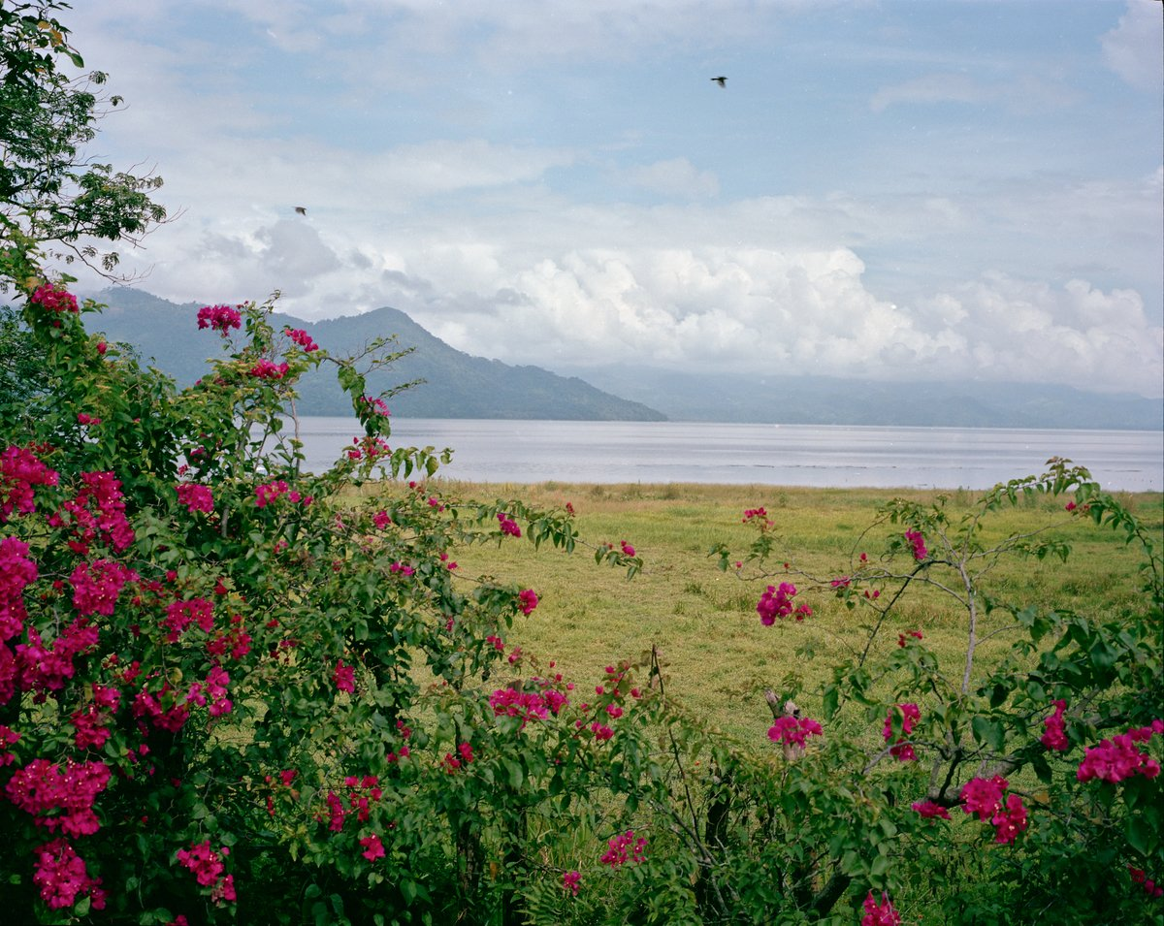
A view of a Lake Yojoa from the side of the highway between Tegucigalpa and San Pedro Sula. Despite its horrors, Honduras remains one of the most beautiful places on earth.

see below:

http://www.businessinsider.com.au/murder-capital-san-pedro-sula-2014-10

