Haiti Fiscal Year
Oct 1, 2013 — Sept 30, 2014
VINCENTIAN FAMILY HAITI INITIATIVE
Vincentian creativity at work in Haiti
2014 ANNUAL REPORT

Letter from the International Coordinator

Highlights
- Graduated 290 women from proven poverty alleviation program.
- 30% increase in assets of 150 women living in rural Haiti.
- Constructed 75 homes and 150 latrines for women in poverty alleviation pro- gram
Dear Friends,

2014 has been a year of transition for us. As the LaHoye fish farm moved from a dream to a busi- ness reality, we have laid the foundation for the sus- tainability of our projects in Haiti: adopting the Hai- tian fiscal year, developing
personnel policies, and positioning our VFHI Foundation to shoulder the demands this growth will entail.

Last year also marked the end of our first three year Strategic Plan. The VFHI Commission has begun the process of developing
a new plan, based on the lessons learned these past years and building upon what we have accom- plished.

We hope to finalize the new Plan by the start of the next fiscal year.

Fr. Joe Agostino, CM

- Began construction on

Tilapia Farm in the Central Plateau

Tilapia Farm to produce 50,000 pounds of fish and dozens of livelihoods.
- Trained 22 vocational students through construc- tion of Tilapia Farm admin- istrative offices who suc- cessfully passed state ex- ams and graduated from program.
- Completed baseline survey of 389 households, com- prised of 995 adults and 1109 children in new ser- vice area obtaining valua- ble information for render- ing future services.
- Offered and accepted membership on steering committee for proposed Haiti Education Fund and Planning Committee for primary and secondary schools.

- Fed 4,200 students daily.

- Began a school evaluation process to develop individ- ualized School Improve- ment Plans with 3-5 year objectives.
In January 2015 breeder fish and fingerlings will be placed in 6 basins and 10 floating cages to produce 50,000lbs of fish. Locat- ed in Savanne Perdue, La Hoye, Central Plateau, an area with extreme poten- tial but without govern- ment services such as electricity and sewer sys- tems.

VFHI’s long-term goal is to become an economic hub creating stability with a hybrid approach tack- ling economic and psy- chological effects of pov- erty. VFHI partnered with a vocational school run by Zanmi Agrikol, the agricultural arm of Part- ners in Health, to con- struct the administrative offices of the farm.

In March 2014, VFHI completed a baseline sur- vey of 389 households.
The direst non-financial needs are literacy, clean water, latrines, and medi- cal services.

Survey Highlights
- 226 households lack access to latrines and utilize the woods.
- 96 households use un- treated lake water as drinking source.
- 273 households have fertile land but 118 do not use due to financial constraints.
- Of 995 adults, only 579 are employed, only 65 in the formal sector.

VFHI projects a yearly cash flow of $200,000 into the local economy by the third year of operation.
VFHI plans to contract mothers in the area as resellers of the fish. Given, the dire circumstances of ultra-poverty, these wom- en are ill- prepared to be resellers.

VFHI will partner again with Fonkoze to launch the proven poverty allevia- tion program for the ultra- poor providing them a
latrine, water purifier, and business training. Chemen Lavi Miyò (CLM) or “Pathway to a better life” costs

$1,500 per family our goal is to fund 150 fami- lies with $225,000.

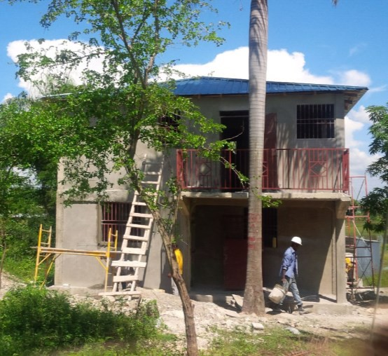
Administrative offices, LaHoye
We ask for your generosity, to support Haitian families.

Please make checks payable to:
Vincentian Family Haiti Initi- ative
c/o Congregation of the Mis- sion
500 East Chelten Avenue Philadelphia, PA 19144

Thank you for your kind sup- port.

Education Program in Haiti
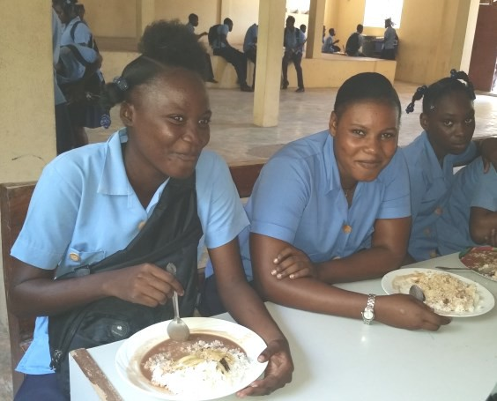Launched in October 2013, our education program tack- les hunger and education improvement. In collabora- tion with Mary’s Meals, an international anti-hunger movement, we feed 14 schools in the Central Plat- eau. Separately, we feed 3

Saint Anne school students, Thomazeau
Vincentian schools in Port- au-Prince. Daily we feed

4,200 students from Kindergarten to High-School.

Initial results of the feeding program indicate significant im- pact on enrollment and presence. Prior to the start of the feeding program, 30% of students would not com- plete the school day due to hunger. Currently, all stu- dents complete the day even though 59% come to school on an empty stomach and 47% do not have dinner at home.

Building on the current school relationship, we are assisting in a multilevel participatory school evaluation process. Each school community will create a common vision developing a School Improvement Plan defining objectives for 3-5 years. Our efforts will focus on monitoring the implementation. Ad- ditionally, Vincentian charism training will be implemented for Vincentian priest schools in Port-au-Prince.

CLM Cohorts Succeed in Central Plateau

The VFHI is proud to announce the graduation of our first Chemen Lavi Miyò (CLM) or Path- way to a Better Life cohort in February 2014. 290 out of
the original 300 members gradu- ated. This 18 month poverty alle- viation program is

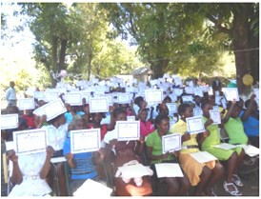
CLM graduates proudly show diplomas

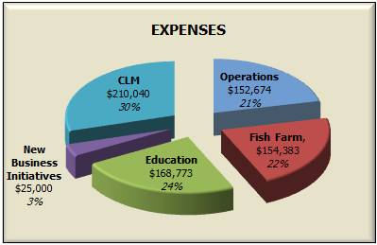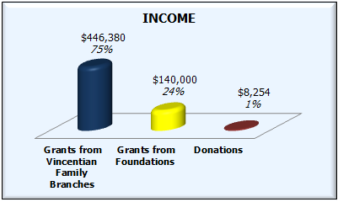directed by our partner Fonkoze, a microfinance institution with vast experience in rural Haiti. Nearly 3,000 women’s lives have been changed through this program.
Our Team: VFHI’s success is due to the collaborative efforts of an international Commission from the Vincentian Family, a Team of two project coordinators located in Haiti and two in the US,
and an advisory group of Haitian experts. VFHI also executes many of its projects in collaboration with Haiti–based successful like-minded institutions.
Mission Statement: Based on the Gospel Values of charity and justice, VFHI collaborates with partners in the creation of systemic change initiatives that build the capacity of Haitian people to meet their own needs and
claim their human rights.
Visit us: www.vfhi.org
2014 Financial Activity
Since I am unable to thank you fittingly, I pray that God Himself will be my thanks and your reward.
St. Vincent de Paul

Our second cohort of 140 members located in Gran Boukan reached its 9th of 18 months. Some of the achieve- ments so far include: construction of 75 houses, completion of all latrines and organization of a mobile medical clinic at a nearby public school. Early in the program, 321 goats, 125 pigs, 198 chickens and 24 turkeys were distributed to partici- pants, assets have already increased by 30%.

