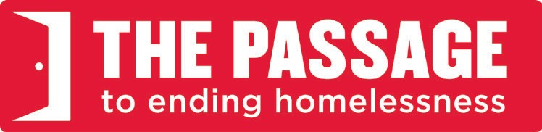

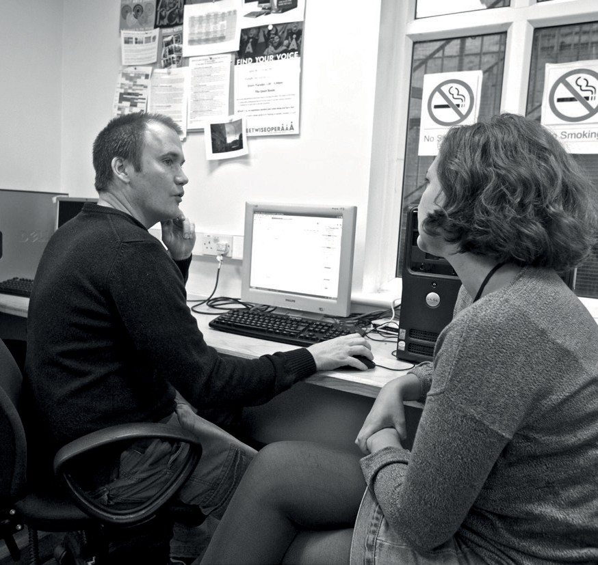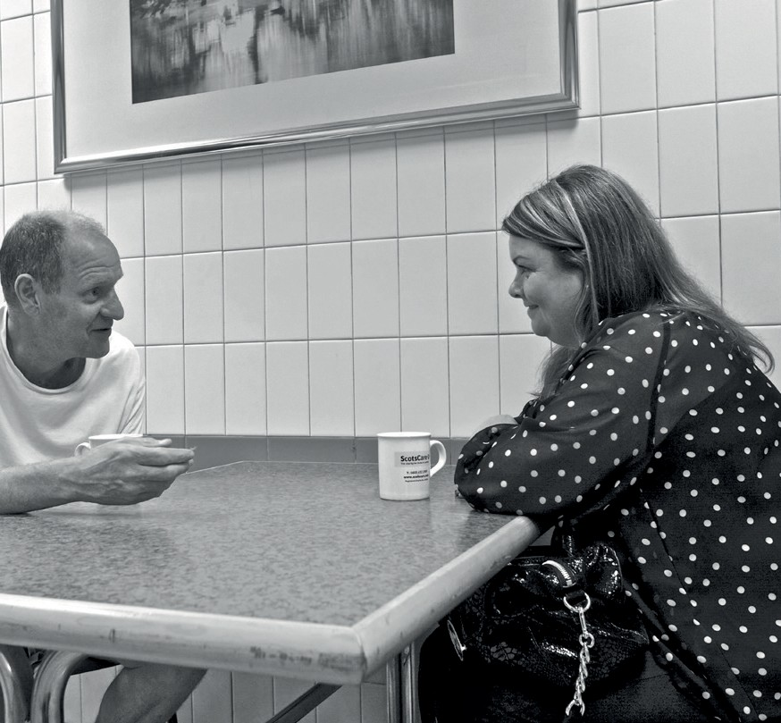Our mission
To provide resources which encourage, inspire and challenge homeless people to transform their lives.

Our ethos
The Passage takes its values and ethos from the teachings and example of St Vincent de Paul, a Christian and social reformer, who co-founded the Daughters of Charity in 1633. Vincent believed in action rather than words and in hands-on service to vulnerable people.

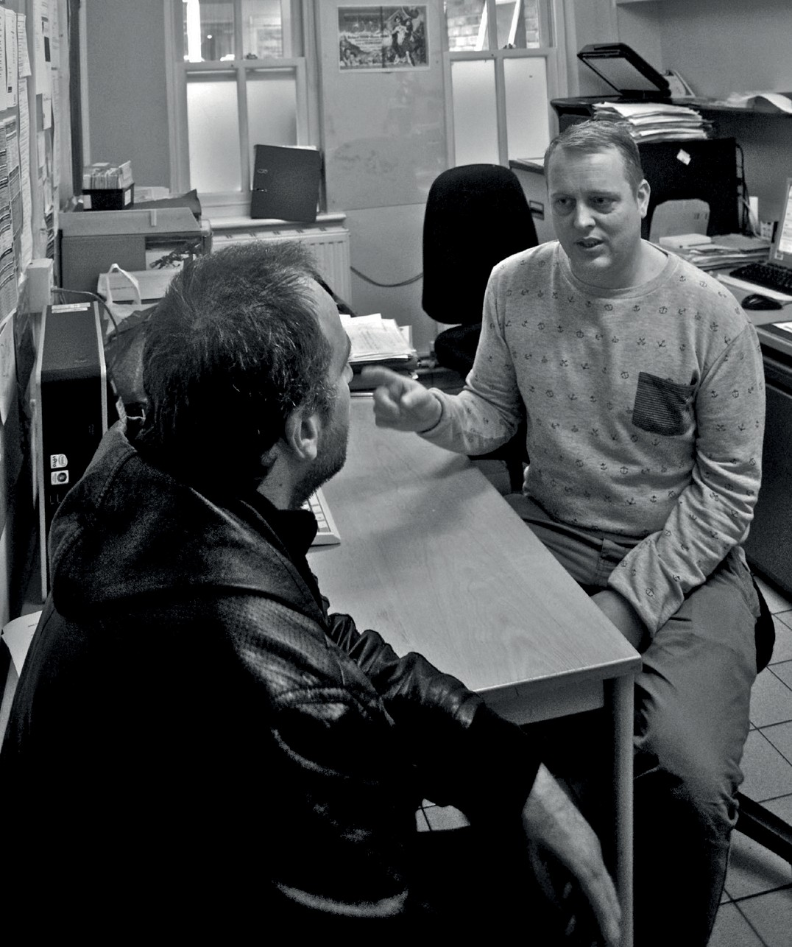As a Vincentian organisation, The Passage strives to be inclusive; encompassing a diverse and rich culture from within our members, clients, volunteers and staff.
Actively working with others across all aspects of society, seeking to have influence and be an advocate for homeless people, The Passage seeks to be a place of hope, aspiration, change and innovation, underpinned by values that reach back over 400 years.

This approach is reflected in our core values.

Our values
- We assist homeless people to realise their own potential to transform their lives

- We act with compassion and kindness
- We are a voice for change and justice
- We build relationships based on trust
- We respect each other

- We are straightforward in all our dealings

- We believe in practical hands-on hard work

- We collaborate across all sectors of society

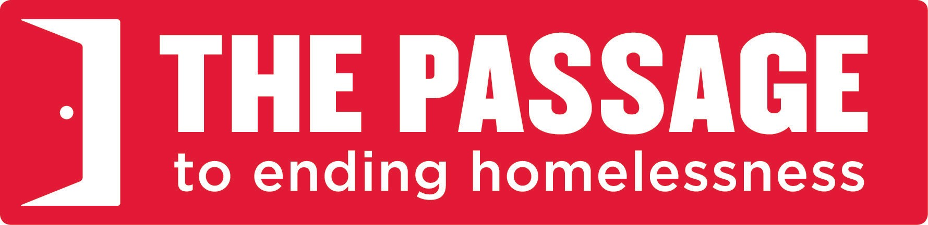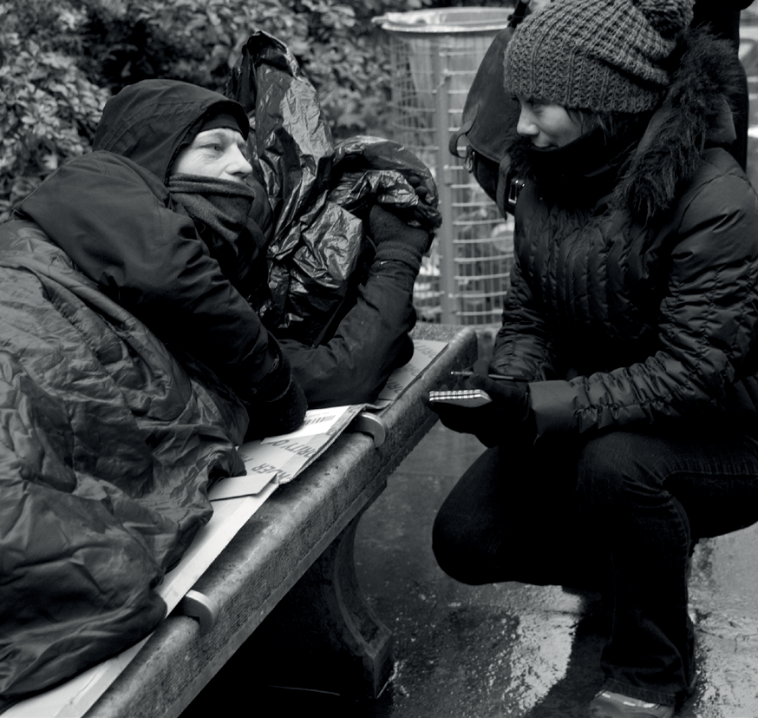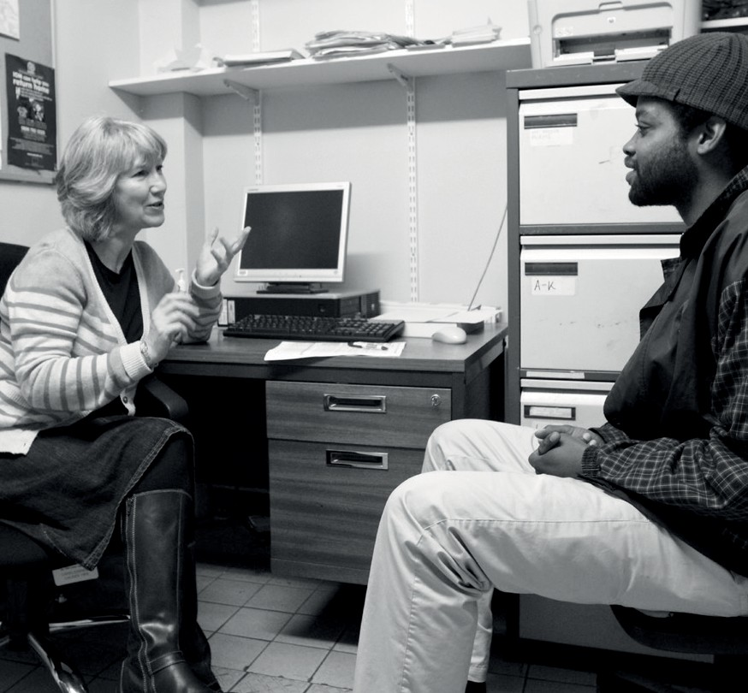Five-year strategy:
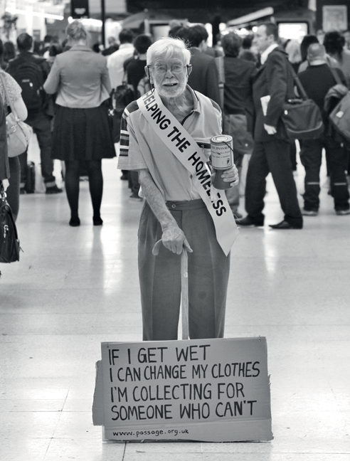2014–2019

Strategic objective 1
Prevent homelessness The Passage will develop its homelessness prevention services so that people in housing crisis do not end up on the streets, and so that former rough sleepers
do not return to them.

Strategic objective 2
Provide a safety net Prevention is always better than cure, but The Passage is determined to ensure that we always provide, and continue to develop, a safety net for people who find
themselves on the streets.

Strategic objective 3
Increase client ownership Clients are the most important people at The Passage. We will ensure that they have real power and influence across all areas of our management and governance.
Strategic objective 8 Inform and influence wider policy and services
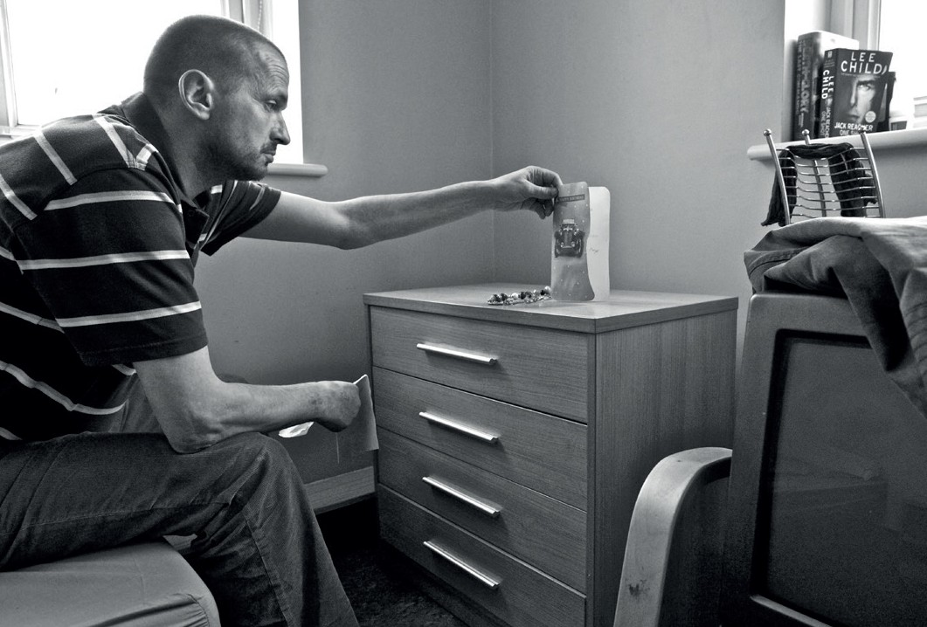The Passage believes in systemic change.
Based in the heart of London, we are often hit by tomorrow’s social exclusion today. We will use our unique position to capture trends and concerns,
and will disseminate this information to influence and bring about positive change for our clients.

Central goal

Refurbish St Vincent’s Centre to create state-of-the-art residential and day facilities for homeless people, and increase voluntary
income to enable us to evolve and develop our services.

The Passage will refurbish St Vincent’s Centre. We will create an inspiring, state-of-the-art Resource Centre, which is flexible and adaptable, to meet the ever changing needs of people who are at risk of homelessness, people who are already on the streets, those who are “hidden homeless”, and former rough sleepers, and develop our residential services for those in housing crisis. To enable us to
respond to these people’s needs – by evolving and developing our services – we will continue to diversify our fundraising income and
will increase voluntary income
by 50%.

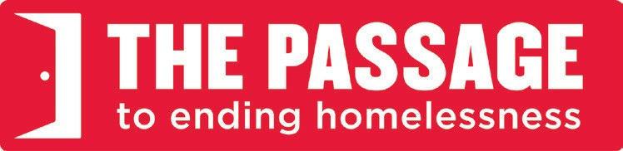Strategic objective 7

clients access to specialist, joined-up services that help them to transform their lives. We will continue to develop existing partnerships and seek to form new ones.

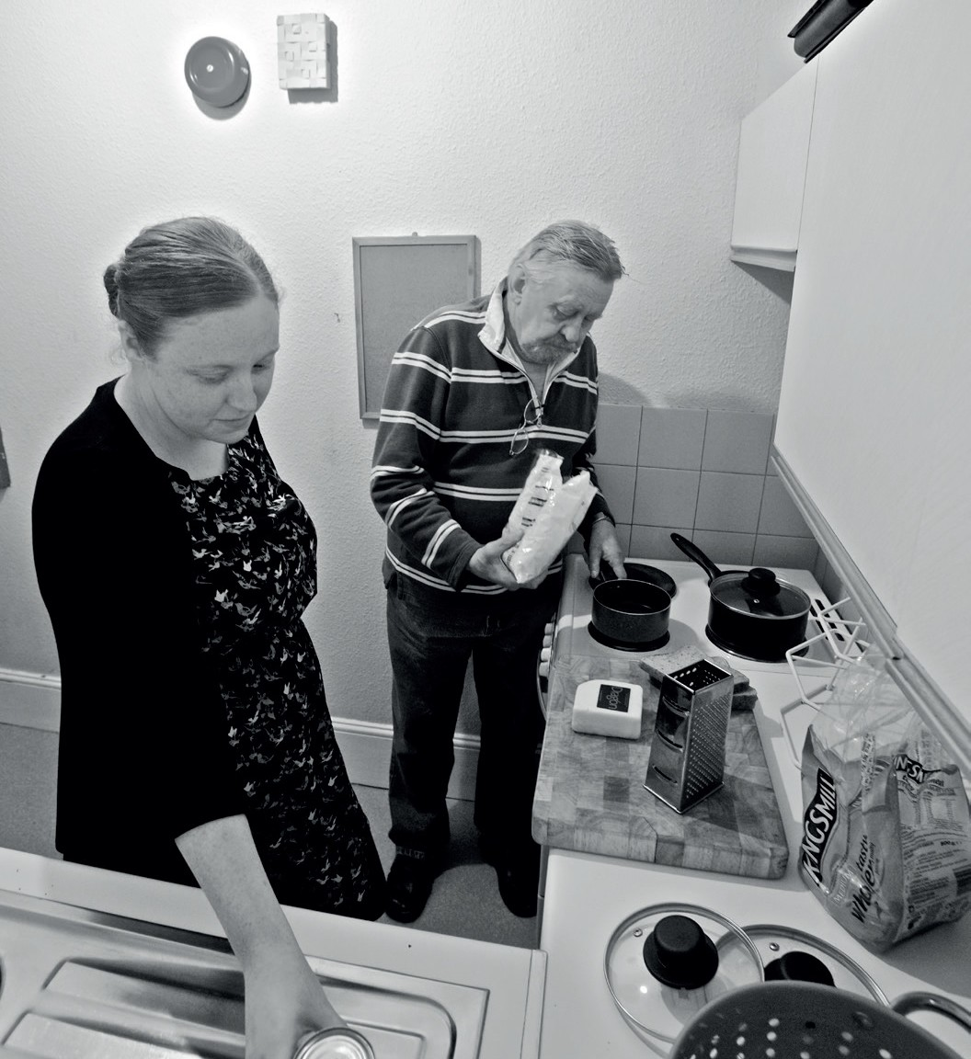

Strategic objective 6
Increase access to health services More than a third of our clients have a health need. Quick access to health

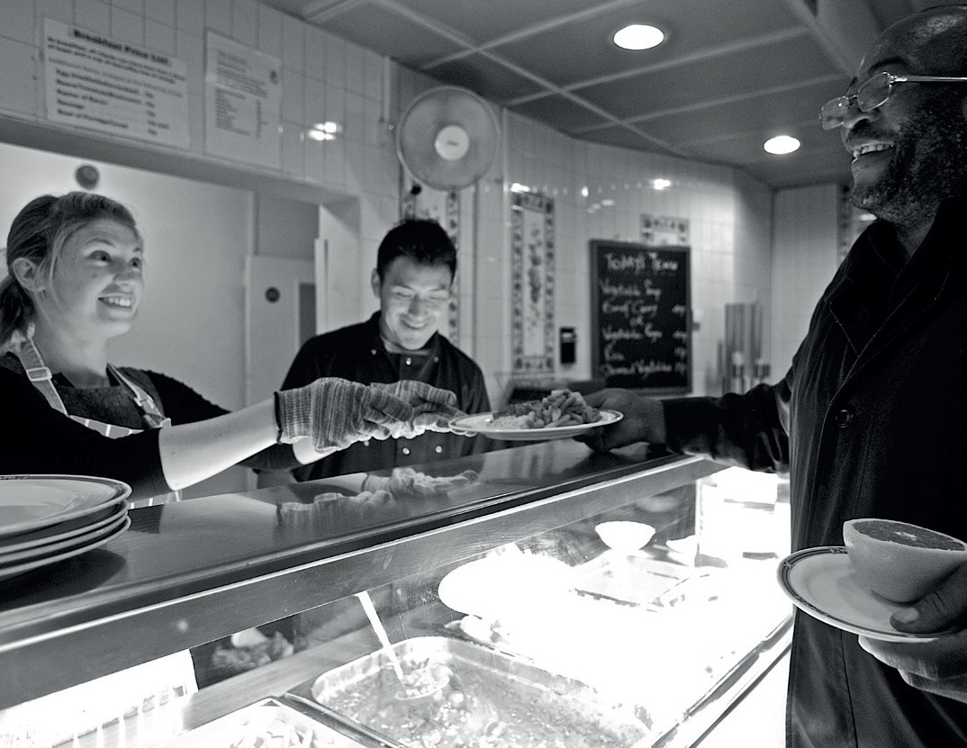Strategic objective 4

and volunteers to ensure that we provide high-quality services to clients and are

and volunteers progress.
Strategic objective 5
Create employment opportunities for all The Passage believes that employment is a meaningful route out of homelessness and back into society. We will build on our impressive record of helping clients into employment by rolling out new employment access routes.
them, but also has a major impact on the economy by preventing long-term health issues. The Passage will develop a
co-ordinated response to our clients’ health needs to help them access appropriate services.

