CONGREGAZIONE DELLA MISSIONE
CURIA GENERALIZIA, ROMA

Advent 2014: Prayer, Peace, and a Place for the Poor

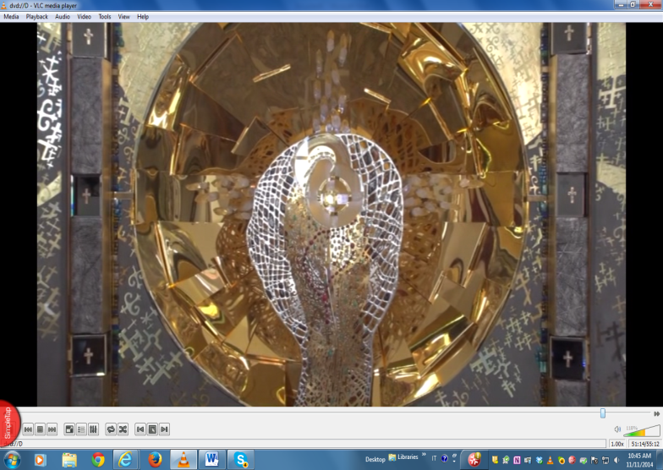
Main altar, Our Lady Queen of Peace Shrine, Kazakhstan

Rome, 30 November 2014 First Sunday of Advent

My brothers and sisters in Jesus and St. Vincent,

May the grace and peace of Our Lord Jesus Christ be forever in our hearts!

The season of Advent is upon us, a time ripe for reflection on the mysteries of our faith. The Scriptures, stories, and hymns of Advent call us to embrace prayer, to seek the peace of Christ, and to open our hearts and hands to serve God’s chosen and our “lords and masters”, the poor.

In this Advent letter, I will share with you three simple, but profound experiences I had in one day. They touched my heart and led me to reflect on a need for prayer, a search for peace, and a deeper commitment to serve the poor. This occurred while visiting a Marian shrine, meeting with contemplative Sisters, and sharing Mass and a meal with a group of recovering addicts.

On September 27, the Feast of St. Vincent de Paul, I arrived in Kazakhstan at the national shrine of Our Lady Queen of Peace, located in a small village. After traveling all night with a Polish confrere serving in the mission in Kazakhstan and Fr. Stan Zontak, we were warmly welcomed by the Archbishop, whose diocese is twice the size of Italy! This shrine is home to the “Star of Kazakhstan,” an altar dedicated to peace, one of twelve worldwide. Why an altar for peace in this far away place? Behind the shrine is a mountain with a cross marking the center of Euro-Asia. The “Star of Kazakhstan” contains precious regional stones and metals. It centers on Mary, in whose heart is the Eucharist to show that Jesus was born from her heart of love.

Following this moving experience, the Archbishop led us to a monastery in the village, where I met four contemplative Carmelite Sisters. We had a wonderful conversation! They spoke of their life with simplicity, grateful for the support of the Archbishop and the people in the village. They were joyous women, and told how prayer is the heart of their life. It moved me deeply.

The last part of the day’s journey was a visit to a shelter for people recovering from addiction to drugs and alcohol. Managed by a woman deeply committed to our Vincentian charism, she said it is her Christian duty to provide an outreach to the poor, especially addicts. The program is a basic one in a clean, warm environment, much needed in Kazakhstan. When the Archbishop arrived, he celebrated the Eucharist, after which we shared a meal and talked, - all twelve of us!

After the meal, the Archbishop asked me to say a few words to the group. My remarks formed the basis of my message for this Advent letter. Later, I reflected on what a wonderful experience it was for the feast of St. Vincent. With the significance of the day and people I met, I believe the Lord was pointing me to reflect on three key goals in my life and for the Vincentian Family. Advent 2014 is a call to engage in prayer, to seek peace, and to joyfully serve God’s poor.

A Time for PRAYER:
After visiting in the monastery with the Carmelites, I reflected on the need for prayer in my own life. Our charism invites us to pray as contemplatives in action, to step out of the busy world of work and other distractions, and focus on the presence of Jesus in Word and Eucharist. In my dialogue with these Sisters, I was so impressed with their simple, joyful witness in sharing their faith. As active contemplatives, we must also come aside to rest and reflect with the Lord.
As St. Vincent told his first companions: “The apostolic life does not exclude contemplation, but encompasses it and profits by it to know better the eternal truths it must proclaim.” (CCD, Vol. 3, Letter 1054) This Advent let us find some time in our busy lives to pray before the Lord. Whether priests, brother, sisters, or laity, all Vincentian Family members know the need for prayer, as it is the motivating force for what we do. It is a distinct mark of our service, grounding us in the love of God. It helps us see the Divine presence in God’s poor.
A Time of PEACE:

At the altar of the Star of Kazakhstan, I reflected on the current state of the world, with its lack of peace on earth. Whether it is Iraq, Syria, Nigeria, and many other places, we see constant acts of violence, terrorism, border and tribal disputes, threatening the peace we seek. Today, there is an urgent need for people to learn how live in peace. After visiting this shrine, I realized the quest for peace begins with me.
I thought of St. Vincent as an example of one who sought peace and shared it with others. He told St. Louise, “The kingdom of God is peace in the Holy Spirit. He will reign in you if your heart is at peace. So, be at peace, Mademoiselle, and you will honor in a sovereign way the God of peace and love.” (CCD Vol. 1 Letter 71) Vincent lived in an era where violence, wars, and skirmishes plagued France. As it happens, the poor often suffered the most from these conflicts.
Yet, St. Vincent was a peacemaker who did so by defending the poor. He made Church and Crown aware of what these conflicts did to “our lords and masters, the poor.” We, as the Vincentian Family must be champions and instruments of God’s peace. This Advent, let us seek peace within to be one with the Prince of Peace of whom the prophet Micah said, “He shall take his place as shepherd by the strength of the LORD… he shall be peace. (Mi. 5:4-5)

Joyful Service to the POOR:

After an intense experience of prayer in the shrine, and profound peace with the Sisters in the monastery, I had the good fortune to share in Mass and a meal at the shelter. I felt Our Lord present in two significant ways: at the altar and at the dinner table. As I moved from being with the Eucharistic body of Christ in the shelter chapel to the small dining room, I saw the embattled, but unbroken Body of Christ in these recovering addicts. In praying with them and sharing a meal, I was given the grace to see that we are all part of the mystical Body of Christ.

Jesus was born into poverty and lived in humble surroundings. This reality- the poverty of Our Lord in his earthly life – is not a sentimental Christmas story, but salvation history. God is revealed in the anawim, a Hebrew word literally means “the poor who depend on the Lord for deliverance.” In Matthew’s Gospel, Jesus’ first major teaching is the Beatitudes to remind us that both Jesus and the Father identify with the least among us. At the end of each liturgical year, we hear Matthew’s Parable of the Last Judgment as our challenge: “I say to you, whatever you did for one of these least brothers or sisters of mine, you did for me.” (Mt.25:40)

St. Vincent reminded us of the intrinsic link between our salvation and that of caring for the poor: “We cannot better assure our eternal happiness than by living and dying in the service of the poor, in the arms of Providence, and with genuine renouncement of ourselves in order to follow Jesus Christ.”(CCD Vol. 3 Letter 1078) Let this Advent be one in which, having prayed and sought the Lord’s peace, we go forth in renewed service to God’s poor.

Advent as a time for CONVERSION OF HEART

Since my return from Kazakhstan, I have been fortunate to visit provinces, missions, and branches of the Vincentian Family in Europe, the Caribbean, and Africa. But that celebration of St. Vincent’s feast day has remained with me. I felt the Lord calling me as Superior General to reflect on how to better integrate prayer, peace, and service to the poor in my own life. I gained insight into times when I had failed to be a man of peace, prayerfulness, or service to the poor. I asked the Lord for the grace of forgiveness. I gave voice to this at the shelter, and I willingly share it with you as we embark on this Advent together.

On the first Sunday of Advent, the prophet Isaiah tells the truth of our human condition: “O Lord, we are the clay and you are the potter: we are all the work of your hands.” (Isa. 64:7) Advent is the time to again entrust ourselves to the merciful love of God by entering into the scriptural stories of our salvation. Through the lives of people such as Mary, Joseph, John the Baptist, Zechariah, and Elizabeth, we experience the saving power of God, the shepherd of our souls. Their stories of salvation are bound up with our life stories.

A good Advent will help us see that God wants to open our minds and hearts to “prepare the way of the Lord.” (Mk. 1:3) The Second Advent preface before the Eucharistic prayer beautifully expresses the true meaning of this holy season: “It is by his gift that already we rejoice at the mystery of his Nativity, so that he may find us watchful in prayer and exultant in his praise.”

A month after the trip to Kazakhstan, I read the address of Pope Francis at the conclusion of the October Synod of Bishops. I share with you what I consider a truly ‘Vincentian excerpt’ that will guide us in Advent to become more prayerful, peaceful, and joyful in the service of the poor.

“And this is the Church, the Lord’s vineyard… not afraid to roll up her sleeves to pour oil on people’s wounds; who doesn’t see humanity as a glass house to judge or categorize people. This is the Church…composed of sinners, needful of God’s mercy. This is the Church, true bride of Christ… not afraid to eat and drink with prostitutes and publicans. The Church with the doors wide open to receive the needy, the penitent, not only the just or those who believe they are perfect! This is the Church…not ashamed of the fallen but on the contrary feels involved and obliged to lift him up and to encourage him to take up the journey and to accompany him…” Pope Francis, 18 October 2014 (Excerpt from his Address, Conclusion of the Third Extraordinary General Assembly of the Synod of Bishops)

May Jesus, evangelizer of the poor, strengthen you, and may St. Vincent inspire and guide you in Advent and for the coming year.

Your brother in St. Vincent,

G. Gregory Gay, C.M. Superior General

