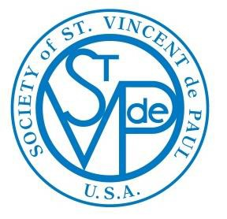OUT OF POVERTY…

Society of St. Vincent de Paul Western Region
INFORMATION FROM VOICE OF THE POOR
Year 4, No. 6 NOVEMBER 2014

FOR OUR WEBSITE CLICK ON: WWW.WRVOP.ORG

Then, find the information you need by clicking on the Tabs on the left rail

it!
VOICE OF THE POOR

Voice of the Poor does not take positions for or against a political party or individual candidates.
However, Voice of the Poor is interested in working with those elected officials of either party, who support initiatives that will benefit people in poverty, children, elderly, immigrants (documented or not), and all of those that SVdP serves.

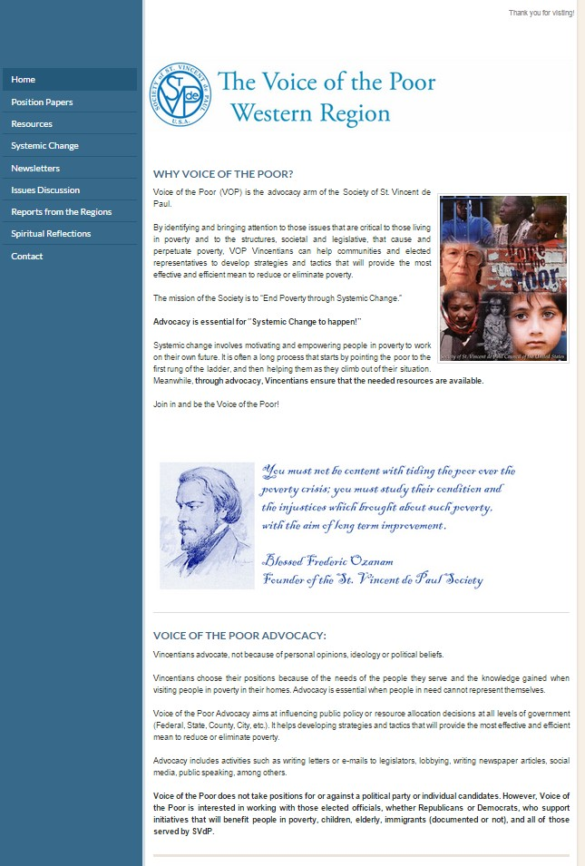You are receiving OUT OF POVERTY… because you expressed interest in the Society of St. Vincent de Paul’s Voice of the Poor.
If you no longer wish to receive OUT OF POVERTY… please send an e-mail to voiceofthepoorwr@cox.net with "Delete" in the message.
If you do not receive OUT OF POVERTY… and you would like to be in the distribution list for future newsletters, please send a request to voiceofthepoorwr@cox.net

NOVEMBER 2014
Dear Western Region Vincentians:
As in all Vincentians meetings, our newsletter always starts with a prayer and a spiritual reflection. The prayer is the “Voice of the Poor Prayer” as always and the reflection, this month, is on the Beatitudes, with quotes from Pope Francis.
Further down, the November issue of OUT OF POVERTY… discusses the way the Society and Voice of the Poor are involved in public life, with articles on “Vincentian Collaborations (on page 5) and on CapWiz, the “Vincentian Megaphone for Social Justice” on page 13. Comments on the recent elections were the subject of two articles on pages 7 and 8 by David Barringer and Giulio Grecchi, respectively.
“A Pilgrim’s Progress: The Legacy of Thanksgiving” is a beautiful article by Roxane Ramos, included here with permission of the Kino Border Initiative, which links todays’ migrants to the pilgrims of four centuries ago, bringing perspective to migration. The following article, on Page 12, is an update on current Immigration issues, the concerns of the US Bishops and potential remedies.
On Page 15, “Just Wage for the Employees of the Society of St. Vincent de Paul” refers to the Society’s position paper approved in September at the Atlanta National Assembly, on our role as a faith based organization to deal justly and morally with the employees of the Society.
The newsletter includes several announcements on coming events, with links to obtain additional information:
- 2014 BiNational Posada Nogales, Agua Prieta, Yuma (Page 24)
- The 2015 National Migration Week – January 4-10 (Page 13)
- The 2015 Catholic Social Ministry Gathering – February 7-10 (Page 16)
- The Social Action Summer Institute – July 19-23 (Page 16)
Page 1 above, has the link to the Western Region Voice of the Poor website www.wrvop.org. You are welcome to visit the website and find useful information on the involvement of the Society in public life.
The “News from the Western Region”, includes updates from Phoenix, Tucson, Patterson, Sacramento, San Diego, Boise, Portland, Salem, North Sound and Seattle.
Giulio Grecchi
Tucson Diocesan Council
Voice of the Poor - Western Region Representative

CONTENT
INTRODUCTION AND CONTENT Page 2 VOICE OF THE POOR PRAYER Page 3 THE BEATITUDES Page 3

ISSUE DISCUSSION VINCENTIAN COLLABORATION Page 5 THE NOVEMBER ELECTIONS:
- FROM YOUR SERVANT LEADER Page 7 -
- DISCONCERTING TRENDS Page 8 A PILGRIM’S PROGRESS:
THE LEGACY OF THANKSGIVING Page 10 UPDATE ON IMMIGRATION Page 12 2015 NATIONAL MIGRATION WEEK Page 13 VINCENTIAN MEGAPHONE
FOR SOCIAL JUSTICE Page 13 JUST WAGE FOR THE EMPLOYEES
OF THE SOCIETY Page 15 CSMG & SASI ANNOUNCEMENTS Page 16

FROM THE WESTERN REGION
ARIZONA Page 17
CALIFORNIA Page 18
IDAHO Page 20
OREGON Page 21
WASHINGTON Page 22
2014 BINATIONAL POSADA
NOGALES, AGUA PRIETA, YUMA Page 24

VOICE OF THE POOR PRAYER (by Ruth Zemek)
Lord of all people,
During your time on earth you identified with the poor and instructed us to care for one another, for our neighbor and especially for the least of our brothers and sisters.
Be with us as we advocate for the poor.
Help us to persevere in joy and love on their behalf.
Add your voice to ours as we speak out for those who are not heard in our communities.
Guide us as we work, comfortable in the knowledge that we are doing your will for this day, and time, and place, and that you will take care of tomorrow.
We ask this in the name of Jesus, his Blessed Mother, our patron St. Vincent and our founder Blessed Frederic.

THE BEATITUDES

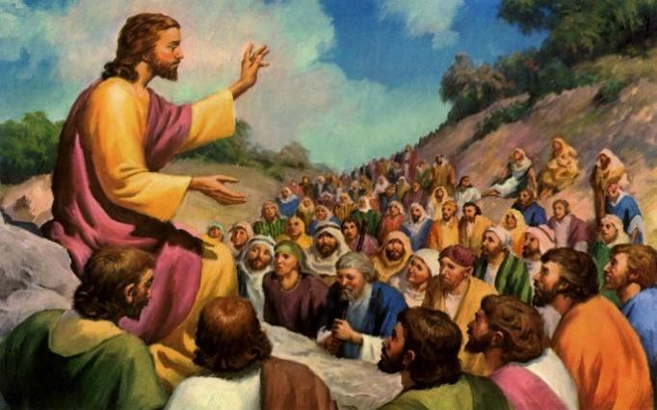On November 1, the Solemnity of All Saints, the Gospel reading (MT 5:1-12) was The Sermon on the Mount, the Gospel that contains the Beatitudes, a roadmap for those who strive to sanctity.

Picture from http://www.viedellospirito.it/

THE SERMON ON THE MOUNT

1 When he saw the crowds, he went up the mountain, and after he had sat down, his disciples came to him.
2 He began to teach them, saying:
3 “Blessed are the poor in spirit, for theirs is the kingdom of heaven.
4 Blessed are they who mourn, for they will be comforted.
5 Blessed are the meek, for they will inherit the land.
6 Blessed are they who hunger and thirst for righteousness, for they will be satisfied.
7 Blessed are the merciful, for they will be shown mercy. 8 Blessed are the clean of heart, for they will see God.
9 Blessed are the peacemakers, for they will be called children of God.
  - Blessed are they who are persecuted for the sake of righteousness, for theirs is the kingdom of heaven.

  - Blessed are you when they insult you, persecute you, and utter every kind of evil against you [falsely] because of me.
  - Rejoice and be glad, for your reward will be great in heaven. Thus, they persecuted the prophets who were before you.

Christians should memorize not only the Ten Commandments but also the beatitudes, which Jesus taught as the path to true happiness, Pope Francis said, at his weekly general audience Aug. 6.
He read each one and asked the crowd repeat it. One repetition of the beatitudes is not enough to "remember them and impress them on our hearts," the pope said, so he gave the crowd "homework," asking them to spend time in the coming days reading the text again, from the Bible "you always should have with you."
The beatitudes are not only "the path God indicates as his response to the desire for happiness present in each person and the perfection of the (Ten) Commandments," he said; they also are "a portrait of Jesus and his way of life" and "the protocol according to which we will be judged."
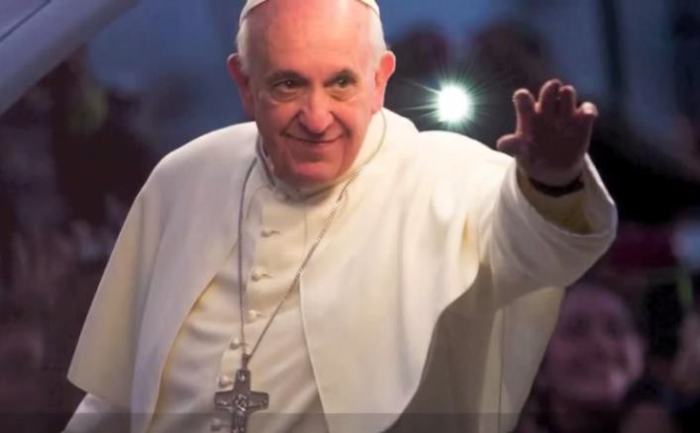"At the end of the world, we will be judged," he said. "And what will the questions be that the judge will ask?" They are listed in Matthew 25: 35-36: Did you feed the hungry, give drink to the thirsty, welcome the stranger, clothe the naked, care for the sick and visit the prisoner?
"Today, your task is to read the fifth chapter of Matthew where the beatitudes are, and also to read the 25th chapter where the questions are that we will be asked on judgment day," he said.
No one, he said, is so important or has done so many virtuous things that he will not be asked the questions in Matthew 25. "The Lord will recognize us if we have recognized his face in the face of the hungry, the poor, the marginalized, the sick and the lonely. These are fundamental criteria for verifying our Christian life."
"I read the beatitudes and think about how my life as a Christian should be," the pope said, "and then, I make an examination of conscience with this 25th chapter from Matthew. Every day I ask, “Did I do this? Did I do that? That?" It is a simple thing to do, he said, and helps people look at the concrete actions in their lives.
Living according to the beatitudes and the criteria listed in Matthew 25, he said, should fill each Christian with joy because together "they make our Christian life a beautiful and credible witness to the love of God for all the brothers and sisters we meet each day."

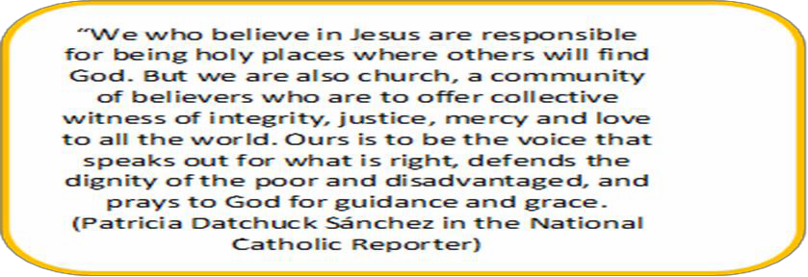

VINCENTIAN COLLABORATION
By Jack Murphy, Atlanta, National Voice of the Poor Chair

If you've been to a business meeting over that last 20 years, you’ve heard the term synergy. While it has almost become cliché, it means that a team produces more than the sum of its parts. Together, we can do more than we can individually.
That concept has great meaning for The Society, as we enter a new phase to truly push the poverty needle in our communities.
I don't mean that we should simply serve more people. If we truly collaborate with the end in mind to eliminate poverty in our communities, we will accomplish much more than we could ever have dreamed possible.
When I was in high school in North Carolina, I wanted to start a CYO (Catholic Youth Organization) group in my parish. I had a lot of relatives from the northeast and they talked about retreats, service projects, movies and it sounded like great fun. So, I put notice after notice in our parish bulletin. Even though my pastor endorsed starting a youth group, I couldn’t get enough participation to field a bowling team.
I mentioned my frustration it to a Quaker neighbor who said that she had the same trouble organizing youth in her congregation. We found another friend who invited us to his small Methodist youth group and we formed the first Ecumenical Youth Organization. Eventually, we had enough participation from our own congregations to break into faith groups. But we continued to meet periodically and did several service projects together.
Each of us in that situation were just looking for a chance to socialize. We didn’t set out to become more aware of, and sensitive to, each other’s faith traditions. And we certainly did not plan to be an ecumenical example to our community. But that’s what we did. We didn’t all get exactly what we wanted at the beginning. In the end, we got much more than we anticipated.
As our St. Vincent de Paul Society evolves to incorporate principles of systemic change into our work, the concept of collaboration becomes more important than ever before.
This is certainly not a new concept for Vincentians. St. Vincent was a master collaborator, as Robert P. Maloney, CM, 23rd Superior General of the Congregation of the Mission (1992 to 2004), reminds us. Just our simple tradition of visiting the poor in pairs is a nod to the power that collaboration can bring to a challenging situation.
When Vincent saw the depth of the problems of his time, he enlisted the help of St. Louise de Marillac. Together, they founded religious orders so that communities could work together to support and teach each other while continuing to advocate and serve.
According to Fr. Maloney, Vincent brought people together to find a solution to the challenges poverty causes in a community. And, as in most collaborations, Vincent wasn’t wedded to one solution. He was driven by service and was open to any group that shared his mission
"St. Vincent brought together as many people as he could, rich and poor, humble and powerful, and used every means to inspire in them sensitivity to the poor, who are the privileged image of Christ." (Constitutions of the Congregation of the Missions, Introduction, p.19)
Collaboration is working together with others to achieve a common goal. When looking at the materials forming the basis of our Systemic Change curriculum, Bridges out of Poverty, collaboration in a community setting is the intentional creation of a continuum or wraparound services between agencies.

Voice of the Poor has always used a collaborative approach to advocacy. We learned early on that, while Vincentians have a great depth of experience in direct contact with those in need, we don’t have a great deal of experience or strength in the public legislative world. Therefore, throughout the US, you will see examples of Voice of the Poor Vincentians working with Catholic Charities, the Catholic Campaign for Human Development, the US Conference of Catholic Bishops, and other like-minded groups to pool our resources to speak on behalf of those we serve.
There certainly are many other groups with much more experience in the public arena. However, other advocates always welcome our contributions because of the unique approach we take to our service, visiting those in need in their homes. That makes for some powerful advocacy.
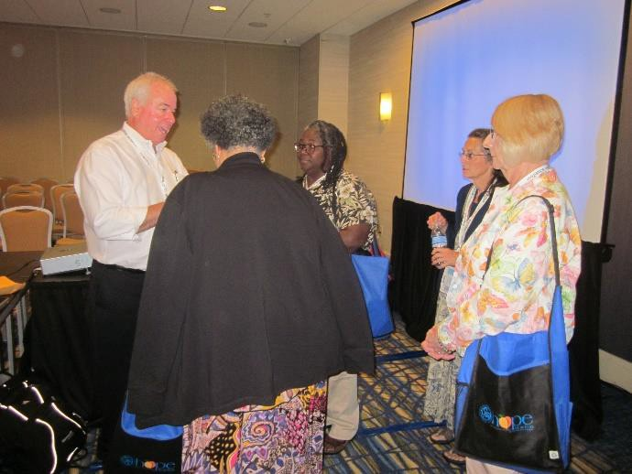Many of us are already collaborating in our conferences. We may partner with other community or faith based organizations to pay a bill for one family, or we may partner on food drives.
Jack Murphy, Voice of the Poor National Chair, making a point on Advocacy at the Atlanta National Assembly
However, if we are to really make a difference in our communities, we have to expand our work from one-to-one direct service to one- to- many through education, advocacy, and collaboration with our parishes, with other conferences and with our communities.
How do we take our collaboration to the next level? Start with a neighboring conference. Look for ways to work together to mitigate the contributors to need in your area. Maybe, it's transportations to jobs. Maybe, it's a lack of affordable healthy food in your area. Or, perhaps its fostering collaboration among those we see on home visits, to teach them how to work together to get a landlord to improve energy efficiency or some other housing condition.
Or, go to others in your parish to enlist their help in dealing with need. You could look to JustFaith groups, social justice ministries,
or others with a concern for people in need. Your role can be to use the facts you gather on home visits to find root causes problems, problems that are common among many or most people. The question to ask is "if we were to get people on a road to self-sufficiency, if we were to help them get out of need, what would we do?"
A few guidelines for collaboration: (1) Only the Board can speak publicly on behalf of The Society. (2) We can't lend our name to any effort that might ever support any policy or initiative counter to Church teaching.
(3) We use the national position papers (http://www.svdpusa.org/members/Programs- Tools/Programs/Voice-of-the-Poor/Position-Papers ) as a guide to the type of issues we tackle.
Here is a final thought from Fr. Maloney:

“I want to express publicly how happy I am at the renewed impetus toward collaboration that is growing within our Vincentian Family. The needs of the poor are enormous. The Lord calls us to respond to them together. St. Vincent was deeply conscious of the communal dimension of gospel service. He knew that by channeling our energies and growing in unity we can be a more effective instrument in meeting the concrete needs of the poor.
"To this end," he wrote to Hugues Perraud on October 15, 1651, "we should help and support one another and strive for peace and union among ourselves. This is the wine that cheers and strengthens travelers along this narrow path of Jesus Christ. I recommend this to you with all the tenderness of my heart" (SV IV, 262).
(Betty Ann McNeil, Monograph 1: The Vincentian Family Tree, published by the Vincentian Studies Institute 2009)

THE NOVEMBER ELECTIONS
From Your Servant Leader
By David Barringer, Chief Executive Officer (CEO), SVdP National Council
(With permission from Dave Barringer - First published by SVDP Frederic's E-Gazette Nov-6-2014)

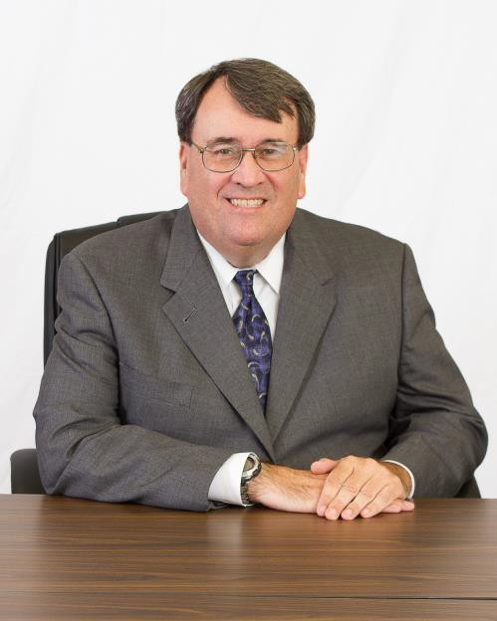Regardless of one's political affiliations, we must admit that this was a very interesting election week! As I write this, there are still several contests around the country that are too close to call. One thing we do know for certain is the shift in power in the U.S. Senate to the Republicans, aligning with an even more Republican House of Representatives.
What does this mean for our Society, and for our friends in poverty? The short answer is that we simply don't know. We can, however, make a few assumptions:
- This will be a Congress of much more action. With the same party now in control of both houses, the gridlock caused by partisan bickering will slow down if not cease. We expect the Senate to be more deliberative as the Republicans hold a small majority, too small for veto overrides. But bills that have stacked up, in the House can now be re-introduced and have a better chance to be on the President's desk.
- The economy will be front and center. This is a wide area of potential smaller topics but candidates from both parties, incumbent and new, ran on getting the economy
back on track in one way or another. This includes tax policy, the federal budget, wage policy, welfare reform, unemployment and immigration. Unfortunately, it can be difficult to look at one issue in isolation, so the risk is there that the work on one area may delay others from completion. But, we will see lots of trial balloon ideas and competing bills vying for attention. The Society's real-world experience with people in poverty can be valuable to lawmakers in evaluating economic policy solutions.
- The race for 2016 begins, as does the last two years of a Presidency. As candidates jockey for attention, the rhetoric grows. Meanwhile, a lame duck President has a short time left to complete agendas and cement a legacy. The Society as a nonprofit cannot endorse candidates but can endorse ideas and values. There may be ample room for the Society at the table for both parties, especially as poverty solutions are introduced and debated. Both parties could hate us or love us, but we need to stay true to our values and seek only the love of Christ as we advocate for our friends in need.
- Politics, and policy, are always local. I believe that the story of this election cycle is the confirmation that being in touch with one's local constituents helped win elections. "Inside the Beltway" politics was firmly rejected by voters who felt they were not heard. Some national figures salvaged relationships through multiple local appearances in the final weeks of their campaigns, while for others the perceived distance in both miles and beliefs from local voters could not be overcome. What this means for the Society is that our Voice of the Poor efforts at the local level may, at least for now, have a receptive audience. Our national presence across 400 dioceses and many election districts gives us the opportunity for many legislator "touches" in the course of policy discussions. Capitol Hill visits are nice, but home district visits often make the difference in vote influence, perceived less as special interest interventions and more as expressions of local constituent values.
A critical aspect of true systemic change is to advocate for policies that improve the opportunities for people in poverty to rise to self-sufficiency. Congress can't do it all but it is a great place to look for improvement. Many in Congress see the next two years as opportunities for sweeping changes. We, as Catholics and as the Society, can simply ride the tide of these changes or we can help to steer the ship with our visits, letters and phone calls to those we have elected. Buckle up for a wild ride ahead!

Disconcerting Trends
By Giulio Grecchi, Tucson, Voice of the Poor, Western Region Representative

Did our work change after the elections? The issues of the people we serve are still the same: generational poverty, job loss, minimum wage, homelessness, lack of documented status, etc. Inspired by the teaching of the Church, our advocacy will persevere, trying to remove the obstacles that keep people in poverty. Their needs seem only to grow larger as time passes.
Taking sides before or after the elections is not our business, as not for profit organization, but we are not happy about some trends that we have observed during this election cycle - trends, which are quite disconcerting.

There was a very limited voter turnout.
The turnout is always lower in the mid-term elections versus the presidential elections, but this time the decrease was huge, even when compared with the turnout of the 2010 mid-term.
Check the chart below with the participation of voter eligible population in the ten states of the Western region. The turnout went from a high of 48% in Montana to a low of 28.8 in Utah.
Among those that have not voted were most of the people we serve, many Hispanics and members of other minorities. Why? Some are using all their energies just in the struggle to survive another day, some do not have transportation to go to the polls, some cannot afford to miss part of their pay when taking time off for voting, and some simply feel so disenfranchised by the process, as not to care. In all cases, they missed the opportunity to make their voices heard.
Many Hispanics are disappointed by the years of delays in implementing a reasonable immigration reform. Many stayed home upset that the President postponed the promised Executive Action, until after the elections. They viewed the move as a betrayal, but by not voting they have shot themselves in the foot, missing the chance to send to Washington candidates more favorable to their plea.
TURNOUT PERCENTAGE FOR VOTER ELIGIBLE POPULATION
State | Mid term 2010 | Mid term 2014
Alaska | 51.90 | 42.70
Arizona | 41.50 | 34.80
California | 45.80 | 34.80
Hawaii | 39.90 | 34.90
Idaho | 42.90 | 37.40
Montana | 48.40 | 48.00
Oregon | 53.80 | 38.60
Utah | 36.80 | 28.80
Washington | 54.30 | 38.60
US Average | 40.90 | 36.60
Data from US News & World Report, except for AK and HI

When two thirds of the potential electorate does not participate, our democratic system is at risk.
A number of SVdP Councils helped the participation of the people we serve through voter registration efforts or by facilitating their participation in other ways. This is something that more of us can do. Let us remember to do it for the 2016 elections.

There were massive amounts spent to promote specific candidates
The second disconcerting trend is the unprecedented amount of money spent to promote specific candidates, in large part big money, corporate money and secret dark money, for a total of $3.76

Billion nationwide. About a fourth of that money came from outside groups (secret dark money). They funneled it primarily to competitive districts to influence the electorate by spreading lies about the opponent of the candidates these groups support. If you live in one of these districts, you have likely received 35/40 pieces of mail in the last month with this type of message.
“Dark money” is now the way for undisclosed interest to “buy” a candidate and to make him / her feel obligated to push their agenda in Congress. The results of this practice are very clear:
- These candidates no longer feel accountable towards their electorate
- Do not feel any need to explain what they stand for (they simply repeat as a broken record how terrible their opponents are) and
- Refuse to participate in public debates or accountability sessions organized by their electors. If you live in a competitive district, you have seen this happening.

In an election, money equals power and money drowns out the power and the voice of ordinary citizens, especially those we serve. This is a threat to our democratic system even more than the low voters’ turnout.
Sixteen states have already passed resolutions either by the legislature or by ballot initiatives asking Congress to overturn the “Citizens United” decision. Several other states have enacted strict spending limits or disclosure rules for “Dark Money”. More states are considering following.

Overturning the Supreme Court decision on “Citizens United” seems to be a key initiative that the majority of Americans expect from the new Legislature.

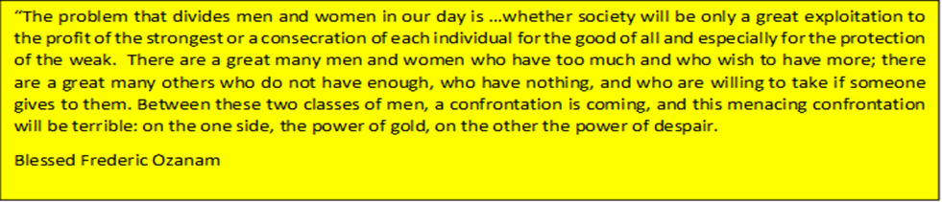

When God created humankind, He instilled in each of us a divine spark that would make us grow, develop in maturity and wisdom, and become great in His eyes. He entrusted us to each other: the days of strength of one person to compensate for the days of fragility of the other. That was the plan, but not everyone liked it. Men started to erect barriers, started to grab what the weak could not defend. Whether it is Russia grabbing Ukraine, or a dictator being deaf to the plea of his subjects, or the US rejecting the desperate people knocking at the border, or an employer not paying a fair wage – that is not God’s plan. Either we strive to be part of the solution, or we become part of the problem. It is not just about hurting other people, simply being indifferent or being neutral is being part of the problem, because in our own heart we have rejected God’s plan. In His plan, He has a place for everyone; He has sustenance for everyone and a dream for everyone, if just we do not get in His way.

A Pilgrim’s Progress: The Legacy Of Thanksgiving
By: Roxane Ramos

The pilgrims and Native Americans who celebrated the first Thanksgiving have a lot in common with the migrants of today.

There are many misconceptions about the origins of the U.S. celebration of Thanksgiving. For one thing, the now- legendary feast on Plymouth Plantation in 1621 was not a celebration of thanksgiving, but an acknowledgement of a successful harvest. Nor was it a “first”—it was common to set aside a time of thanks well before this Plymouth event, though fasting more than feasting was the order of the day. There were no shoe buckles, no table or utensils, and no turkey. And the notion that the settlers extended a formal invitation to the Wampanoag residing nearby (who were more likely attracted by the revelry and inspired to contribute five deer to the party) is pure invention.

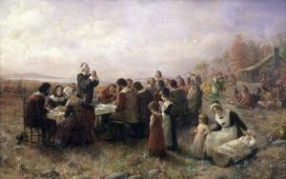The Myth: Paintings such as The First Thanksgiving at Plymouth (1914), by Jennie A. Brownscombe, enshrine a picture of the “first” Thanksgiving that is more sentimental than factual. - Public domain image.

What we do know with certainty is that before those European settlers survived the winter of 1620 and the following planting season (only 50 remained of the original 100) they survived a two-month cross- Atlantic voyage. They were, indeed, pilgrims, travelers who had journeyed a long distance, in this case, to escape persecution and pursue a better
life. During this time of giving thanks and sharing abundance, the similarities between those early immigrants and today’s migrants are worth reflecting on.
Like their predecessors, modern-day migrants undertake arduous and lengthy journeys, over land and sea, and are often subject to grave dangers along the way. They are motivated by the same urges to improve one’s quality of life, find gainful livelihood, and flee oppression and violence. And upon arriving at their destination, they are pitted against further challenges that may prove insurmountable, including making a home with their families in unfamiliar, perhaps unfriendly surroundings, and suffering the pain of exile. Today, deportation is also a frequent outcome, and despite all the risks, efforts and expenditures, they may be forced to start again. In most instances, the entire endeavor is a test of survival, and a gamble on “making it” in a “new world.”
Rather than considering the migration of these contemporary pilgrims as a new phenomenon, it’s important to remember that it is simply a continuation of an ages-old human impulse to move—from farm to city, from country to country, from continent to continent—and evidence of a very understandable yearning within us for security, safety

and well-being, wherever that can be found. So people migrate as they have done for millennia. The movements of those who were brave, steadfast or desperate enough to take to the road, with all its hopes and risks, have shaped all of human history and culture. It is how, in this country that has memorialized the Plymouth pilgrims’ sacrifices and perseverance in a much-treasured national holiday, the U.S. became the U.S.

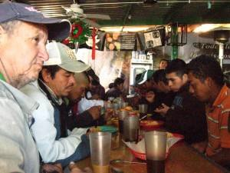The Real Deal: Migrants gather at the KBI comedor to share a meal in a spirit of gratitude for the gifts of safety, nourishment and companionship. - Photo by Roxane Ramos.

The other participants in that seminal celebration—the Native Americans who taught the settlers how to fish and farm—were pilgrims, too, but their migrations, often to lands far from their original homes, were not voluntary. The forced relocation of native populations is part of any full history of migration in North America, and it touches on another element of the migrant experience, namely, displacement. To leave is one part of migration, to journey
another, but to at last settle into a new life in a new land, in any number of circumstances, involves a bittersweet goodbye to one’s former home, and sometimes an extended or permanent separation from loved ones. While other aspects of migration are daunting, the separation of families is heart breaking, and finding a way to keep families together fuels a big part of the current immigration debate in the U.S. Can we institute a humane and compassionate immigration policy that unites migrants with their children, parents and spouses, rather than coldly discounting those ties?
The connections we have with family, community and the wider world are at the heart of the upcoming holiday— though today, the “wider world” is, in fact, the planet—and find their origins in that 500-year-old harvest festival. The Native Americans shared their knowledge of their land, the pilgrims shared the fruits of their labor, and a satisfying, if short-lived, exchange of resources was forged. Today, we honor interdependence and express our gratitude for what we have by traveling to be with family, volunteering to help others who are not as fortunate, and gathering to share a plentiful Thanksgiving meal.
When Pope Francis recently wrote that the “Church is a pilgrim in the world,” he reminded Catholics and others around the world of the centrality of the journey. The supporters, staff, volunteers and board members of the Kino Border Initiative strive to live up to this ideal. We are all pilgrims, implicated in each other’s journeys and called to make a migration that is at once personal and collective, literal and metaphoric. We are invited to participate in that grand tradition of movement—on a road, in our hearts, perhaps outside our comfort zones—and to gather around a table that seats all of us.

(This article was first published by Passages, The KBI Newsletter, November 2014. For more information on the Kino Border Initiative and its direct aid, education, and advocacy and research programs, please go to https://www.kinoborderinitiative.org/)

UPDATE ON IMMIGRATION
By Giulio Grecchi, Tucson, Voice of the Poor, Western Region Representative

At the end of summer, the President delayed the promised administrative action on deportation relief, pledging to implement it for “after the November elections”.
Now, that the elections have taken place, it is very likely that the President will act, in spite of the continuing unfavorable political climate. [Will it ever be favorable?] Any further delay would undermine the President’s credibility to a very damaging point. We hope that action is indeed forthcoming, because every month of delay results in tens of thousands of fathers, mothers, children being deported and separated from their families. Can we continue to remain indifferent?

In September, the US Bishops, through Justice for Immigrants, conveyed to the Administration the category of migrants needing protection, which they hope the President will consider when taking action. After excluding those who have committed serious crimes, they specifically requested deportation relief for the following groups:
- Immigrants with strong community ties and equities in the United States and have lived in the United States for ten years or longer
- Parents of U.S. citizens
- Parents of recipients of Deferred Action for Childhood Arrivals (DACA)
- Individuals residing in the United States with already approved family and employment petitions.
Estimates of how many people are included in the above categories vary – they are probably several million.

Why do our Bishop get involved with such a controversial issue as Immigration? The reason is that undocumented migrants live in our communities, go to our churches and the Bishops, as pastors responsible for the wellbeing of their flock, have to speak-up against the injustices that undocumented migrants suffer, such as the break-up of families, or lengthy imprisonment and deportation for simply being here undocumented.
In addition, in recent weeks, Justice for Immigrants communicated another deep concern of the US Bishops: private prisons in New Mexico and Texas detaining undocumented Central America mothers and children in horrible conditions, after separation from male members of their families. These are refugees escaping targeted violence in their home countries. Overcrowding, lack of privacy, lack of recreational space, etc. are damaging for the children’s psychology and health. The Bishops have proposed letting these migrants join relatives already residing in the US or implementing community based models, as an alternatives to detention, which would be more humane, far less costly and more efficient.
Justice for Immigrants requested that we call the White House every day and urge others in your networks to call as well.

The toll-free number to use to call the White House is 1-855-589-5698 and the message suggested by Justice for Immigrants is simple: “Protect as many immigrants and their families as possible from deportation”.

MARK YOUR CALENDAR!
National Migration Week 2015: January 4 - 10
WE ARE ONE FAMILY UNDER GOD

National Migration Week 2015 will take place January 4 – 10 with the theme, "We are One Family Under God," which brings to mind the importance of family in our daily lives. This reminder is particularly important when dealing with the migration phenomenon, as family members are too often separated from one another.
Councils and Conference are invited to reflect on Catholic teaching on Migration to foster a new understanding of the moral dimensions of migration (with a particular emphasis on children and family unity issues) and a willingness to engage in practical and public policy efforts.
For resources on National Migration week see
http://www.usccb.org/about/migration-and-refugee-services/national-migration-week/

Vincentian Megaphone for Social Justice

Capwiz: SVdP’s On-line Voice of the Poor
By Tom Dwyer, Voice of the Poor, North-East Region Representative

Recently, members of the Society of St. Vincent de Paul were asked, “Do you take to heart this statement from the Rule of the Society of St. Vincent de Paul?”
“Where injustice, inequality, poverty, or exclusion are due to unjust economic, political or social structures or to inadequate or unjust legislation, the Society should speak out clearly against the situation, always with charity, with the aim of contributing to and demanding improvements.” (Rule, Part 1, Article 7.6, emphasis added)
This is a question every member of the Vincentian Family ought to ask… especially if we are to take seriously the call of St. John Paul II who challenged us to look into underlying causes and long term solutions.
“If so, then you must sign up for the SVdP edition of CapWiz (http://www.capwiz.com/svdpusa/mlm/signup/), the online advocacy alert tool that the Society uses to promote Catholic Social Justice principles in our public policy deliberations at the federal level with the president and our U.S. senators and representatives. In today’s culture of instantaneous communication, it is an online megaphone and the modern way to respond to the age-old Vincentian call to be “the Voice of the Poor.”
The Society today and all of the Vincentian Family stresses justice as well as charity. Charity alone will not bring about the systemic change needed to enable the poor, the marginalized and the vulnerable to work their way back into the mainstream of society as contributing, productive and self-sufficient citizens. While critically important and always a hallmark of Vincentian care and compassion, charity is more like a band-aid that stops the bleeding but does not necessarily bring about

a cure. Justice – or, more precisely, social justice in the tradition of Catholic Social Justice Teaching dating back more than a hundred years to Pope Leo XIII’s 1891 Encyclical “Rerum Novarum: On the Condition of Workers” – is the medicine to bring about a cure.
That is where CapWiz enters. When federal legislation is proposed that either hurts or helps the poor and the marginalized, when national policies and programs seem to stray from the principles and values of Catholic Social Justice Teaching and when federal budget priorities ignore the needy and disadvantaged, the National Council Office of the Society will email CapWiz Action Alerts to all those subscribed to the free service.
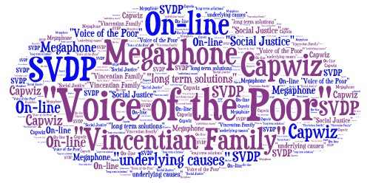Usually, the CapWiz Action Alerts have been developed and vetted through the Society’s National Voice of the Poor Committee, in consultation with the U.S. Conference of Catholic Bishops. The Society’s National Voice of the Poor Committee is comprised of volunteer Vincentians acting as Voice of the Poor Coordinators from each of eight regions across the country. Typically, the Action Alert
contains a cover message from SVdP President Sheila Gilbert or another national SVdP leader, plus an electronic link to a proposed letter to be sent to the president and congressional representative and senators.
The letter itself can be easily modified to make it personal to you, or you can simply send it as is. With a few clicks of your computer mouse, the letter is in minutes electronically on its way to your specific U.S. Senators and Representative and the President. A few minutes later, you will receive an email delivery confirmation for your letter, along with the full text of what you wrote. If you want to send the letter by regular mail, you can cut and paste the text into word-processing software and send the hard copy on its way.
In short, CapWiz is a vitally important resource that enhances our collective Vincentian ability to be effective Voice of the Poor advocates. But only about 5,000 Vincentians of our estimated 150,000 members in the U.S. are signed up for this service. So, there is plenty of room to turn up the volume of the Voice of the Poor to Congress and our President.
Hopefully, members of the wider Vincentian Family will untie so that we form a lobby for those who cannot to lobby for themselves… or when they do find themselves dismissed in all manner of ways.
CapWiz is a service operated by CQ (Congressional Quarterly) Roll Call, a well-respected organization with a long history dating back to 1945. CQ Roll Call characterizes itself as an organization that provides non-partisan insights and tools for those who lead, shape or follow public policy.

Just Wage for the Employees of the Society of St. Vincent de Paul

At the Atlanta National Assembly, the National Council approved the position paper on “Just Wage for the Employees of the Society of St. Vincent de Paul”. The paper recommends that the employees of the Society be provided the income necessary to meet basic needs without public subsidies (public housing, food stamps, Medicaid or child care) and without private assistance (food by local Churches or food banks, free babysitting by a relative, etc.)

Some Diocesan Councils have already started the implementation of the position paper, striving to fully comply with its recommendations based on an agreed upon timetable, which takes into consideration the economic viability of their operations (store, soup kitchen, shelter, etc.)
The implementation eliminates existing contradictions, such as serving people in poverty, on one side, and not paying our own employees sufficiently, on the other, forcing them to seek help elsewhere.
While there is no shortage of debate in our country about wages, it is our role as a faith based organization to deal justly and morally with those the Society employees, in accordance with Catholic Teaching.
As we implement this position paper, we will set an example and a new standard for other Catholic organizations and even for our own Parishes and Dioceses on the respect and fair treatment that we owe our employees.
See the position paper at:
http://www.svdpusa.org/LinkClick.aspx?fileticket=6aTS2y31qE4%3d&tabid=342&portali d=1&mid=1278&forcedownload=true
And Frequently Asked Questions on the paper at:
http://www.svdpusa.org/LinkClick.aspx?fileticket=pb6LPQ84tfM%3d&tabid=342&portali d=1&mid=1278&forcedownload=true

Recommended Steps for determining a Self-Sufficient Wage
- Investigate the cost of public benefits in your state or geography. How much money does a family of three, for example, need to be independent of SNAP, Medicaid, TANF, etc. Are we paying more than that?
- Examine the local wage calculator (http://livingwage.mit.edu/). Does that calculation provide a reasonable snapshot of the cost of living in your geography? Do you need to validate any of the components? Does that wage allow people to live without long- term public/private assistance?
- Compare the self-sufficient wage with your current pay scale. If you were below that pay scale how long would it take to raise pay to a self-sufficient level?

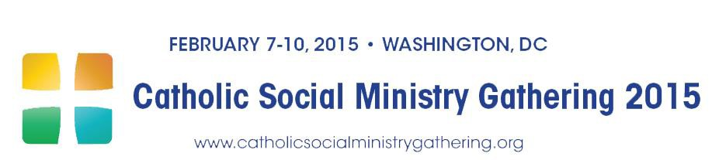
To Go Forth: Encountering Christ in the Heart of the World
AS ONE OF THE 16 SPONSORING ORGANIZATIONS OF THE 2015 CATHOLIC SOCIAL MINISTRY GATHERING, THE SOCIETY OF ST. VINCENT DE PAUL ENCOURAGES YOU TO:

Register for the 2015 Catholic Social Ministry Gathering!

February 7-10, 2015, Omni Shoreham Hotel, Washington, DC

Join the leadership of the Society and other U.S. leaders in Catholic social ministry and advocacy. Connect with colleagues from around the country, and meet current and emerging leaders sharing new energy and ideas. Excellent plenary presentations, briefings, and workshops will focus on pressing domestic and international social concerns and our response as Church. Then lend your voice to our advocacy for the poor and the common good with members of Congress during the Tuesday visits on Capita Hill.

To register or for more information visit www.CatholicSocialMinistryGathering.org.

The annual Catholic Social Ministry Gathering is organized by the Department of Justice, Peace and Human Development in collaboration with 4 other USCCB departments and 16 national Catholic organizations.

----------- 00 ------------

SAVE THE DATE

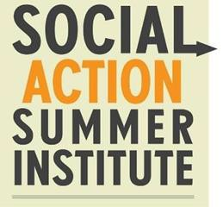JULY 19–23, 2015 PORTLAND, OREGON
A 5-Day National Institute for Social Action Ministers

Care for God’s Creation:
Life, Earth, and the Common Good

http://catholicroundtable.org/sasi

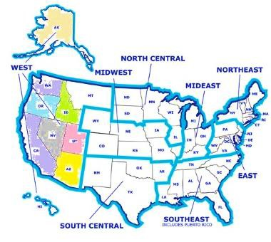

From Phoenix
FROM THE WESTERN REGION

ARIZONA

Members of the Voice of the Poor Committee met last week with Peter Hershberger, Director of FosterEd Arizona. This group, based out of Tucson, works to connect foster children with “educational liaisons”. These volunteers focus on ensuring that these children receive the educational opportunities needed to succeed in school and thrive in life. There are over 14,000 Arizona children in foster care. Many of these children have suffered abuse or neglect and studies show the following sobering results:
  - Foster children are twice as likely to be absent from school
  - Repeat a grade twice as frequently
  - Are twice as likely to be suspended, and three times as likely to be expelled
  - Perform significantly worse on standardized tests than any other at-risk subgroup
  - Are half as likely to graduate
  - Without educational success, foster children are ill equipped to support themselves as adults.
  - Over 22% experience homelessness
  - Are ten times as likely to be arrested
  - Three times as many live below the poverty line
  - Five times as many receive public cash assistance
  - Over 50% receive some type of government benefits
This program utilizes volunteers that serve as educational champions for these children. California and Indiana have had this program in place and have found remarkable results. Arizona is the third state to embark on a pilot program. Here is a brief list of things that we can do:
  - Volunteer as an Educational Champion
  - Advocate for funding of this program in upcoming Arizona legislative sessions
  - Advocate for early childhood education
For more information on becoming an educational champion, visit www.foster-ed.org Reported by Julie Douglas, Phoenix, AZ

17

See below information on a Foster-ed pilot program in Pima County

Pima County School Superintendent Highlights FosterEd: Arizona
The Office of the Pima County School Superintendent highlighted its partnership with FosterEd: Arizona in its annual report for the 2013-2014 school year. Through the end of August 2014, FosterEd Education Liaisons with the Pima County pilot program had worked on behalf of 187 students in foster care.
http://www.foster-ed.org/Modules%20SCC/Pima%20County%20Schools%20Annual%20Report%202013-14.pdf

From Tucson Systemic Change
Three members of Tucson Voice of the Poor attended the August Systemic Change training in Los Angeles. During the spring and the summer, the VOP team concentrated its efforts on getting Systemic Change up and running in our Diocesan Council, acting as an incubator. Tom Jefferson of the St. Cyril of Alexandria Conference is leading Systemic Change, which is attracting other Vincentians to join in. During 2014, both Giulio Grecchi and Tom Jefferson have trained as facilitators for the Getting Ahead Program.
In October, the team met managers of Pima County ONE STOP. Independently, they are involved with Bridges out of Poverty, together with one of the school districts and a local not-for-profit. We are looking forward to potential synergies between these groups going forward.

VOP / Systemic Change information sessions
The VOP/SC team gave presentations on Voice of the Poor and Systemic Change at a Council meeting at St. Rita in the Desert in Vail, AZ. In spite of the long day of meetings, the presentations triggered a lively conversation with the Vincentians in the audience.
Currently, on a weekly basis, the VOP/SC team is showing the DVD series of Bridges out of Poverty
- Strategies for professionals and communities - to train interested Vincentians on Systemic Change. In addition, starting in December, on the first Saturday of every month, the Council office plans to host an informal get together, where Vincentians will be able to share information on Voice of the poor, Systemic Change, Resources available, etc.

Homelessness and Single Mothers
Dan Torrington, Council President and Giulio Grecchi, Voice of the Poor prepared a paper on Homelessness, explaining what the Society does to prevent it through its rental and utility assistance programs. We focused our attention primarily on single mothers and made a number of recommendations on how the Catholic community can best support help them.
On November 11, we presented the paper to the Catholic Community Services Public Policy Committee, of which SVdP is a member. The idea of providing a safe place for single mothers to meet drew much interest and was expanded beyond what we initially proposed.
Other organizations participating in the meeting described their efforts in this area, mostly directed at sheltering homeless people or providing cooling places during the summer.
As a background, Homelessness is one of the key concerns of Bishop Kicanas, second only to Immigration. Catholic Community Services will summarize all findings and proposals for the Bishop.
Reported by Giulio Grecchi, Tucson, AZ

From Patterson Restorative Justice

CALIFORNIA

Restorative Justice is one of the key priorities of Patterson conference. At a recent conference meeting, we discussed the difference between retributive justice and restorative justice.

New Stockton Council
Nancy Ban, VOP and former conference president is now the President of the Stockton SVdP Council. She is planning to attend the first meeting of the St. Bernadette Conference and has invited me to go with her.

A Morning with St. Vincent De Paul
Saturday morning, I was privileged to spend a few hours with 20 other Vincentians listening to a talk by former National Council President, Deacon Gene Smith, about St. Vincent's special devotion to God and view of Christ. Deacon Smith is now the Western Regional Spiritual Advisor of the Society of St. Vincent de Paul, and he spent the morning sharing his thoughts with us.
He said that St. Vincent viewed Christ as an evangelizer and a missionary, who spent His life working among the poor. Deacon Smith talked about the virtues of Christ that are the model for Vincentians as well as all good Christians - simplicity, humility, gentleness, selflessness and zeal. I couldn't help but wonder how I would measure up to Christ's model. How many days do I hit or miss the mark? If I could stand before Christ now, would He be pleased or disappointed with my behavior? I left the morning slightly uncomfortable and pondering how I must change to become more Christ-like.
The other important thought I carried away from Deacon Smith's talk was about the importance of connecting prayer to action. I don't always do this, but I can see the importance of doing this and how it can impact success, especially in interacting with the poor.
The other realization I gained from Deacon Smith's talk is that I should start my day with prayer. I usually pray in the evening, but now I see the sense of praying before starting the day and going about the work of Christ. Hopefully, Christ will overlook my shortcomings and welcome my resolve to change! (Reflection on "A Morning with St. Vincent de Paul" by Janet Dolan, Sacred Heart Conference, Patterson)
Reported by Sister Anne Marie Berthiaume, Patterson, CA

From Sacramento Reorganization
Our Diocesan Council is continuing its reorganization into District Councils in order to improve the efficiency and impact of the St. Vincent DePaul Society in the Sacramento Diocese. New District Council leaders have begun work on identifying needs and putting resources into action. Voice of the Poor Advocates are being recruited and will be aligned with the District Councils in 2015.

Proposition 47
The passage of the Restorative Justice Proposition 47 in California has been a top priority of Voice of the Poor this fall. In cooperation with our bishop, Bishop Jamie Soto, and our local partners and collaborators, we had a major impact on the passage of this important proposition. Although reaction to the passage has been mixed between advocates for the poor and the law enforcement community, we are looking forward to positive results in prisoner outcomes and the benefits of cost savings. Special thanks to Diane Clarke of our St. James, Davis, Ca. Conference for her guidance and leadership on this issue.

Homelessness
The Voice of the Poor has been active in the “Bridge to Housing Pilot Project” in West Sacramento, Ca. The program is intended to reduce the homeless population in Yolo County and West Sacramento and provide them with housing and supportive services. This partnership of city, county, faith based and private industry groups has been supported by Vincentians and Voice of the Poor Advocates from the Holy Cross and Our Lady of Grace Conferences. We look forward to promoting more projects like this in the coming years.
Reported by Dennis McSweeney, Sacramento, CA

From San Diego
Council Presidents Marleen Steffan nominated Kenneth Poggenburg as Voice of the Poor Chair for the San Diego Diocesan Council. She requested conference presidents that they include VOP on the agenda for one of their meetings and solicit emails from Vincentians who might be willing to participate in this mission.
Reported by Kenneth Poggenburg, Encinitas, CA

IDAHO
From Boise
November VOP Meeting
The V.O.P. Committee met the 1st Wednesday of November and discussed the articles we have been putting in the parish bulletins. I encouraged everyone to try to get them into the bulletins at their parish, so that we are all speaking with the same voice.
The November article was the "participation" statement on the last page of the Voice of the Poor booklet. I added the words "Please remember this when you go to vote on Tuesday Nov 4th.”
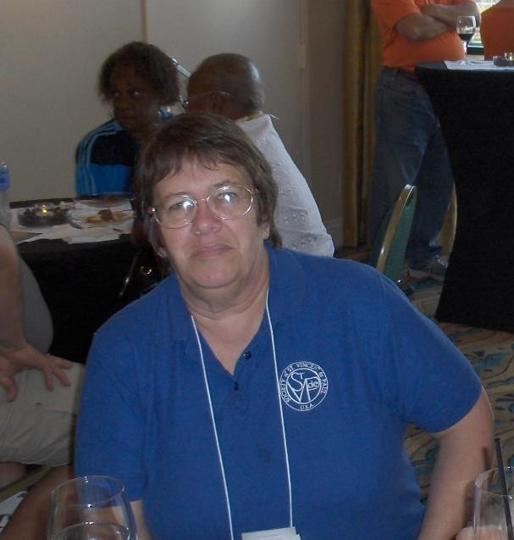At our meeting, we also discussed our participation in the Public Policy Committee of Catholic Charities. We are coordinating the topics of our bulletin articles to be consistent with the articles that they publish in the Idaho Catholic Register.
At the same meeting, we discussed the issues we want to address in the upcoming Legislative session and they are:
  - Increasing the minimum wage
  - Medicaid expansion
  - Payday lending
Mike Gallagher, our Council President, thought that, when we will testify on Medicaid expansion, we should share with the Legislature my story on how it was to be uninsured and then to be able to have medical insurance through the affordable healthcare act.
Frank Monasterio is planning to write an article on Medicaid expansion for the Idaho Catholic Register.
In the picture: Kelly Anderson

Payday Lending
On Payday Lending, the bill passed in early 2014 allowed a needy person to borrow against gross earnings instead of net. We believe that this is wrong and we plan to draft a bill ourselves and see if we can get it printed for this legislative session. Ida Fisk said that we need to keep this issue fresh in the minds of the Legislators, so we do not lose any credibility by stepping off the issue. She is the past president of our SVDP Council and we need her wisdom. She is also our oldest committee member, so her advice and knowledge are invaluable.
The VOP Committee will have the opportunity to attend on November 19 a planning and zoning committee meeting in Garden City, ID to speak out against a variance that is being requested to turn a residential property into a commercial one, for the purpose of opening a title loan business. This would just add another predatory lender to a city that has more of this type of businesses than banks or grocery stores, in a low-income area. Will let you know how the vote goes. Keep us in your prayers!
Below, you will see what will go into bulletins in Boise on Payday Lending the 1st weekend in December. We thought that the timing is good as people with little income may go to payday lenders for Christmas shopping money. Lenders seem to advertise heavily during this time of year.
“Did you know…That payday loans are taken out by over 12 million American adults, each year? On average, a borrower takes out eight loans of $375 each per year and spends $520 on interest. The Voice of the Poor calls for access to fair, responsible, affordable credit that provides consumers clear, realistic terms and practical repayment periods. Currently, 17 states have enacted legislation to curtail the excessive cost of monies through payday loans. Idaho is not one of the seventeen.
“Out of Poverty” is the newsletter of the St. Vincent de Paul Society/Voice of the Poor for the Western Region, which helps us understand the complicated issues of poverty, hunger, homeliness, just wages, medical needs and much more.
Visit the website www.wrvop.org to learn more about our voices. To be placed on the email version of the newsletter email: kelly.anderson@svdpid.org with the word newsletter in the subject line.”
Reported by Kelly Anderson, Nampa, ID

From Portland Measure 88

OREGON

Unfortunately, Ballot Measure 88, which would have provided Oregon resident "driver card" without requiring proof of legal residence in the United States, was badly defeated despite the faith community's efforts and Archbishop's support.

2015 State legislature
Maureen Sloan is planning to attend a program on Nov. 22 to look at upcoming legislation for our State Legislature in 2015. Information will be relayed to Council President and possibly brought-up to a Council meeting.
Reported by Maureen Sloan, Portland, OR

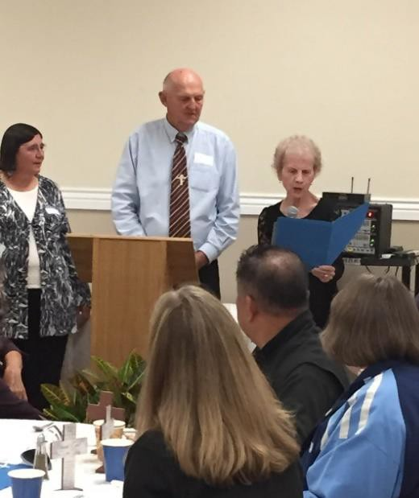From Salem
On September 11, the Mid-Willamette Valley Society of SVDP had its annual dinner, with a very nice turnout. At the dinner, I was asked to speak and give an award to our SVDP Director of Emergency Services. My portion of the program and VOP comments were favorably received.
The Woodburn conference, primarily of Latino member, was well represented at the dinner. They offered to host the annual meeting next year, featuring ethnic foods from their culture. It will occur on Sunday noon, instead of Saturday night. We were pleased with the change, because many of our members are older and do not drive at night so daytime functions are better for us in Oregon, where it is dark and rainy in the evening.
In the picture, l. to r. Shari Crawford, SVDP Director of Emergency Services, Corky Carron, Council President and Sue Woodford, VOP Council Member & QP Conference President
In September our council signed a Memorandum of Understanding with the Society of St. Vincent DePaul of Lane County in Eugene, OR to initiate stores, recycling and manufacturing operations in the Linn, Marion and Polk County areas to develop jobs for those most in need. We are excited about this new opportunity to assist families in our community. Terry McDonald, the Executive Director of the St. Vincent DePaul Society of Lane County, is famous nationwide for its outstanding recycling programs.
Reported by Sue Woodford-Beals, Salem. OR

WASHINGTON

From North Sound District
Some of us from this area headed up to Sacred Heart Catholic Church in Bellingham on Nov. 12, to participate in one of the Seattle Archdiocese meetings, called Dialogue for Justice. At the meeting, we discussed current social justice issues, preparing ourselves for the upcoming Washington state legislative session in January. We also talked about what the Catholic Bishops in Washington State are expecting from this session. The group that went to the meeting in Bellingham from this area included folks from St. Michael’s and St. Mary of the Valley Catholic churches who are involved with SVdP, SVdP/VOP, JustFaith and other social justice ministries. We were also preparing for our Catholic Advocacy Day in Olympia on March 26, 2014.

SVdP and JustFaith members of St. Michael’s Catholic Church in Snohomish, WA are currently planning a Legislators forum for the evening of Dec. 9. Legislators from a couple of legislative districts that encompass many of our Snohomish County Catholic churches (and therefore many of our Catholic voters) are invited to attend and dialogue with those of us interested in advocating for the poor. This event is also in preparation for the upcoming 2015 legislative session in Olympia. We are concerned that the poor, the needy and other vulnerable populations are going to get

“short-shrift” after some Washington state Supreme Court decisions that will have our legislators looking to use available state funds for other than helping the poor and vulnerable.
Reported by Jim Bloss, Monroe, WA

From Seattle
Michael Stratton, Archdiocesan Council VOP Chair, recently completed Formator training for the Ozanam Orientation. His first opportunity to teach Vincentians on Voice of the Poor was at an Ozanam training session in Longview, in Southwest Washington State. Feedback received was very positive. Members of the host conference felt that "there are different ways to serve the poor other than with food." They will be discussing new ways to serve those in need. Well worth the two and a half hour drive to Longview.

Michael will be taking part in the “Getting Ahead” training in November, which will qualify him as a facilitator for the program.
Reported by Michael Stratton, Seattle, WA

2014 BiNational Posada Nogales, Agua Prieta, Yuma
Dioceses without Borders & the Kino Border Initiative invites you
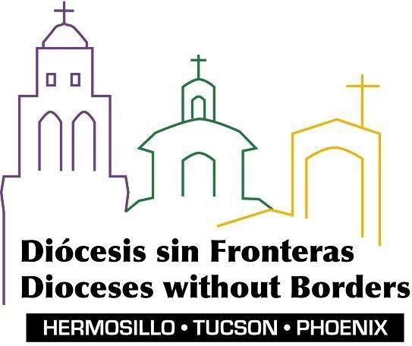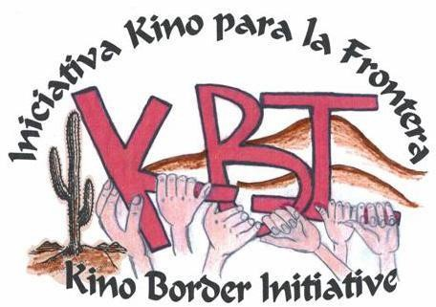

http://dioceses-without-borders.blogspot.com

Nogales – Saturday, December 13th at 3:00 p.m. Meet at the
DeConcini Port of Entry. The event will take place in Mexico and a festive dinner will follow at the Kino Border Initiative.*
Agua Prieta – Tuesday, December 9th at 4:00 p.m.

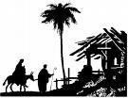Beginning at the west side of the Douglas Port of Entry and concluding at the Migrant Resource Center in Agua Prieta.
Yuma – Wednesday, December 17th at 6:00 p.m. at Immaculate Conception Parish, 505 S. Ave. B.

For more information:

Fr. Cayetano Cabrera, Archdiocese of Hermosillo 011-52-631- 316-0895, sagfamap@hotmail.com
Ignacio Rodriguez, Diocese of Phoenix
602-354-2042, irodrig@diocesephoenix.org Sr. Gladys Echenique, OP, Diocese of Tucson
520-838-2540, gechenique@diocesetucson.org

PLEASE NOTE: Passports are required for 16 yrs. or older. Children may use a birth certificate and ID.
*Parking in Nogales ONLY: Travel to the end of I-19 and after passing the Burger King, take the first left and then a right into “24-hour public parking.” Parking $4. Walk toward Grand Ave. (past McDonald’s at the lights), right on Grand to the Border gate. Walk to the port of entry and pass through the gate, proceed about 100 yards to the plaza where the Posada will begin. We will walk for 20 to 25 minutes during the Posada. After the meal, rides will be provided back to the DeConcini Port.

