********

*vincentian marian youth INTERNAtIONAL*

year 14, N.96 February 2014







**CONTENT**

## **VMY IN THE WORLD:**

Europe and the Middle East

## **PAGE 2**

## **FORMATION**

Accompanying Youth

## **PAGE 3**

## **WITNESS:**

## VMY United States

## **PAGE 4**

## **INTERNATIONAL MEETING**

## CENMEX Panama

## **INTERNATIONAL COUNCIL AND SECRETARIAT**

## **PAGE 5**



JUNIO 2013

JUNIO 2013

Our annual motto expresses the words that the young men and women of our Association cry out to our advisors. It is a cry that wants to express gratitude to the many advisors who guide and share our life in good times and in bad times. They nourish our desire to attain a deeper knowledge of Christ and to establish a more intimate relationship with Mary. They strengthen us to be authentic agents of change and true servants of the poor.

 Our motto for 2014 is dynamic. It involves “walking” because the journey of faith implies moving forward and looking forward, it means taking the risk of encountering Jesus who first encountered us. Walking also involves maturing in our faith in a twofold manner: deepening our faith and making a commitment to confront the present challenges of evangelization. We will give life to these words if we are willing to set our course on a path that will allow us to become more aware of our interior movements and thus enter into a deeper relationship with God. We will also give life to these words if we reach out to others and serve our sisters and brothers who are in need. This year, 2014, provides us with the opportunity to continue to live our faith both as a gift and as a commitment, accepting with joy and trust the obligations that our faith places upon us as Christians and Vincentians, places upon us as members of a pilgrim Church that is at the service of the Kingdom.

We can never be too insistent on the fact that we always “walk with someone”. Jesus called his disciples to walk with him and he helped them to understand and to fulfill God’s plan. The journey of faith is never a solitary path but is always a path on which we establish different relationships, a relationship with God and relationships with our brothers and sisters. The celebration of the International Encounter of Advisors (Paris, July 2014) will be a time that will enable the advisors to come to a deeper understanding of the meaning of accompanying the members of the VMY on their journey of faith. Not everyone will be able to participate in this event but we are all challenged to reflect on how we accompany others and how we allow others to accompany us. In the meantime, let us continue our journey toward the IV General Assembly (July 2015) where we will deepen our understanding of and our response to the challenges of evangelization.

May you continue to rejoice in the journey of faith and may you become ever more convinced that God is present in the people you encounter and the events that you experience. Finally, may God’s plan of love be fulfilled in our life and in the life of our Association.



**Yasmine Cajuste**

International President VMY

## **VMY IN THE WORLD**

## **EUROPE AND THE MIDDLE EAST**

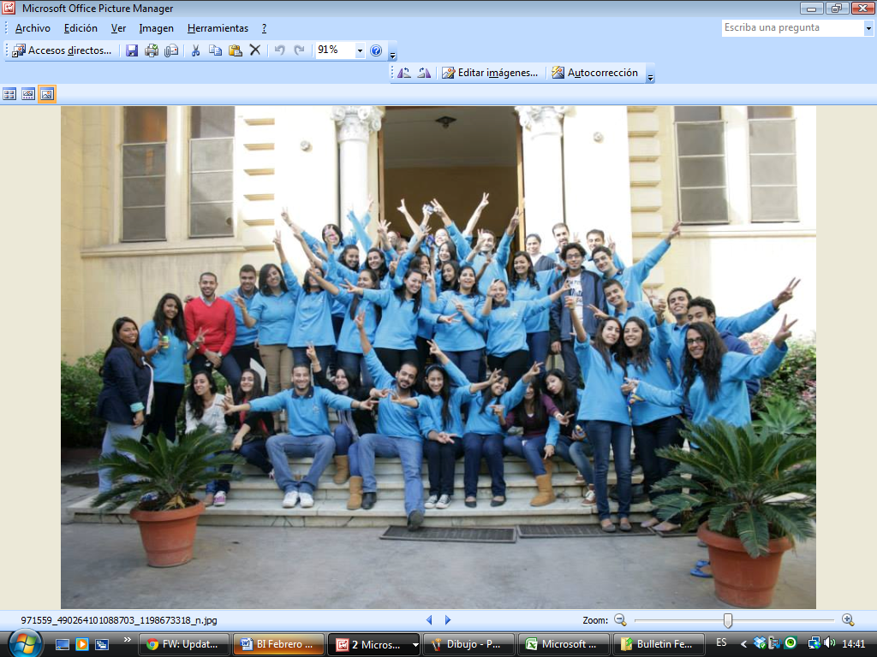

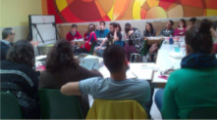







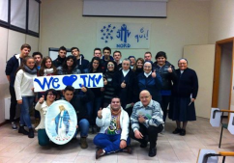

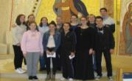







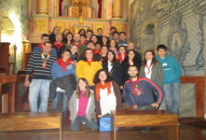





## **ACCOMPANYING YOUTH**

## **FORMATION**



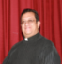

**Fr. Irving G. Amaro R.**

International Sub-Director VMY



**Do we realize that at various times in our life we have learned to do something through the help of another person? We learned to walk with the help of our parents. We also learned how to read and to write and to play different games and to add and subtract numbers because someone helped us with those tasks. Later, because of the foundation that we had received, we are able to do many other things. There were, however, moments in our life when we walked along: without the assistance of parents, teachers, and friends, nevertheless, we continued to move forward.**

**I invite you to reflect on the following questions: What do we do when we find ourselves in a situation that is distinct from anything that we know? On a daily basis we encounter people who are distinct from us and we find ourselves it situations where we are presented with values and anti-values. We ask ourselves: what should we do? It is precisely in the midst of these situations that we should ask for assistance, but what kind of help should we ask for? This question makes us ask other questions: what do I want to achieve in my life? How will I achieve these things and what must I do? Could an advisor help me in this situation?**

**Certainly the first question is: what do we mean when we refer to someone who accompanies us on our journey through life? The word “accompany” has its roots in the Latin *cum panis* which means “break bread”. Such people are willing to share their life with us so that we recognize who we are and what we want from life and what are our options in order to achieve those things. Thus those who accompany us are people who are close to us, who walk with us, who dialogue with us and help us to discern what are the next steps that we need to take. They also promote interpersonal communication while respecting our social, cultural, historical and spiritual situation.**

**Why can we refer to such people as people who accompany young men and women? We can speak of people in this way because they motivate the young people to be protagonists in the midst of a society that desperately needs young leaders who are also men and women of faith. Our society needs young men and women are committed, who have clothed themselves in gospel values, and who are willing to collaborate with one another in order to build a new society. Those who accompany us on our journey share with us certain tools and strategies that will enable us to journey forward.**

**According to the biblical text that narrates the Emmaus event (Luke 23:13-35) there are two travelers who are sad because the plan that they had believed in was not realized: Jesus died. They are disillusioned and discouraged as a result of the events of the past few days and they seem to have lost their way. As they travel along they meet a person who listens to them and is concerned about their discouragement, who understands what they are feeling and experiencing. This companion accompanies them until he sees that their attitude has changed and they decide to return to their friends and share with them the joyful message, namely that the life and the hope and the joy of Jesus’ plan do indeed have meaning.**

**Who then can these companions on our life journey be? Such a person could be a priest, a brother, a Sister or some layperson who is willing to engage in this service and who also possess certain qualities: If a blind person leads a blind person, both will fall into a pit (Matthew 14:14). They are people who have a sense of belonging to the church and they motivate young people to share their experience of God, to see God in the poor and the poor in God, to give witness to their life of faith. Above all else they are convinced that the young person is the one who must make the decision with regard to the direction that he/she will give to their life. Indeed, those who accompany us realize that youth must be the designers and the protagonists of their own history.**



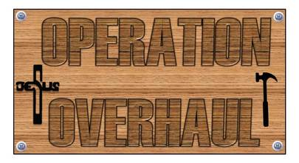

## **VMY UNITED STATES OF AMERICA**

## **WITNESS**

**This past summer our region had the opportunity to take 90 teens and adults to Rosenberg, TX for our annual Operation Overhaul; our week long summer mission trip. Our group was taken in by Our Lady of Guadalupe Parish and its members. We were able to work for the community in so many ways - painting homes, installing interior walls and exterior siding, general yard work and renovating an entire home. Our evenings were spent building faith and deepening relationships through witness talks, group discussions, Adoration and prayer, Reconciliation and daily Mass. Our focus during this trip was "holiness revolution" and how we as Catholics must stand tall and firm in our faith in order to see the change we want to in this world.**

***A witness from one of our young adults, Allisyn Dalton (age 20):***

**Operation Overhaul Rosenberg, Texas was my fifth consecutive mission trip with Vincentian Marian Youth. Each year I make new friends, learn new things, and most importantly grow in a deeper relationship with Our Lord and His Church. Each year I grow in a better understanding of the faith that I would not experience anywhere else.**

**The insight of faith I gained this year was one of evangelization. Throughout the week I saw youth giving everything they had, pushing themselves to the extremes so that someone else’s life could be changed. These youth were not just repairing people’s homes so they would be better suited for living, but repairing their homes so** **they could better understand the love of Christ. In my five mission trips with Vincentian Marian Youth, this is always the case - families, communities, and cities are changed through the acts of service of the youth volunteers.**

**During my week in Texas I spent time in prayer meditating on Acts 17:6. In this verse the early Christians are described as “people who have been creating a disturbance all over the world.” I truly believe these are the words that can also describe Vincentian Marian Youth. In the many mission trips VMY leads, they create disturbances in parts of the world that change lives back to the Lord and this is the heart of Evangelization. I am so thankful for Vincentian Marian Youth exemplifying to me what it means to evangelize. I believe we are all called to give ourselves to extreme levels to create disturbances of truth with the people in our lives challenging them to bring their hearts back to Christ.**

**To Jesus through Mary,**

**VMY, USA - South Central Region**

**Samantha Kertz**

**South Central Regional Director**

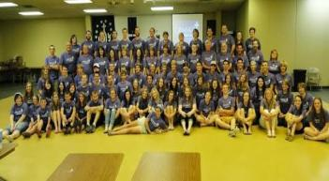









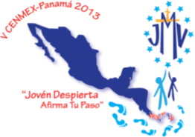

## **INTERNATIONAL MEETINGS**



## **CENMEX PANAMA 2013**

**CENMEX was created to unite the countries of Central America and Mexico and from December 15-21, 2013 young men and women from this region met in Panama City, Panama under the motto: *now is the time to be reborn – affirm your steps!***

**With this theme young people from Mexico, Guatemala, El Salvador, Honduras, Costa Rica and Panama gathered together and participated in a time of formation. As they reviewed their activities and the commitments that they had accepted, they affirmed the importance of maintaining effective communication among the different organisms of the Association. They also affirmed the need for effective formation that will deepen their understanding of the missionary identity that is proper to the VMY and at the same time will enable them to reach out to their brothers and sisters in need. They also spoke about self-financing and the responsibility that they have to make this objective a reality so that they can continue to respond to the needs of young people throughout the world. They shared their different experiences and returned to their countries enriched and more deeply committed as members of the VMY.**

**VMY Panama**









## **INTERNATIONAL COUNCIL AND SECRETARIAT**





The Director General of the VMY, Fr. Gregory Gay CM, has confirmed the following appointments: **Fr. Sergio Asenjo, CM** (Advisor, Spain), **Fr. Rey Araneta, CM** (Advisor, Philippines), **Sr. Isabel Higueras, DC** (Advisor, Spain), **Sr. Gregoria Díaz, DC** (Advisor Venezuela), **Sr. Rositha Belizaire, DC** (Advisor, Haití), **Diana Cristina Velásquez Popoca** (President, Mexico).

Fr. Gregory Gay, CM approved the National Statutes of Colombia (January 2014).

January 15-18: Father Irving Amaro (International Sub-director) and Karmen Kunc (Councilor) participated in the Annual Meeting of the International Leaders of the Vincentian Family which took place in Paris. The objective was to share our work and plans and to establish networks that will strengthen our service on behalf of our sisters and brothers who are poor.

January 22-25: the International Council met in Madrid and Father Gregory was present at this meeting. This time provided us with an opportunity to evaluate our activities, to initiate some new projects, to do some planning for the International Meeting of Advisors and to strengthen the ways in which we accompany the Association in the different countries. We thank you for your prayers which accompanied us during those days.





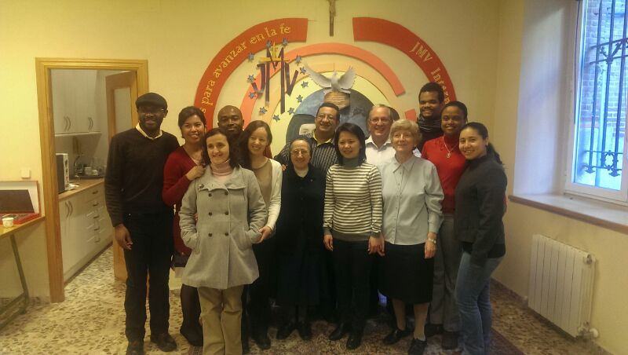





## @sijmv









**www.secretariadojmv.org**