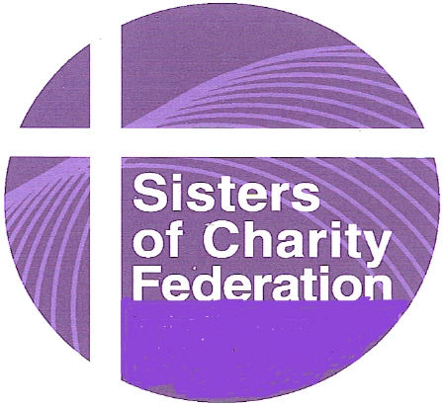
The United Nations and You
September 2011 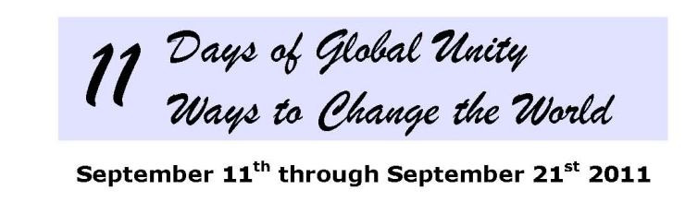
“11 Days of Global Unity”, first started by We, The World, is expanding this year to mark the tenth anniversary of the tragic events surrounding September 11, 2001 and the thirtieth anniversary of the UN resolution creating the International Day of Peace, which takes place September 21st.
Day 1: Unity – Commemorate the 10th Anniversary of 9/11; strengthen interfaith dialogue and understanding; commit to visiting a mosque or attending a lecture to learn more about Islam.
Day 2: Interdependence – Reflect on the Global Pledge of Interdependence
We, the people of planet Earth, in recognition of the interconnectedness of all life and the importance of the balance of nature, hereby acknowledge our interdependence and affirm our dedication to life-serving environmental stewardship, the fulfillment of universal human needs worldwide, economic and social well-being, and a culture of peace and nonviolence to ensure a sustainable and harmonious world for present and future generations. (Sign the declaration at http://we.net/declaration)
Day 3: Environment – Choose an action to reduce your ecological footprint.
Day 4: Economic Justice – Read the Bishops’ Pastoral on Economic Justice: www.osjspm.org/economic_justice_for_all.aspx
Day 5: Health – Do something healthy for yourself today; exercise; take a walk.
Day 6: Children & Youth – Petition President Obama to ratify the UN Convention on the Rights of the Child (only the U.S. and Somalia have not ratified it); read to a child today.
Day 7: Women – Volunteer at a local women’s center or make a donation to a microfinancing project. (Check out www.zafen.org – the Vincentian Family Microfinancing website for Haiti.)
Day 8: Human Rights – Sign the NGO Committee for Social Development’s petition for basic social protections for all at www.gopetition.com/petitions/signature-campaign-social-protection-floor.html
Day 9: Freedom – Write a letter to the editor about an issue of importance to you.
Day 10: Disarmament – Contact your President/Prime Minister and urge him to reduce military spending.
Day 11: The International Day of Peace – Sponsor a prayer service in your local communities, schools, or other places of ministry.

